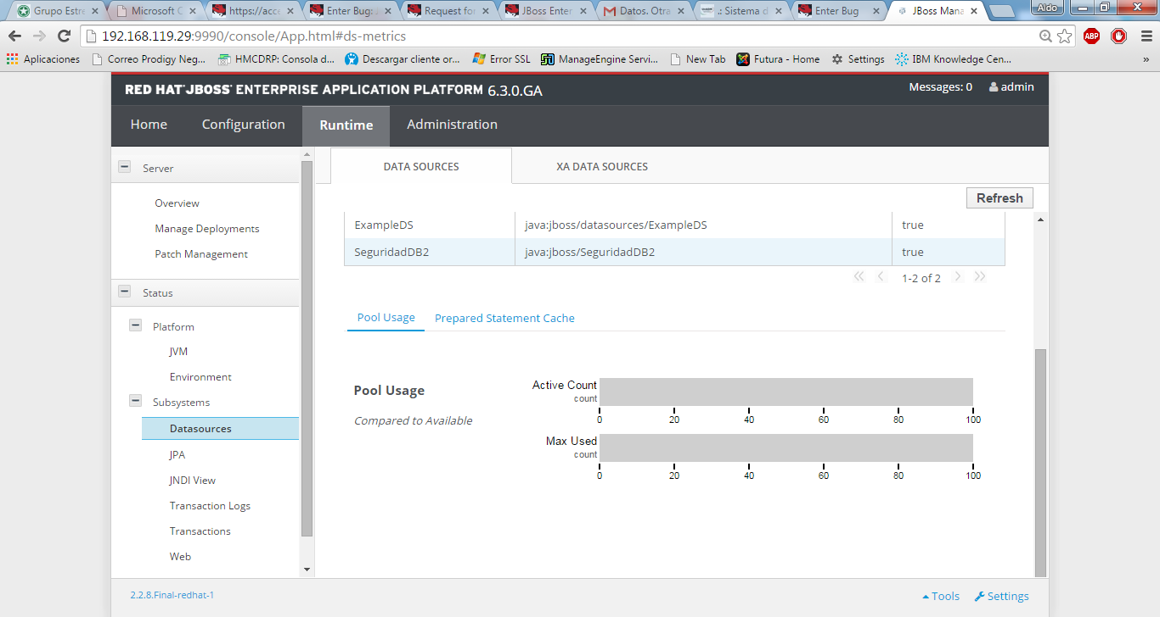
Don’t appers de active count, but there are many user working

