Issue description –
When trying to record https web traffic from Tririga web pages using Jmeter Proxy recording, we see that redirection urls are not constructed properly thus server responding back with a 404-Not Found response.
We do not see this issue while recording the application in Fiddler, LoadRunner, Silk performer or any other tools at our disposal.
We also notice that for the first selection on the form, the redirect happens correctly, and the selection options are displayed but from second selection onwards, we start seeing the issue no matter which page we select or which field on the page. If we stop recording after first selection and then start again, we would be able to do one more selection and so on.
First selection on the form
Success –
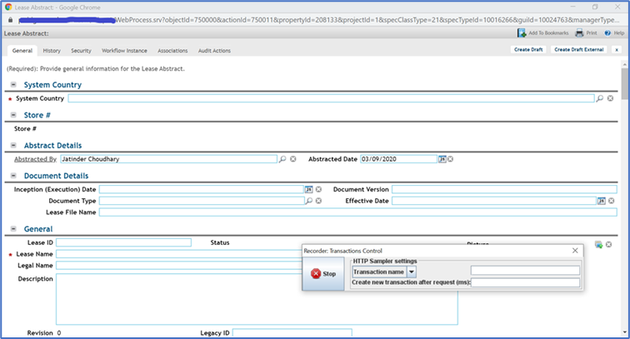
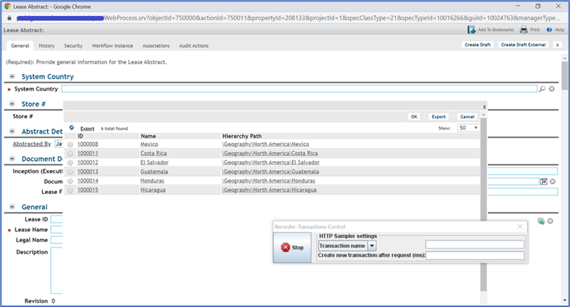

Failure –
