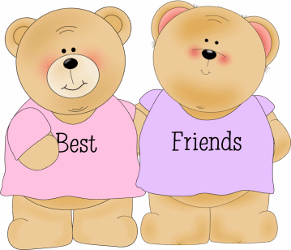
友

些 年 一 个 人 风 也 过 雨 也 走
过 泪 有 过 错 还 记 得 坚 持 什 么

爱 过 才 会 懂 会 寂 寞 会 回 首
有 梦 终 有 你 在 心 中
友 一 生 一 起 走
些 日 子 不 再 有
句 话 一 辈 子 一 生 情 一 杯 酒
友 不 曾 孤 单 过
声 朋 友 你 会 懂
有 伤 还 有 痛 还 要 走 还 有 我

Vocabulary List

些 these
wind

1. pass, experience, go over
2. a particle attached to the verb as a suffix and thus expresses a particular occurrence in the indefinite past. In English, it often is translated as “already” or ”before”.
rain
move, pass, go, leave
tear
mistake, wrong
still
得 remember
持 hold on to
real
finally
can
understand
寞 lonely
首 look back, recollect
finally, in the end
dream
生 a life
些 those
子 days
再 no longer, no more
句 话 a sentence
辈 子 a life time
生 情
a life-long affection
一 杯 酒 a glass of wine
不 曾 never
孤 单 alone, lonely
一 声 a sound
伤 hurt
痛 pain
要 want to

