Switch Checkbox to ‘On’ for setting ‘Use 1904 date system’ on Excel Options
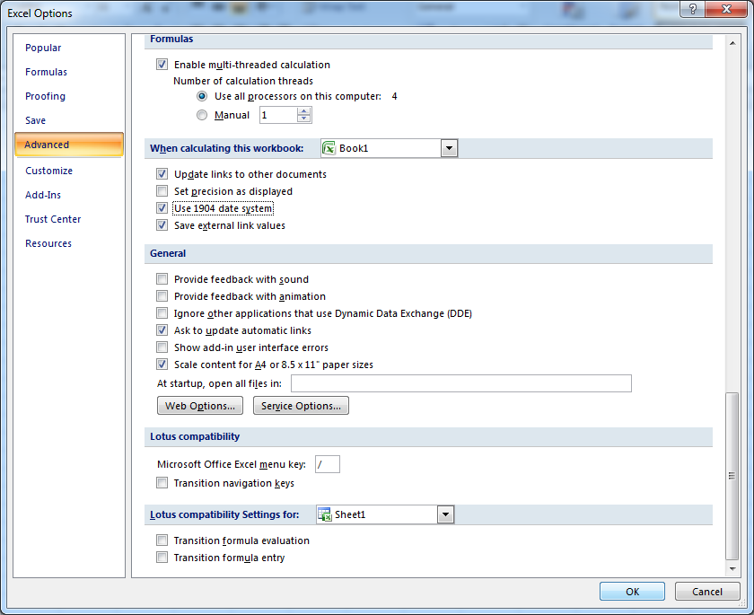

Input number 0 in A1 and change format (Ctrl-1) to Date.
Input number -1 in A2 and change format (Ctrl-1) to Date.
Input number -2 in A3 and change format (Ctrl-1) to Date.
Results:

Example Test:

package com.intechcore.scell.application;
import com.intechcore.scell.model.document.value.NumericValue;
import org.apache.poi.ss.usermodel.DateUtil;
import org.junit.Test;
import java.util.Calendar;
import java.util.Date;
import java.util.Locale;
import static org.junit.Assert.*;
import org.apache.poi.ss.usermodel.DataFormatter;
/**
* Created by Sokrat on 23.09.2016.
*/
public class MainTest {
@Test
public void start() throws Exception {
String stOutDate;
String stStandardDate;
double dateValue;
boolean use1904windowing = true;
DataFormatter dataFormatter = new DataFormatter(Locale.US);
dateValue = 0;
stStandardDate = "1904-01-01 00:00:00";
stOutDate = dataFormatter.formatRawCellContents(dateValue, 0, "YYYY-MM-DD hh:mm:ss", use1904windowing);
assertEquals(stStandardDate, stOutDate);
dateValue = -1;
stStandardDate = "-1904-01-02 00:00:00";
stOutDate = dataFormatter.formatRawCellContents(dateValue, 0, "YYYY-MM-DD hh:mm:ss", use1904windowing);
assertEquals(stStandardDate, stOutDate);
//stOutDate returning '1970-01-01 02:59:59', not standard
dateValue = -1;
stStandardDate = "-1904-01-03 00:00:00";
stOutDate = dataFormatter.formatRawCellContents(dateValue, 0, "YYYY-MM-DD hh:mm:ss", use1904windowing);
assertEquals(stStandardDate, stOutDate);
}
}

