TAFADZWA MASOCHA (R062075B)
tmasocha06@gmail.com
0775988427
Contents
This document contains a portfolio for High Voltage Engineering in partial fulfillment for the requirements of an MSc in Electrical Power Engineering at the University of Zimbabwe UZ.
MEPE504 HIGH VOLTAGE ENGINEERING
LECTURER: PROFESSOR E.CHIKUNI
PORTFOLIO
Department of Electrical Engineering
MSc HIGH VOLTAGE ENGINEERING PORTFOLIO
MEPE504

Contents
1.0 HIGH VOLTAGE ENGINEERING 3
1.1 Advantages of HV transmission 3
1.1.1 Reduction in the volume of conductor material 3
1.1.2 Transmission Efficiency increases 4
1.1.3 Reduction in percentage line drop 4
1.2 Why we need to generate high voltages in the laboratory 5
2.0 MECHANISM OF BREAKDOWN OF GASES, LIQUIDS AND SOLIDS 2.1 HV Insulation 5
2.2 Ionization 5
2.2.1 Ionization by electron impact 5
2.2.2 Photo-ionization 6
2.2.3 Secondary ionization 6
2.3 Townsend’s First ionization Coefficient 6
Example Townsend’s ionization 8
Solution Townsend’s ionization 8
2.3 Townsend breakdown Criteria 8
2.4 Paschen’s law 8
Example Paschen’s law 9
Solution Paschen’s law 9
3.0 CIRCUIT BREAKERS 10
3.1 CIRCUIT BREAKER INTRODUCTION 10
3.2 TYPES OF CIRCUIT BREAKERS 10
3.2.1 Air circuit breakers 10
3.2.2 Oil Circuit Breakers 10
3.2.3 SF6 Circuit Breakers 10
3.2.4 Vacuum Circuit Breakers 10
3.3 Circuit breaker requirements 10
CABLE SIZING 11
Example 11
Solution 11
CAPACITANCE OF A CABLE 11
Example 11
Solution 11
GENERATION OF HIGH VOLTAGES 12
IMPULSE GENERATOR CIRCUIT ANALYSIS 12
Method 1: Voltage Divider Principle 13
Method 2: Kirchhoff’s Current and Voltage Law 13
Example impulse generator calculations 18
Solution impulse generator calculations 18
Example impulse generator calculations (approximate method) 20
Solution impulse generator calculations (approximate method) 20
Cascaded Transformers 20
Transformer 1 21
Transformer 2 21
Transformer 3 21
High voltage measurements 23
Schering bridge 23
Example Schering bridge 25
Solution Schering bridge 25
The Electrostatic voltmeter 26
Example Electrostatic voltmeter 27
Solution Electrostatic voltmeter 27
Potential Dividers 27
Resistance Division 27
Resistance Divider Calculations 28
Capacitance Potential Dividers 30
Capacitance Divider Calculations 30
Simple matching 30
Compensated matching / Split capacitor connection 31
Sphere gaps 32
Importance of sphere gap measurement 32
Construction 33
Rod gaps 33
Examples Rod Gap 34
Solution 1 Rod Gap 34
Solution 2 Rod Gap 34
Solution 3 Rod Gap 34
Earthing 34
Example: Earth rod calculations 35
Solution1 35
Solution 2 35
REFERENCES 35

1.0 HIGH VOLTAGE ENGINEERING
The need for bulk power transfer led to the development of high voltage transmission. It can be proven that the power transmitted over transmission lines increases with the surge impedance loading or the square of the system’s operating voltage.

Advantages of HV transmission

1.1.1 Reduction in the volume of conductor material
From the equation
I=P3*Vcos∅
And
$$R=ρ\frac{L}{A}$$
We know that the total power loss is given by
$$W=3I^{2}R$$
Substituting the above we get
$$W=3{\left(\frac{P}{\sqrt{3}*Vcos∅}\right)}^{2}\left(ρ\frac{L}{A}\right)$$
Rearranging we get
$$A={\left(\frac{P}{Vcos∅}\right)}^{2}\left(\frac{ρL}{W}\right)$$
The above equation shows that the conductor size is inversely proportional to the square of the transmission voltage. The greater the transmission voltage, the greater lesser the conductor size.

1.1.2 Transmission Efficiency increases
$$input power=P+total losses$$
$$=P+{\left(\frac{P}{Vcos∅}\right)}^{2}\left(ρ\frac{L}{A}\right)$$
But the current density is given by
$$j=\frac{I}{A}$$
Substituting into input power we get
$$input power=P+{\left(\frac{P}{Vcos∅}\right)}^{2}\left(\frac{ρLJ}{I}\right)$$
$$Transmission efficiency, ƞ=\frac{Output power}{input power}$$
$$ƞ=\frac{P}{\left(P\left[1+\frac{\sqrt{3} JρL}{Vcos∅}\right]\right)}$$
The equation shows that if transmission voltage increases, efficiency also increases.

1.1.3 Reduction in percentage line drop
$$Line drop=IR$$
$$=\frac{IρLJ}{I}$$
$$=ρLJ$$
$$Line drop \%=\frac{ρLJ}{V}*100$$
The equation shows that line drop decreases with increase in transmission voltage.

Why we need to generate high voltages in the laboratory
- For testing apparatus rated to transmission voltages.
- For generating impulse voltages for simulating over voltages that can occur in a power system due to lightning or switching surges.
- For testing insulating capabilities of various components used in a high voltage power system. Examples of these voltages are power frequency withstand voltage, switching impulse voltage, lightning impulse voltage etc.

2.0 MECHANISM OF BREAKDOWN OF GASES, LIQUIDS AND SOLIDS
2.1 HV Insulation
There are different types of insulation in high voltage applications. These are the main building blocks of all matter, gases/vacuum, liquids and solids. A combination of these materials is called composites. A property of the insulating material that is chosen in selecting a suitable material for HV applications is called the dielectric strength, which is defined as the maximum dielectric stress that the material can withstand. It is also defined as the voltage at which current starts increasing to very high values. This dielectric strength of material is depended on a variety of parameters including but not limited to:
- Pressure
- Temperature
- Humidity
- Electric Field configuration and strength
- Nature of applied voltage
- Flaws in the material etc
In choosing a suitable insulating material electrical engineers look for the following properties:
- The dielectric strength must be high enough
- The material must have excellent thermal and chemical stability
- The material must be inflammable
- The material must have high thermal conductivity
- Excellent arch extinguishing abilities

2.2 Ionization
When a potential difference is applied across two electrodes immersed in a gaseous media, the potential at which the gas begins to conduct is called the breakdown voltage. This process by which a gas begins to conduct due to a potential difference applied to it is called ionization. Ionization in gases occur by three processes:

2.2.1 Ionization by electron impact
If electrons are introduced into the between an anode and cathode, the electric field between them cause the electrons to be accelerated towards the anode. As the electrons drift, they make elastic collisions with molecules or atoms of the gas. If the applied field is increased to a value such that the energy reaches the ionization energy, the electron-molecule collision results in ionization causing the gas to conduct.
$$e^{-}+A→A^{+}+e^{-}$$
Where
$A^{+}$ is the positive ion
$e^{-}$ is the electron
$A$ is the atom

2.2.2 Photo-ionization
Electrons of lower energy than the ionization energy may, on collision, excite the gas atoms to higher states. The reaction can be represented as
$$A+e\underset{→}{Energy}A^{*}+e; A^{*}+ \underset{→}{ } A+hv$$
Where $A^{*}$ is an atom in excited state.
On returning from the excited state, the atom may emit radiation which may ionize another atom whose ionization potential is equal or less than the incident photon energy.
Photo excitation can occur whereby on returning from the excited state, radiation emitted by an atom in this manner, if it is it less than the ionization potential of another atom, but may cause it to raise its energy to a higher level is called photo excitation.

2.2.3 Secondary ionization
Preceding the above mentioned processes, secondary electrons may be produced which may be able to sustain a discharge. These secondary electrons may be emitted due to:
- Positive ion impact
- Photons
- Metastables and neutral atoms

2.3 Townsend’s First ionization Coefficient
Townsend’s first ionization coefficient is defined as the number of electrons produced by an electron per unit length of path in the direction of the field.
In the absence of an electric field a state of equilibrium can exist by which the rate of electron and positive ion generation in arbitrary gas is counterbalanced by the decay processes. Application of a sufficiently high field will disturb this state of equilibrium.
Townsend studied the variation of gas current measured between the two electrodes and made the following observations:
- The current at first increased with the applied voltage
- It then remained nearly constant at a value $i_{o}$ which corresponds to the saturation current, or if the cathode was irradiated with u.v. light, $i_{o}$ gave the emitted photocurrent.
- As the voltage increased further, the current increased above $i_{o}$ at an exponential rate as shown in the figure below.
- The increase in current beyond $V_{2}$ was described by Townsend as ionization of the gas by electron collision.
- As the field increases, electrons leaving the cathode are accelerated more and more between collisions until they gain enough energy to cause ionization on collision with the gas molecules or atoms.
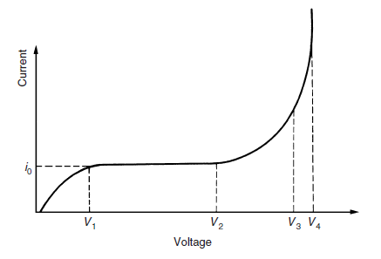
Figure 2.0 Current-voltage relationship in prespark region
Townsend introduced a quantity called $α$ seeking to explain this current increase and termed it the Townsend’s first ionization coefficient.
Consider two parallel plates, cathode and anode, separated by a distance d. A field is applied between the plates such that the direction of the field is from anode to cathode.
The field causes n electrons to travel a distance x from the cathode. The field is increased such that an additional electrons dn travel a further distance dx such that the increase in electrons is given by
$$dn=αndx$$
Integral over the separation of the plates, d gives
$$n=n_{0}e^{αd}$$
And
$$I=I_{0}e^{αd}$$
Where $n_{0}$ is the number of electrons generated by the cathode and $I_{0}$ is the current leaving the cathode.
The term $e^{αd}$ is the electron avalanche and it represents the number of electrons produced by one electron in travelling form the cathode to the anode.

Example Townsend’s ionization
A steady current of 600µA flows through the plane electrodes separated by a distance of 0.5cm when a voltage of 10kV is applied. Determine the Townsend’s first ionization coefficient $α$if a current of 60µA flows when the distance of separation is reduced to 0.1cm and the field is kept constant at the previous value.

Solution Townsend’s ionization
Using $$I=I_{0}e^{αd}$$
$600=I_{0}e^{0.5α}$…………. (1)
$60=I_{0}e^{0.1α}$…………… (2)
Solving equations 1 and 2 and eliminating $I_{0}$ gives,
$$\frac{600}{60}=\frac{e^{0.5α}}{e^{0.1α}}$$
$$10=e^{(0.5-0.1)α}$$
$$In[10]=0.4α$$
$$α=\frac{In(10)}{0.4}$$
$$α=5.75 inonising collisions per cm$$

2.3 Townsend breakdown Criteria
$γe^{αd}=1$ , breakdown gap
Where
$γ$ is Townsend’s second ionization coefficient.

2.4 Paschen’s law
Paschen’s law states that the breakdown strength depends on pressure and distance between the electrodes.
$$V=f\left(p,d\right)$$
A special formula of this is when we are dealing with certain pressure which gives us certain empirical law.
$$V=Ad+B\sqrt{d}$$
Where B=6.29kV/cm and A=24.4kV/cm

Example Paschen’s law
Consider a transformer rated 132kV and a protective margin of 1.5. Calculate d.

Solution Paschen’s law
$$peak voltage=132kV*\sqrt{2}=186.6kV$$
$$V=186.6kV*1.5=280kV$$
Let
$$f\left(d\right)=Ad+B\sqrt{d}-V$$
$$f\left(d\right)=24.4d+6.29\sqrt{d}-280$$

$$f^{'}\left(d\right)=A+\frac{B}{2\sqrt{d}}$$
$$f^{'}\left(d\right)=24.4+\frac{6.29}{2\sqrt{d}}$$

Using Newton Raphson method
$$d_{n+1}=d_{n}-\frac{f\left(d_{n}\right)}{f^{'}\left(d_{n}\right)}$$
Let the initial guess $d_{1}=10cm$
$$f\left(d_{1}\right)=24.4\left(10\right)+6.29\sqrt{10}-280=-16.10927352$$
$$f^{'}\left(\left(d_{1}\right)\right)=24.4+\frac{6.29}{2\sqrt{10}}=25.39453632$$
$$d_{2}=10-\frac{\left(-16.10927352\right)}{25.39453632}=10.63410235cm$$
$$f\left(d_{2}\right)=24.4\left(10.63410235\right)+6.29\sqrt{10.63410235}-280=-0.009700043$$
The iterations are performed using Microsoft excel as below:
d | n | d | f(d) | f'(d)
d1 | 0 | 10.00000 | -16.10927352 | 25.39454
d2 | 1 | 10.63436 | -0.009700043 | 25.36442
d3 | 2 | 10.63474 | -3.31579E-09 | 25.3644
d4 | 3 | 10.63474 | 0 | 25.3644

It can be seen that the required value converges to
$$d=10.63cm$$

3.0 CIRCUIT BREAKERS

3.1 CIRCUIT BREAKER INTRODUCTION
Circuit breakers are an essential part of any protection scheme. Circuit breakers in conjunction with relaying equipment are required to isolate a faulted power system component.
A circuit breaker is a mechanical switching device capable of making, carrying and breaking currents under normal and abnormal circuit conditions like short circuits.

3.2 TYPES OF CIRCUIT BREAKERS

3.2.1 Air circuit breakers
They operate but stretching the arch until the dielectric strength of the gap is larger than the voltage across the gap. There are magnetic circuit breakers as well as compressed air circuit breakers.

3.2.2 Oil Circuit Breakers
They operate by surrounding the arch with oil. Arching due to separation of contacts causes oil to be vaporized and producing a bubble filled with hydrogen gas which impairs ionization. The breakdown of oil by the arch helps in conducting heat away from the arch and thus contributing to deionization of the arch.

3.2.3 SF6 Circuit Breakers
Uses SF6 gas to quench the arch due to its good thermal conductivity and stability up to 150⁰C. The gas is nontoxic and is 5 times more dense than air.

3.2.4 Vacuum Circuit Breakers
Mainly used for low to medium voltage applications. It utilizes a vacuum to extinguish the arch during CB opening and as a dielectric to insulate the contacts after arch interruption.

3.3 Circuit breaker requirements
- Should be a perfect conductor in the closed position.
- Should be a perfect insulator in the open position.
- Should be fast when closing
- Should be fast when opening
- Must not extinguish the current before its zero crossing and must not produce over voltages

CABLE SIZING

Example
Conductor single core cable is 5km long, insulation resistance = 0.4MΩ. Core diameter=20mm, cable diameter over the insulation=50mm. Calculate resistivity of the material.

Solution
$$R=\frac{ρ}{2πl}In\left(\frac{r_{2}}{r_{1}}\right)$$
$$ρ=\frac{2πRl}{In\left({r_{2}}/{r_{1}}\right)}$$
$$ρ=\frac{2π*0.4*5000}{In\left({50}/{20}\right)}$$
$$ρ=1.37*{10}^{4}Ωm$$

CAPACITANCE OF A CABLE

Example
Given that r1=30mm, r2=62mm, r=10mm, E1=3, E2=5, V=250kV, calculate V1 and V2.

Solution

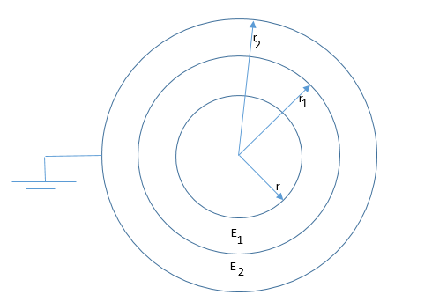
$$C_{1}=\frac{E_{1}}{18*{10}^{9}In\left({r_{1}}/r\right)}$$
$$C_{1}=\frac{3}{18*{10}^{9}In\left({30}/{10}\right)}$$
$$C_{1}=1.517*{10}^{-10}F/m$$
$$C_{2}=\frac{E_{2}}{18*{10}^{9}In\left({r_{2}}/{r_{1}}\right)}$$
$$C_{2}=\frac{5}{18*{10}^{9}In\left({62}/{30}\right)}$$
$$C_{2}=3.82647*{10}^{-10}F/m$$
$$C_{Total}=\frac{C_{1}C_{2}}{C_{1}+C_{2}}$$
$$Q_{Total}=\frac{\left(1.517*{10}^{-10}\right)\left(3.82647*{10}^{-10}\right)}{1.517*{10}^{-10}+3.82647*{10}^{-10}}$$
$$C_{Total}=1.086326861*{10}^{-10}F/m$$
$$Q_{Total}=C_{Total}*V$$
$$Q_{Total}=1.086326861*{10}^{-10}*250*{10}^{3}$$
$$Q_{Total}=27.1581*{10}^{6}C$$
$$V_{1}=\frac{Q_{Total}}{C_{1}}$$
$$V_{1}=\frac{27.1581*{10}^{6}}{1.517*{10}^{-10}}$$
$$V_{1}=179.025kV$$
$$V_{2}=\frac{Q_{Total}}{C_{2}}$$
$$V_{2}=\frac{27.1581*{10}^{6}}{3.82647*{10}^{-10}}$$
$$V_{2}=70.974kV$$

GENERATION OF HIGH VOLTAGES

IMPULSE GENERATOR CIRCUIT ANALYSIS

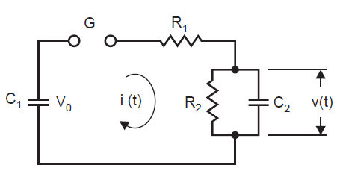
Figure 1.0 Single stage generator circuit

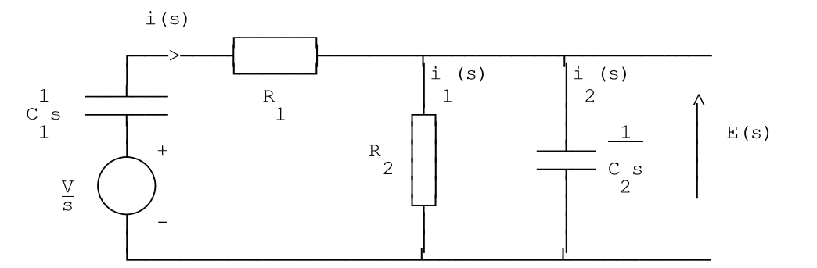
Figure 2.0 Laplace equivalent of figure 1.0 above

I am going to discuss two methods of solving these circuits.

Method 1: Voltage Divider Principle
From figure 2.0, the output voltage is given by
$V_{o}=\frac{V}{s}\left(\frac{Z_{1}}{Z_{1}+Z_{2}}\right)$ ………………………………………………………………………………. (1)
Where
$Z_{1}=R_{1}+\frac{1}{C_{1}s}$ ………………………………………………………………………………….(2)

$Z_{2}=\frac{R_{2}}{R_{2}C_{2}s+1}$ …………………………………………………………………………………(3)
Substituting equation (2) and (3) into (1) we get
$V_{o}=\left(\frac{V}{s}\right)\left(\frac{R_{1}+\frac{1}{C_{1}s}}{\left(R_{1}+\frac{1}{C_{1}s}\right)+\left(\frac{R_{2}}{R_{2}C_{2}s+1}\right)}\right)$ ………………………………………………………………..(4)

Which simplifies to
$V_{o}=\frac{VC_{1}R_{2}}{R_{1}R_{2}C_{1}C_{2}s^{2}+\left(R_{1}C_{1}+R_{2}C_{1}+R_{2}C_{2}\right)s+1}$ ………………………………………………………………(5)

Method 2: Kirchhoff’s Current and Voltage Law
From figure 2.0
$\frac{V}{s}=i\left(s\right)\frac{1}{C_{1}s}+i\left(s\right)R_{1}+ i_{1}\left(s\right)R_{2}$ …………………………………………………………………(6)
$V_{o}\left(s\right)=i_{s}\left(s\right)R_{2}=i_{2}\left(s\right)\frac{1}{C_{2}s}$ ……………………………………………………………………..(7)
Given that $i\left(s\right)=i_{1}\left(s\right)+i_{2}(s)$ and substituting into (6) above we get,
$$\frac{V}{s}=i_{2}(s)\left[R_{1}+\frac{1}{C_{1}s}+i_{1}(s)\left(R_{2}+R_{1}+\frac{1}{C_{1}s}\right)\right]$$
Where $i_{2}\left(s\right)=C_{2}R_{2}si_{1}(s)$ and substituting into the above expression and rearranging gives
$\frac{V}{s}=i_{1}(s)\left[\frac{R_{1}R_{2}C_{1}C_{2}s^{2}+\left(R_{1}C_{1}+R_{2}C_{1}+R_{2}C_{2}\right)s+1}{C_{1}s}\right]$ ……………………………………………(8)
Substituting (8) into (7) gives
$V_{o}\left(s\right)=\frac{VC_{1}R_{2}}{R_{1}R_{2}C_{1}C_{2}s^{2}+\left(R_{1}C_{1}+R_{2}C_{1}+R_{2}C_{2}\right)s+1}$ ………………………………………… (9)
Which can be simplified to
$V_{o}\left(s\right)=\left(\frac{V}{R_{1}C_{2}}\right)\left[\frac{1}{s^{2}+\left(\frac{1}{R_{1}C_{1}}+\frac{1}{R_{1}C_{2}}+\frac{1}{R_{2}C_{2}}\right)s+\left(\frac{1}{R_{1}R_{2}C_{1}C_{2}}\right)}\right]$ ………………………………. (10)
$V_{o}\left(s\right)=\left(\frac{V}{k}\right)\left[\frac{1}{s^{2}+as+b}\right]$ where $k=R_{1}C_{2}$ , $a=\frac{1}{R_{1}C_{1}}+\frac{1}{R_{1}C_{2}}+\frac{1}{R_{2}C_{2}}$ and $b=\frac{1}{R_{1}R_{2}C_{1}C_{2}}$
$R_{1}R_{2}C_{1}C_{2}s^{2}+\left(R_{1}C_{1}+R_{2}C_{1}+R_{2}C_{2}\right)s+1=0$ or
$s^{2}+\left(\frac{R_{1}C_{1}+R_{2}C_{1}+R_{2}C_{2}}{R_{1}R_{2}C_{1}C_{2}}\right)s+\left(\frac{1}{R_{1}R_{2}C_{1}C_{2}}\right)$ = 0 …………………………………………… (11)
The solution to equation (11) can be found as below,
$$\frac{1}{2}\left[\frac{-\left(R_{1}C_{1}+R_{2}C_{1}+R_{2}C_{2}\right)}{R_{1}R_{2}C_{1}C_{2}}±\sqrt{{\left(\frac{R_{1}C_{1}+R_{2}C_{1}+R_{2}C_{2}}{R_{1}R_{2}C_{1}C_{2}}\right)}^{2}+\frac{4}{R_{1}R_{2}C_{1}C_{2}}}\right]$$
If we let $α=\frac{R_{1}C_{1}+R_{2}C_{1}+R_{2}C_{2}}{{2R}_{1}R_{2}C_{1}C_{2}}$ and $β=\frac{1}{2}\sqrt{{\left(\frac{R_{1}C_{1}+R_{2}C_{1}+R_{2}C_{2}}{R_{1}R_{2}C_{1}C_{2}}\right)}^{2}+\frac{4}{R_{1}R_{2}C_{1}C_{2}}}$
With ($-α-β) and (-α+β)$as the roots.
$$\left(s+∝-β\right)\left(s+∝+β\right)=0$$
We use partial fractions to solve $V_{o}\left(s\right)= \frac{V}{R_{1}C_{2}}.\frac{1}{\left(s+∝-β\right)\left(s+∝+β\right)}$ as shown below
$$\frac{1}{\left(s+∝-β\right)\left(s+∝+β\right)}=\frac{A}{\left(s+∝-β\right)}+\frac{B}{\left(s+∝+β\right)}=\frac{As+Aα+Aβ+Bs+Bα-Bβ}{\left(s+∝-β\right)\left(s+∝+β\right)}$$
After comparing coefficients we have A+B=0, A=-B, 2Aβ=1, Aα+Bα-Bβ+Aβ=1, Aα+Aβ-Aα+Aβ=1, and finally we get $A=\frac{1}{2β}$ and $B=-\frac{1}{2β}$
Substituting values for A and B we get
$$V_{o}\left(s\right)= \frac{V}{R_{1}C_{2}}.\frac{1}{\left(s+∝-β\right)\left(s+∝+β\right)}=\frac{V}{R_{1}C_{2}}.\frac{1}{2β}.\left[\frac{1}{s+(α-β)}-\frac{1}{s+(α+β)}\right]$$
Taking the inverse Laplace transform gives,
$V_{o}\left(t\right)=\frac{V}{C_{2}R_{1}}.\frac{1}{2β}.\left(e^{-(α-β)t}-e^{-(α+β)t}\right)$ ………………………………………………. (12)
The maximum voltage occurs when its rate of change becomes zero, i.e when
$\frac{dV_{0}(t)}{dx}=0$ , which gives $(α-β)e^{-αt}=(α+β)e^{-βt}$
But since $β≫α$ , $e^{\left(β-α\right)t_{}}=\frac{α+β}{α-β}≈e^{2βt_{1}}$
$$2βt_{1}=In\left(\frac{α+β}{α-β}\right)$$
$t_{1}=\frac{1}{2β}In\left(\frac{α+β}{α-β}\right)$ ………………………………………………………………………………… (13)
The Peak voltage is given by,
$E_{max}=\frac{V}{C_{2}R_{1}}.\frac{1}{2β}.\left[e^{-(α-β)t_{1}}-e^{-(α+β)t_{1}}\right]$ …………………………………………………. (14)
In time, t2, after it reaches the peak, the voltage falls to half maximum given by,
$$\frac{V}{C_{2}R_{1}}.\frac{1}{2β}.\left[e^{-(α-β)t_{2}}-e^{-(α+β)t_{2}}\right]=\frac{1}{2}.\frac{V}{C_{2}R_{1}}.\frac{1}{2β}.\left[e^{-(α-β)t_{1}}-e^{-(α+β)t_{1}}\right]$$
If we let $t_{2}=Kt_{1}$ where K is a constant, then the above equation becomes,
$\frac{V}{C_{2}R_{1}}.\frac{1}{2β}.\left[e^{-(α-β){Kt}_{1}}-e^{-(α+β){Kt}_{1}}\right]=\frac{1}{2}.\frac{V}{C_{2}R_{1}}.\frac{1}{2β}.\left[e^{-(α-β)t_{1}}-e^{-(α+β)t_{1}}\right]$ ………………………… (15)
This becomes $\left[e^{-(α-β){Kt}_{1}}-e^{-(α+β){Kt}_{1}}\right]=\frac{1}{2}\left[e^{-(α-β)t_{1}}-e^{-(α+β)t_{1}}\right]$
But since, $e^{-(α-β){Kt}_{1}}≫e^{-(α+β){Kt}_{1}}$, the above equation becomes
$$e^{-(α-β){Kt}_{1}}=\frac{1}{2}\left[e^{-(α-β)t_{1}}-e^{-(α+β)t_{1}}\right]$$
$$2e^{-(α-β){Kt}_{1}}.e^{(α-β)t_{1}}=\left[1-e^{-\left(α+β\right)t_{1}}.e^{(α-β)t_{1}}\right]$$
$$e^{-(α-β)({K+1)t}_{1}}=\frac{\left[1-e^{-2βt_{1}}\right]}{2}$$
$$(α-β)({K+1)t}_{1}=-In\left(\frac{1-e^{-2βt_{1}}}{2}\right)$$
$(α-β)=\frac{1}{({K+1)t}_{1}}In\left(\frac{2}{1-e^{-2βt_{1}}}\right)$ …………………………………………………………………… (16)
Taking, $2βt_{1}>4$, then $In\left(\frac{2}{1-e^{-2βt_{1}}}\right)≈0.7$ and the above equation becomes,
$(α-β)=\frac{0.7}{({K+1)t}_{1}}$ (±2%Error) ………………………………………………………………………… (17)
From the expressions of α and β above we get,
$$α^{2}-β^{2}=\frac{1}{4}{\left(\frac{1}{R_{1}C_{1}}+\frac{1}{R_{1}C_{2}}+\frac{1}{R_{2}C_{2}}\right)}^{2}-\frac{1}{4}{\left(\frac{1}{R_{1}C_{1}}+\frac{1}{R_{1}C_{2}}+\frac{1}{R_{2}C_{2}}\right)}^{2}+\frac{1}{R_{1}R_{2}C_{1}C_{2}}=\frac{1}{R_{1}R_{2}C_{1}C_{2}}$$
Rearranging gives $\frac{1}{R_{1}C_{2}}=R_{2}C_{1}\left(α^{2}-β^{2}\right)$ …………………………………………. (18)
Substituting this equation into equation (12) gives
$V_{o}\left(t\right)=VR_{2}C_{1}\frac{\left(α^{2}-β^{2}\right)}{2β}\left(e^{-(α-β)t}-e^{-(α+β)t}\right)$ ………………………………. (19)
Since $=\frac{1}{2}\left(\frac{1}{R_{1}C_{1}}+\frac{1}{R_{1}C_{2}}+\frac{1}{R_{2}C_{2}} \right)$ , if we make $γ=\frac{C_{1}}{C_{2}}$ and substitute it into α together with (18)
And substitute $\frac{1}{R_{1}C_{1}}=R_{2}C_{2}\left(α^{2}-β^{2}\right) and {\frac{1}{R_{1}C_{2}}=R}_{2}C_{1}\left(α^{2}-β^{2}\right)$
$$α=\frac{1}{2}\left[R_{2}C_{2}\left(α^{2}-β^{2}\right)+\frac{1}{R_{2}C_{2}}{+R}_{2}C_{1}\left(α^{2}-β^{2}\right)\right]$$

$$=\frac{1}{2}\left[\frac{R_{2}C_{1}}{γ}\left(α^{2}-β^{2}\right)+\frac{γ}{R_{2}C_{1}}{+R}_{2}C_{1}\left(α^{2}-β^{2}\right)\right]$$
$$=\frac{1}{2}\left[\frac{\left(γ+1\right)}{γ}\left(α^{2}-β^{2}\right)R_{2}C_{1}+\frac{γ}{R_{2}C_{1}}\right]$$

$$\frac{1}{2}\left[\frac{\left(γ+1\right)}{γ}\left(α^{2}-β^{2}\right)R_{2}C_{1}+\frac{γ}{R_{2}C_{1}}\right]-α=0$$
$$\frac{1}{2}\left[\frac{\left(γ+1\right)}{γ}\left(α^{2}-β^{2}\right)R_{2}C_{1}+\frac{γ}{R_{2}C_{1}}\right]\frac{R_{2}C_{1}}{γ}-α\frac{R_{2}C_{1}}{γ}=0$$
$${\left(\frac{R_{2}C_{1}}{γ}\right)}^{2}\left(γ+1\right)\left(α^{2}-β^{2}\right)-2α\frac{R_{2}C_{1}}{γ}+1=0$$
$${\left(\frac{R_{2}C_{1}}{γ}\right)}^{2}-\frac{2α}{\left(γ+1\right)\left(α^{2}-β^{2}\right)}.\frac{R_{2}C_{1}}{γ}+\frac{1}{\left(γ+1\right)\left(α^{2}-β^{2}\right)}=0$$
The roots of the quadratic equation
$$\frac{R_{2}C_{1}}{γ}=\frac{α}{\left(γ+1\right)\left(α^{2}-β^{2}\right)}±{\left[{\left\{\frac{α}{\left(γ+1\right)\left(α^{2}-β^{2}\right)}\right\}}^{2}-\frac{1}{\left(γ+1\right)\left(α^{2}-β^{2}\right)}\right]}^{1/2}$$
$${\left(\frac{R_{2}C_{1}}{γ}\right)}^{2}=\frac{α^{2}}{{\left(γ+1\right)}^{2}{\left(α^{2}-β^{2}\right)}^{2}}±\left[\frac{α^{2}}{{\left(γ+1\right)}^{2}{\left(α^{2}-β^{2}\right)}^{2}}-\frac{\left(γ+1\right)\left(α^{2}-β^{2}\right)}{{\left(γ+1\right)}^{2}{\left(α^{2}-β^{2}\right)}^{2}}\right]$$
$$R_{2}=\frac{1}{C_{1}}\left[\frac{γ}{\left(γ+1\right)\left(α^{2}-β^{2}\right)}\left(α±\sqrt{α^{2}-\left(γ+1\right)\left(α^{2}-β^{2}\right)}\right)\right]$$
$R_{2}=\frac{1}{C_{1}}\left[\frac{α±\sqrt{α^{2}-\left(γ+1\right)\left(α^{2}-β^{2}\right)}}{\frac{\left(γ+1\right)}{γ}\left(α^{2}-β^{2}\right)}\right]$ …………………………………………………….. (20)
By using the same method, the value of R1 becomes
$$R_{2}=\frac{1}{C_{1}}\left[\frac{\left(γ+1\right)}{α±\sqrt{α^{2}-\left(γ+1\right)\left(α^{2}-β^{2}\right)}}\right]$$
${R_{1} and R}_{2}$ are only true if $α^{2}-\left(γ+1\right)\left(α^{2}-β^{2}\right)≥0$, that is
$$α^{2}≥\left(γ+1\right)\left(α^{2}-β^{2}\right)$$
$$\frac{α^{2}}{\left(α^{2}-β^{2}\right)}≤\left(γ+1\right)$$
And
$\frac{β^{2}}{\left(α^{2}-β^{2}\right)}≥γ$ ………………………………………………………………… (21)

$E_{max}=\frac{V}{C_{2}R_{1}}.\frac{1}{2β}.(1-α-\frac{α-β}{α+β})≈\frac{V}{β2C_{2}R_{1}}$
In time, t2, after it reaches the peak, the voltage falls to half maximum given by
$$\frac{V}{2βC_{2}R_{1}}≈\frac{V}{βC_{2}R_{1}}{.e}^{-αt_{2}} since e^{-αt_{2}}≫e^{-βt_{2}}$$
Hence $e^{-αt_{2}}≈\frac{1}{2}$ ………………………………………………………………………………… (12)

$s^{2}+\left(β+α\right)s+αβ=0$ ……………………………………………………………….(13)
Comparing (12) and (11) we see that
$$\left(β+α\right)=\left(\frac{R_{1}C_{1}+R_{2}C_{1}+R_{2}C_{2}}{R_{1}R_{2}C_{1}C_{2}}\right)≈β since β≫α$$
Hence $β=\left(\frac{R_{1}C_{1}+R_{2}{(C}_{1}+C_{2})}{R_{1}R_{2}C_{1}C_{2}}\right)$
$$αβ=\frac{1}{R_{1}R_{2}C_{1}C_{2}}$$
Substituting for β,
$$α=\frac{1}{\left(C_{1}+C_{2}\right)R_{2}+R_{1}C_{1}}$$
But given that $R_{1}≪R_{2}$, then expressions for β and α finally reduces to:
$β=\frac{C_{1}+C_{2}}{R_{1}C_{1}C_{2}}$ …………………………………………………………………………………… (14)
And,
$α=\frac{1}{\left(C_{1}+C_{2}\right)R_{2}}$ …………………………………………………………………………. (15)
β is a function of $R_{1}$ which determines the rate of rise of voltage across the load and ultimately the wave front time (t1). On the other hand, $α$ is a function of $R_{2}$ which determines the wave tail time (t2).
The maximum output voltage is then given by,
$$V_{0\left(max\right)}=\frac{V}{βC_{2}R_{1}}=\frac{VR_{1}C_{1}C_{2}}{{\left(C_{1}+C_{2}\right)C}_{2}R_{1}}≈V.\frac{C_{1}}{C_{1}+C_{2}}$$
Where efficiency,
$$ƞ=\frac{C_{1}}{C_{1}+C_{2}}$$
We can also see that,
$\frac{1}{α}=\frac{R_{1}C_{1}}{ƞ}$ And that $\frac{1}{β}={ƞC}_{2}R_{2}$

Thus the maximum (peak) voltage available at the output will depend on the ratio of C2 to C1, and on the charging voltage. If C2 is low compared to C1, then we can have a higher voltage peak.
The wavefront control resistance, $R_{1}$ can be connected either outside or within the impulse generator, or partly within and partly outside.

Example impulse generator calculations
A ten-stage impulse generator has 0.250μF condensers. The wave front and wave tail resistances are 75Ω and 2600Ω respectively. If the load capacitance is 2.5nF, determine the wave front and wave tail times of the impulse wave.

Solution impulse generator calculations
$$t_{1}=\frac{1}{2β}In\left[\frac{α+β}{α-β}\right]$$
$$α-β=\frac{0.7}{t_{1}\left(K-1\right)} where K=\frac{t_{2}}{t_{1}}$$
From the simplified equivalent circuit of an impulse generator,
$$α=\frac{1}{2}\left[\frac{1}{R_{2}C_{1}}+\frac{1}{R_{1}C_{1}}+\frac{1}{R_{2}C_{2}}\right]$$
And
$$β=\frac{1}{2}{\left[4α^{2}-\frac{4}{R_{1}R_{2}C_{1}C_{1}}\right]}^{1/2}$$
From the question we are given
$$R_{1}=75Ω, R_{2}=2600Ω, C_{1}=\frac{250}{10}=25nF and C_{2}=2.5nF$$
Substituting
$$α=\frac{{10}^{9}}{2}\left[\frac{1}{2600*25}+\frac{1}{75*25}+\frac{1}{75*2.5}\right]$$
$$≈2.933*{10}^{6}$$

$$β=\frac{1}{2}{\left[4{\left(2.933*{10}^{6}\right)}^{2}-\frac{4*{10}^{18}}{75*2600*25*2.5}\right]}^{1/2}$$

$$β=2.92*{10}^{6}$$
$$t_{1}=\frac{1}{2*2.92*{10}^{6}}In\left[\frac{2.933*{10}^{6}+2.92*{10}^{6}}{2.933*{10}^{6}-2.92*{10}^{6}}\right]$$

$$t_{1}=1.046µs$$
$$α-β=\frac{0.7}{t_{1}\left(K-1\right)}$$
$$α-β=2.933*{10}^{6}-2.92*{10}^{6}=0.014*{10}^{6}$$
$$\frac{0.7}{t_{1}}=\frac{0.7}{{1.04*10}^{-6}}={7*10}^{-5}$$
$$K=\frac{0.7}{t_{1}\left(α-β\right)}+1$$

$$K=\frac{0.7}{1.04*0.014}+1=49$$
$$\frac{t_{2}}{t_{1}}=49=\frac{t_{2}}{{1.04*10}^{-6}}$$
$$t_{2}=49*{1.04*10}^{-6}=50.96µs$$

Example impulse generator calculations (approximate method)
Consider an impulse generator with 12 stages. The generator has a 0.12µF capacitor, a wave front and wave tail resistances of 800Ω and 500Ω respectively. If the load capacitor is 1000pF, find the front and tail ties of the impulse wave produced.

Solution impulse generator calculations (approximate method)
$$Generator capacitance C_{1}=\frac{0.126}{12}=0.0105µF$$
$$C_{2}=0.001µF$$
$$R_{1}=800Ω$$
$$R_{2}=5000Ω$$
$$Front Time, t_{1}=3R_{1}C_{e}=3R_{1}\left(\frac{C_{1}C_{2}}{C_{1}+C_{2}}\right)$$
$$t_{1}=2*800*\left(\frac{{0.0105*10}^{-6}*0.001*{10}^{-6}}{{0.0105*10}^{-6}+0.001*{10}^{-6}}\right)=2.19µs$$
$$Tail Time, t_{2}=0.7\left(R_{1}+R_{2}\right)\left(C_{1}+C_{2}\right)$$
$$t_{2}=0.7\left(800+500\right)\left({0.0105*10}^{-6}+0.001*{10}^{-6}\right)$$
$$t_{2}=46.69µs$$

Cascaded Transformers
Two or more transformers can be cascaded if high voltages above 300kV are required.
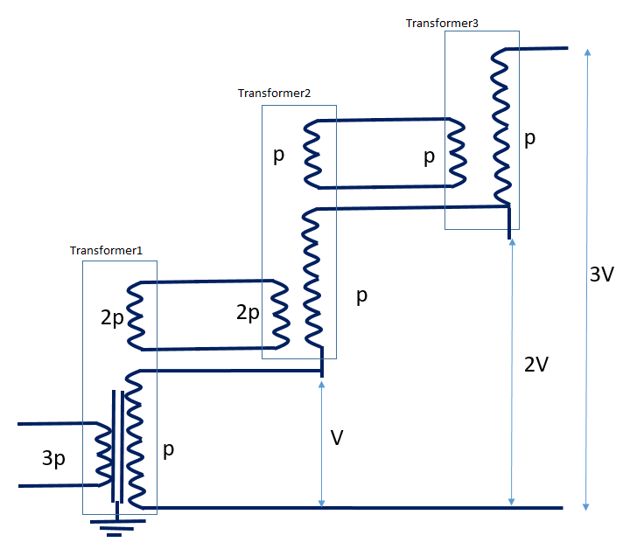
Referring to the figure of cascaded transformers above;

Transformer 1
- Must be a three winding transformer
- Primary winding carries 3 times the power of the system
- A low voltage is applied across the primary of transformer 1
- This induces a voltage V across the secondary winding
- The tertiary winding of transformer 1 has the same number of turns as the primary of the same transformer and it is used to feed the primary of the second transformer

Transformer 2
- Must be a three winding transformer
- Secondary winding of transformer 2 is connected in series with the secondary of transformer 1 such that the potential between its terminal and ground is 2V.

Transformer 3
- If it the last stage, does not necessarily have to be three winding
- Secondary winding of transformer 3 is connected in series with the secondary of transformer 2 such that the potential between its terminal and ground is 3V.
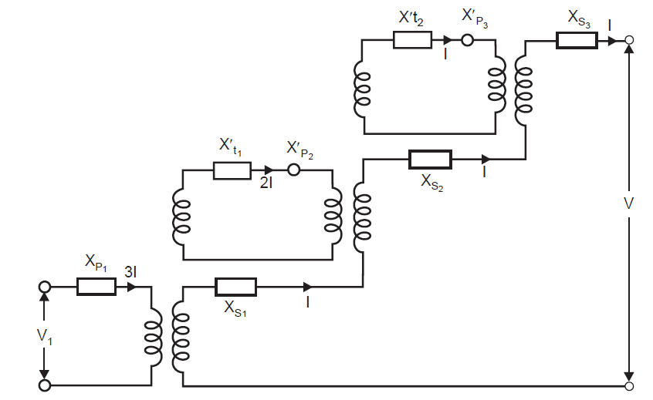
The figure above shows a lossless equivalent circuit of a three stage cascaded transformer system.
If the impedance are referred to the primary side,
$$Z_{ps}=Z_{p}+Z_{s}Z_{pt}=Z_{p}+Z_{t}$$
$$Z_{st}=Z_{s}+Z_{t}$$
Where,
$Z_{ps}$ = leakage impedance measured on primary side with secondary short circuited and tertiary open.
$Z_{pt}$ = leakage impedance measured on primary side with tertiary short circuited and secondary open.
$Z_{st}$ = leakage impedance on secondary side with tertiary short circuited and primary open.
Solving the two equations above, we get,
$$Z_{p}=\frac{1}{2}\left(Z_{ps}+Z_{pt}-Z_{st}\right)$$
$$Z_{s}=\frac{1}{2}\left(Z_{ps}+Z_{st}-Z_{pt}\right)$$
$$Z_{t}=\frac{1}{2}\left(Z_{pt}+Z_{st}-Z_{ps}\right)$$
Neglecting the magnetizing current, the sum of the ampere turns is given by
$$N_{p}I_{p}-N_{s}I_{s}-N_{t}I_{t}=0$$
Since we had assumed lossless transformers,
$$Z_{p}=jX_{p}$$
$$Z_{s}=jX_{s}$$
$$Z_{t}=jX_{t}$$
From the 3 stage equivalent circuit, a simplified equivalent circuit can be obtained as below:
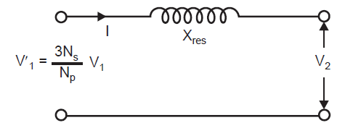
In order to calculate the short circuit reactance $X_{res}$ the power rating of the simplified equivalwnt circuit must equal the power rating of the 3 stage equivalent circuit.
$$I^{2}X_{res}={\left(3I\right)}^{2}X_{p}+{\left(2I\right)}^{2}X_{p}+I^{2}X_{p}+3I^{2}X_{s}+{\left(2I\right)}^{2}X_{t}+I^{2}X_{t}$$
$$X_{res}=14X_{p}+3X_{s}+5X_{t}$$
The generalized equation then becomes
$$X_{res}=\sum_{i=1}^{n}{\left[{\left(n-i-1\right)}^{2}X_{pi}+X_{si}+{\left(i-1\right)}^{2}X_{ti}\right]}$$
Where $X_{pi}$,$X_{si }$and $X_{ti}$ are short-circuit reactance of primary, secondary and tertiary windings of the ith transformer.

High voltage measurements

Schering bridge
It is used to measure capacitance and $tanδ$, or loss factor or loss angle of high voltage insulators so as to give an indication of the quality of that insulating material. The bridge has two high voltage arms made up of the standard, high quality capacitor with no significant losses and the sample under test and two low voltage arms with an adjustable precision capacitor and resistors.
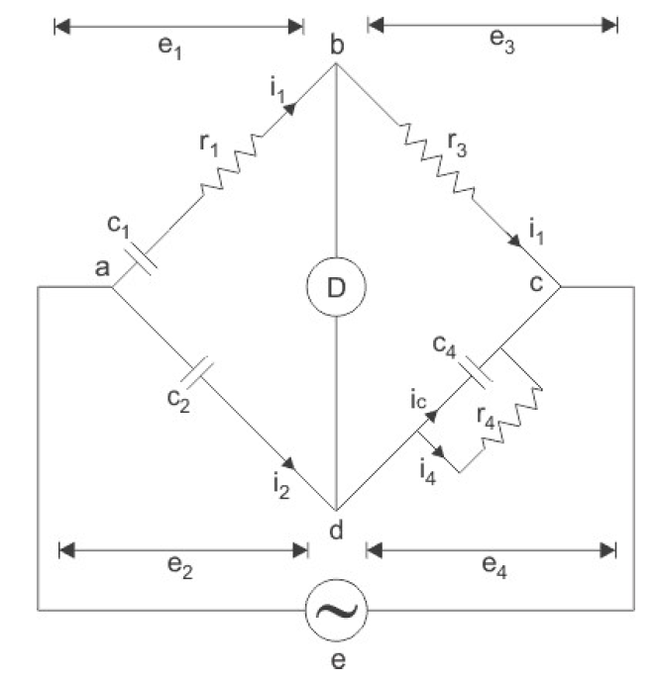
Let
$$Z_{1}=R_{1}+\frac{1}{jωC_{1}}$$
$$Z_{2}=\frac{1}{jωC_{2}}$$
$$Z_{3}=R_{3}$$
$$Z_{4}=\frac{{R_{4}}/{jωC_{4}}}{R_{4}+1/{jωC_{4}}}=\frac{R_{4}}{jωR_{4}C_{4}+1}$$
When the bridge is balanced,
$$Z_{1}Z_{4}=Z_{2}Z_{3}$$
$$Z_{1}=\frac{Z_{2}Z_{3}}{Z_{4}}$$
$$=\frac{\left(\frac{1}{jωC_{2}}\right)\left(R_{3}\right)}{\left(\frac{R_{4}}{jωR_{4}C_{4}+1}\right)}$$
$$=\left(\frac{R_{3}}{jωC_{2}}\right)\left(\frac{jωR_{4}C_{4}+1}{R_{4}}\right)$$
$$=\left(\frac{R_{3}}{R_{4}}\right)\left(\frac{jωR_{4}C_{4}}{jωC_{2}}+\frac{1}{jωC_{2}}\right)$$
$$=\frac{R_{3}R_{4}C_{4}}{R_{4}C_{2}}+\frac{R_{3}}{jωC_{2}R_{4}}$$
Finally, $Z_{1}=\frac{R_{3}C_{4}}{C_{2}}+\frac{R_{3}}{jωC_{2}R_{4}}=R_{1}+\frac{1}{jωC_{1}}$
Equating the real and imaginary parts we get,
$\frac{R_{3}C_{4}}{C_{2}}=R_{1}$ ……………………………………
$$\frac{1}{jωC_{1}}=\frac{R_{3}}{jωC_{2}R_{4}}$$
$C_{1}=\frac{R_{4}C_{2}}{R_{3}}$ ………………………………….
$$tanδ={ωR}_{1}C_{1}=ω\left(\frac{R_{3}C_{4}}{C_{2}}\right)\left(\frac{R_{4}C_{2}}{R_{3}}\right)$$
$$tanδ={ωR}_{4}C_{4}$$
For parallel equivalent circuit
$$tanδ_{p}=\frac{1}{ωR_{p}C_{p}}$$

Example Schering bridge
Describe the concept of $tanδ$ and how it is measured using a Schering bridge. During measurements on an oil sample, the following resistor and capacitor values were found when the bridge was balanced: R3=200Ω, R4=258.27Ω and C4=0.12325µF. The standard capacitor value C2=92.926pF. Compute the capacitance and the tan δ for the sample.

Solution Schering bridge

$$R_{1}=\frac{R_{3}C_{4}}{C_{2}}$$
$$=\frac{200*0.12325*{10}^{-6}}{92.926*{10}^{-12}}$$
$$=265.2648kΩ$$
$$C_{1}=\frac{R_{4}C_{2}}{R_{3}}$$
$$=\frac{258.27*92.926*{10}^{-12}}{200}$$
$$=119.99pF$$
$$tanδ={ωR}_{1}C_{1}=2π*50*119.99*{10}^{-12}*265.2648*{10}^{3}$$
$$tanδ=0.001$$

The Electrostatic voltmeter
Is used to measure voltages above 10kV. Two plates/electrodes placed parallel to each other develop a force of attraction if a high voltage is impressed on one of the plates. The force (Coulomb force of attraction) is created by the process in which a change in stored electrostatic energy between the plates is converted into mechanical work which cause one of the plates to move towards the fixed plate. The input impedance of the meter is capacitive and hence in the case of DC measurement, it does not load the measured circuit.
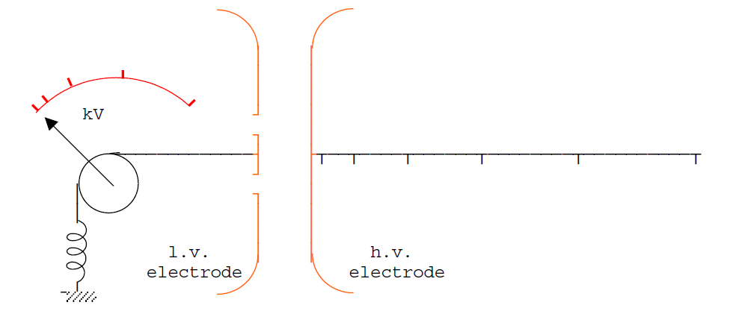
In the above figure, suppose that the two plates are separated by a distance x when a voltage in applied on the HV electrode. A capacitance C is developed between the plates such that the electrostatic energy stored between them is
$$W\left(t\right)=\frac{1}{2}CV^{2}\left(t\right)$$
A change in the electrostatic energy d$W\left(t\right)$ will be converted into mechanical work which causes the plates to separate by a distance dx such that
$$dW\left(t\right)=-F\left(t\right)dx$$

$$\left|F\left(t\right)\right|=\frac{dW\left(t\right)}{dx}=\frac{1}{2}V^{2}\left(t\right)\frac{dC}{dx}$$
The mean force becomes
$$\overline{F}=\frac{1}{2}\left(\frac{dC}{dx}\right)\left[\int_{0}^{T}{V^{2}dt}\right]$$

$$\overline{F}=\frac{1}{2}\left(\frac{dC}{dx}\right)V^{2}$$
But $C=\frac{ε_{0}A}{x}$, where $ε_{0}$ is permittivity of free space and A is area of the plate. Substituting into the above gives
$$\left|\overline{F}\left(t\right)\right|=\frac{ε_{0}AV^{2}}{{2x}^{2}}$$

Example Electrostatic voltmeter
An absolute electrostatic voltmeter has a movable circular plate 8 cm in diameter. If the distance between the plates during a measurement is 4 mm, determine the potential difference when the force of attraction is 0.2 gm wt.

Solution Electrostatic voltmeter
$$A=\frac{πd^{2}}{4}=\frac{π*{0.08}^{2}}{4}=0.0050265m^{2}$$
$$F=mass*gravity=0.0002*9.8=0.00196N$$
$$V=\sqrt{\left(\frac{2Fx^{2}}{ε_{0}A}\right)}=\sqrt{\left(\frac{2*0.00196*{0.004}^{2}}{8.854*{10}^{-12}*0.0050265}\right)}$$
$$V=1188V$$

Potential Dividers

Resistance Division
Resistance division is mainly used for measuring DC voltages. A delay cable is used when observation of waveforms is to be done using an oscilloscope, through a potential divider. This cable also causes a small delay between the arrival of the trigger pulse and the waveform.

Resistance division: Matching at the divider end
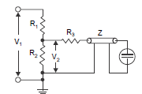

Resistance division: Matching at the oscilloscope end
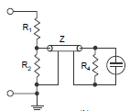

Resistance division: Matching at both ends of the delay cable
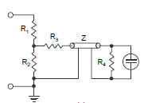

Resistance Divider Calculations
Resistance at the divider end $R_{3}$ is chosen such that
$$R_{2}+R_{3}=Z$$
Which puts and upper limit on $R_{2}$ such that $R_{2}<Z$.
Sometimes the condition for matching is given as
$$Z=R_{3}+\frac{R_{1}R_{2}}{R_{1}+R_{2}}$$
But since usually $R_{1}{≫R}_{2}$ the above relation reduces to
$$Z=R_{3}{+R}_{2}$$
The voltage appearing across $R_{2}$ is
$$V_{2}=\frac{Z_{1}}{Z_{1}+R_{1}}V_{1}$$
Where $Z_{1}$ is the equivalent impedance of $R_{2}$ in parallel with $\left(Z+R_{3}\right)$, the surge impedance of the cable being represented by an impedance Z to ground.
$$Z_{1}=\frac{\left(Z+R_{3}\right)R_{2}}{R_{2}+Z+R_{3}}=\frac{\left(Z+R_{3}\right)R_{2}}{2Z}$$
Therefore,
$$V_{2}=\frac{\left(Z+R_{3}\right)R_{2}}{2Z}\frac{V_{1}}{Z_{1}+R_{1}}$$
However, the voltage entering the delay cable is
$$V_{3}=\frac{V_{2}}{Z+R_{3}}Z=\frac{Z}{Z+R_{3}}\frac{\left(Z+R_{3}\right)R_{2}}{2Z}\frac{V_{1}}{Z_{1}+R_{1}}=V_{1}\frac{R_{2}}{2\left(Z_{1}+R_{1}\right)}$$
As this voltage reaches the CRO end of the delay cable, it suffers reflections as the impedance offered by the CRO is infinite and as a result the voltage wave transmitted into the CRO is doubled. The CRO, therefore, records a voltage
$$V_{3}^{'}=\frac{R_{2}}{Z_{1}+R_{1}}V_{1}$$
The reflected wave, however, as it reaches the low voltage arm of the potential divider does not suffer and reflection as $Z=R_{2}+R_{3}$ and is totally absorbed by ($R_{2}+R_{3}$).
Since $R_{2}$ is smaller than Z and $Z_{1}$ is parallel combination of $R_{2}$ and (Z + $R_{3}$), $Z_{1}$ is going to be smaller that $R_{2}$ and since $R_{1}≫R_{2}$, $R_{1}$ will be much greater than $Z_{1}$ and therefore to a first approximation
$$Z_{1}+R_{1}≈R_{1}$$
Therefore
$$V_{3}^{'}=\frac{R_{2}}{R_{1}}V_{1}≈\frac{R_{2}}{R_{1}+R_{2}}V_{1} as R_{2}≪R_{1}$$
Matching at the oscillography end and matching at both ends of the delay cable id done by the a pure ohmic resistance $R_{4}=Z$ at the end of the delay cable and the voltage reflection coefficient is zero i.e the voltage at the end of the cable is transmitted completely into $R_{4}$ and hence appears across the CRO plates without being reflected. Since the resistance of the delay cable $R_{4}=Z,$ this resistance is parallel to $R_{2}$ and forms an integral part of the divider’s low voltage arm. Voltage of such a divider is therefore calculated as
$$Equivalent impedance=R_{1}+\frac{R_{2}Z}{R_{2}+Z}=\frac{R_{1}\left(R_{2}+Z\right)+R_{2}Z}{\left(R_{2}+Z\right)}$$
And current is given by,
$$I=\frac{V_{1}\left(R_{2}+Z\right)}{R_{1}\left(R_{2}+Z\right)+R_{2}Z}$$
And voltage
$$V_{2}=\frac{IR_{2}Z}{R_{2}+Z}=\frac{V_{1}(R_{2}+Z)}{R_{1}\left(R_{1}+Z\right)+R_{2}Z}\left(\frac{R_{2}Z}{R_{2}+Z}\right)$$
$$V_{2}=\frac{R_{2}Z}{R_{1}\left(R_{2}+Z\right)+R_{2}Z}V_{1}$$
Because of matching at the CRO end of the delay cable, the voltage does not suffer any reflection at that end and the voltage recorded by the CRO is given as
$$V_{2}=\frac{R_{2}Z}{R_{1}\left(R_{2}+Z\right)+R_{2}Z}V_{1}=\frac{R_{2}ZV_{1}}{{R_{1}R}_{2}+{Z(R}_{1}+R_{2})}=\frac{R_{2}V_{1}}{\left(R_{1}+R_{2}\right)+\frac{R_{1}R_{2}}{Z}}$$
For undistorted wave shape through the cable
$$Z≈R_{2}$$
Therefore
$$V_{2}=\frac{R_{2}}{2R_{1}+R_{2}}V_{1}$$
Matching of both ends of the delay cable, voltage recorded by the CRO will be half that recorded by the CRO when matching at the oscillography end of the delay cable is implemented and the voltage is thus given
$$V_{2}=\frac{R_{2}}{2(R_{1}+R_{2})}V_{1}$$

Capacitance Potential Dividers
They are mainly used for measurement of impulse voltages up to 1MV. Capacitance dividers are usually made of many capacitors mounted one on top of the other and bolted together.
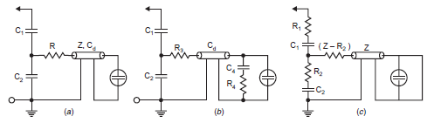
Figure for capacitive dividers (a) Simple matching (b) Compensated matching (c) Damped capacitor divider simple matching
The low voltage capacitor $C_{2}$ must be non-inductive so that the coupling between the high and low voltage arms of the divider be purely capacitive so as to ensure that the current cannot pass from the high voltage circuit to the delay cable without actually going through the capacitor electrodes.

Capacitance Divider Calculations
If $V_{2}$ is the voltage across the capacitor $C_{2}$ and $V_{1}$ is the voltage being measured,
$$V_{2}=\frac{1/{C_{2}}}{{\left(C_{1}+C_{2}\right)}/{C_{1}C_{2}}}V_{1}$$
$$V_{2}=\left(\frac{C_{1}}{C_{1}+C_{2}}\right)V_{1}$$

Simple matching
The sending end is terminated with a resistance $R=Z$ in series with the cable.
$$V_{3}=V_{2}\frac{Z}{Z+R}=\frac{1}{2}V_{2}, since R=Z for matching$$
Where $V_{3}$ is the potential between matching resistor R and cable impedance Z.
Due to perfect reflection at the receiving end, $V_{3}$ travelling towards it would be reflected and hence the voltage transmitted to the CRO would be doubled.
$$V_{r}=3V_{3}=2*\frac{1}{2}V_{2}=V_{2}=V_{1}\frac{C_{1}}{C_{1}+C_{2}}$$
After some time the cable capacitance charges up and the voltage becomes
$$V_{r}=V_{1}\frac{C_{1}}{C_{1}+C_{2}+C_{d}}$$

Compensated matching / Split capacitor connection
In this case the cable is matched at the sending end (R=Z) as well as the oscilloscope end ($R_{4}=Z)$. In addition, to ensure that the long term ratio remains the same as the initial ratio, the lower end capacitor is split into $C_{2}$ and $C_{4}$.
Initially the capacitances $C_{d}$ and $C_{4}$ would not have charged, and only the capacitances $C_{1}$ and $C_{2}$ would be effective in the voltage ratio
Initially,
$$E_{2}=E_{1}\frac{C_{1}}{C_{1}+C_{2}}$$
Also
$$V_{3}=V_{2}=\frac{Z}{R_{3}+Z}=\frac{1}{2}V_{2} since R_{3}=Z for matching$$
Due to perfect matching at the receiving end, the voltage wave is transmitted without reflection. Therefore the observed voltage is given by
$$V_{r}=V_{3}=\frac{1}{2}V_{2}=\frac{V_{2}}{2}\frac{C_{1}}{C_{1}+C_{2}}$$
After some time the capacitances $C_{4} and C_{d}$ would have completely charged up, and the receiving end in effect would be open circuit, since $C_{4}$ would no longer be conducting.
Since all the capacitors$C_{2}$, $C_{4}$ and $C_{d}$ are in parallel,
$$V_{2}=V_{1}\frac{C_{1}}{C_{1}+C_{2}+C_{4}+C_{d}}$$
$$\frac{V_{1}}{2}\frac{C_{1}}{C_{1}+C_{2}}=V_{1}\frac{C_{1}}{C_{1}+C_{2}+C_{4}+C_{d}}$$
$$i.e. C_{1}+C_{2}=C_{4}+C_{d}$$

Sphere gaps
The working principle is based on Paschen’s law ±3%.

Importance of sphere gap measurement
- Since it the peak value of voltage that usually causes dielectric breakdown a sphere gap can be used for measurement of the peak value of the voltage if the gap distance is known.
- Measurement of peak value of high voltage DC, AC and impulse voltages can be done using sphere gaps.
- The sphere gap is also used for checking voltmeters and other voltage measuring devices used in HV testing circuits.
There are usually two types of sphere gap arrangement:
- Horizontal
- Vertical sphere gap arrangement
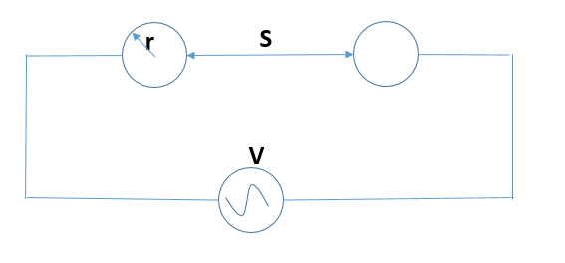
Figure showing a typical sphere gap during measurement
$$δ=\frac{293b}{\left(760\right)\left(273+t\right)}$$
Where;
b is the pressure,
t is the temperature
then
$$V(kV)=δ\left(A+BS\right)\left(4\right)\sqrt{5.1*{10}^{-2}\left(h+8.65\right)}$$
Where S is the gap and h is the humidity.
A=20kV for positive polarity
A=15kV for negative polarity

Construction
Standard diameter of the spheres are range from 20, 50, 62.5, 100, 125, 150, 250, 500, 750, 1000, 1500 and 2000mm. The horizontal configuration is mostly found on spheres with diameter d<500mm for low voltage applications. The device is made up of two spheres, one fixed and the other one other one movable (adjustable). Impulse voltages with wave front time approximately 1μs & wave tail time approximately 5μs can be measured using sphere gap measuring devices.
The gap, S between the spheres, gives a measure of the spark over voltage and is always less than the sphere radius. Inorder to limit the breakdown current and inorder to suppress unwanted oscillations in the source voltage when breakdown occurs, a series resistance is usually connected between the source and the sphere gap.

Rod gaps
Is it used to measure peak voltage value of power frequency and impulse voltages. The gap usually consists of two 4.27cm² rod electrodes square in section at their end and are mounted on insulating stands so that a length of equal to or greater than one half of the gap spacing overhangs the inner edge of the support.
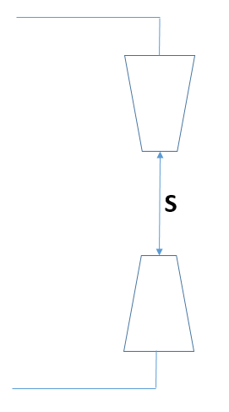
Figure showing a Rod Gap for measurement of peak voltages
$$V=24.22S+6.08\sqrt{S}$$
At 20⁰C and 760mm
S is in cm

Examples Rod Gap
- If S=2mm, calculate V.
- If S=20mm, calculate v.
- Calculate $δ$ given that b=700mm, and t=30⁰C

Solution 1 Rod Gap
$$V=24.22S+6.08\sqrt{S}=24.22*\left(\frac{2}{10}\right)+6.08*\sqrt{\left(\frac{2}{10}\right)}=7.563kV$$

Solution 2 Rod Gap
$$V=24.22S+6.08\sqrt{S}=24.22*\left(\frac{20}{10}\right)+6.08*\sqrt{\left(\frac{20}{10}\right)}=57.038kV$$

Solution 3 Rod Gap
$$δ=\frac{293(700)}{\left(760\right)\left(273+30\right)}=0.891$$

Earthing
Step potential – Is the difference in voltage between two points which are 1m apart along the earth when the ground fault current is flowing.
Touch potential – Is the potential difference between the GPR and the surface potential at the point where a person is standing whilst at the same time having hands in contact with the grounded structure.
IEEE calculations of step and touch potential are as below:
$$E_{step}\left(50\right)=\left(1000+6C_{s}ρ_{s}\right)\frac{0.116}{\sqrt{t_{s}}}$$
$$E_{step}\left(70\right)=\left(1000+6C_{s}ρ_{s}\right)\frac{0.157}{\sqrt{t_{s}}}$$
$$E_{touch}\left(50\right)=\left(1000+1.5C_{s}ρ_{s}\right)\frac{0.116}{\sqrt{t_{s}}}$$
$$E_{touch}\left(70\right)=\left(1000+1.5C_{s}ρ_{s}\right)\frac{0.157}{\sqrt{t_{s}}}$$
Where
$$E_{step}-step voltage limit$$
$$E_{touch}-touch voltage limit$$
$$C_{s}-surface layer derating factor$$
$$ρ_{s}-soil resistivity$$
$$t_{s}-maximum ault clearing time$$
$$C_{s}=\frac{1-0.09\left(1-\frac{ρ}{ρ_{s}}\right)}{2h_{s}+0.09}$$
Where
$$ρ-soil resistivity$$
$$ρ_{s}-resistivity of the surface layer material (Ωm)$$
$$t_{s}-thickness of surface layer$$

Example: Earth rod calculations
Calculate the resistance of a given rod driven into the soil with buried length of L=1.8m and diameter d=19mm if the soil resistivity $ρ=180Ωm$. Suppose the number of electrodes n=10 with factor of parallel $λ=3.81$, rod spacing, $ρ=180Ωm$, S=1.2m.

Solution1
$$R=\frac{ρ}{2πL}\left[In\left(\frac{8L}{d}\right)-1\right]$$
$$R=\frac{ρ}{2π*1.8}\left[In\left(\frac{8*1.8}{0.019}\right)-1\right]$$
$$R=89.613Ω$$

Solution 2
$$R_{n}=\frac{R\left(1+λα\right)}{n}$$
$$α=\frac{ρ}{2πRS}=\frac{180}{2π*89.613*1.2}=0.2664$$
$$R_{10}=\frac{89.613\left(1+3.81*0.2664\right)}{10}=18.056Ω$$

REFERENCES
- John Kuffel, E. Kuffel, W. S. Zaengl - High Voltage Engineering Fundamentals, Second Edition (2000, Newnes)
- High Voltage Engineering. Practice and Theory. Dr JP Holtzhausen Dr WL Vosloo
- C.L. Wadhwa - High voltage engineering (2006, New Age International Pvt Ltd Publishers)

