Using XSSFWorkbook to generate excel2007, we find out below issue:
After we run the ‘BugTest’ project, please get and open the export excel ’BugPOI. xlsx’.
- We can see the comment is displayed in drawing object like text box.
Please see the below screenshot (5 sheets and shape of Comment):
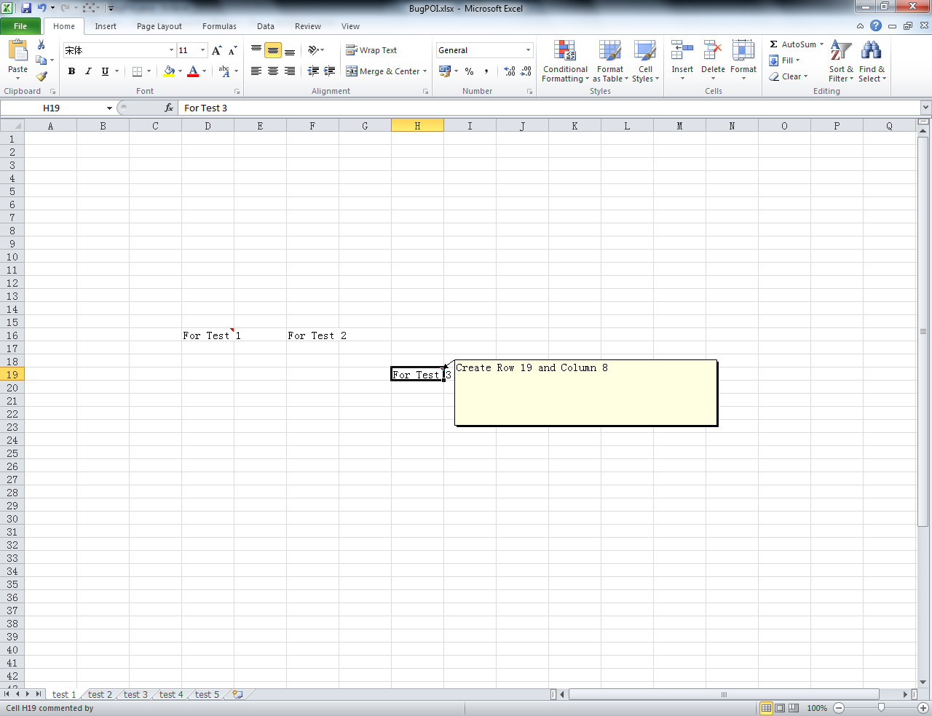

- Shape of the comment box in all the remaining sheets changes to a giant Curved Arrow after we delete one sheet.
Please see the below screenshot (For example: delete third sheet (test 3)):
