Bitmap 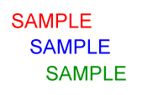

Tiff sample.tif

Encapsulated Postscript EPSsample.eps

WordPerfect Graphicssample.wpg

Compressed EMF

sample.emz