Exceuting
TestExcelConditionalFormattingByFormula_2
compiled with POI libraries version 3.8 has been produced the file
conditional-sheet_poi-3.8.xls
Opening this file I’ve
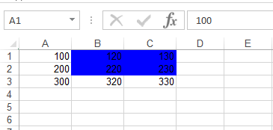
that is cell A1 > 75 and for this reason the cells B1,C1,B2,C2 al blue.
When I change the value of cell A1 from 100 to 50 I’ve
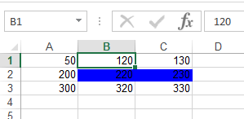
that is only cells B2,C2 are white (to change the color of B2,C2 I have to execute FORMULAS > Show Formulas).
Exceuting
TestExcelConditionalFormattingByFormula_2
compiled with POI libraries version 3.8 modified has been produced the file
conditional-sheet_poi-3.8_mod.xls
Opening this file
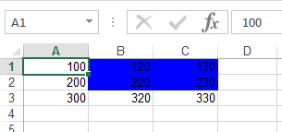
which is the same as for the previous test;
if I change A1 from 100 to 50 the result is
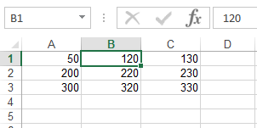
which is the expected result;
if I change A1 from 50 to 100 the color return blue.

