QUERIES
BANNER FINANCE IMPLEMENTATION – 2006

© 2005 – The University of Alabama

To move from one block of information to the next, use the function Next Block, ( or Ctrl/PgDn).

test phrase

Searching in Finance Query screens

List of Values (LOV):
- 1. Fields that have blue labels have a “List of Values” associated with that field. Double-click your mouse in the empty field, or if the cursor is in the empty field, press F9 to view.

2. Certain fields will have the Search Tool beside them.

3. If you click the tool, you may get:
  - a. A pop-up window with the list of values to choose from

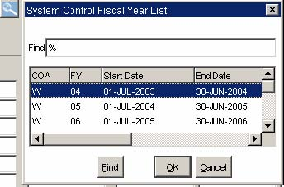

- b. A new corresponding search screen may open

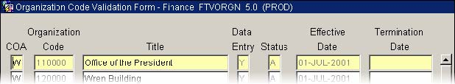

- c. Or, the Options List will display choices for a new corresponding search screen.

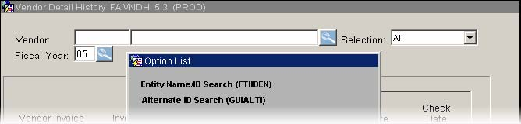

Please refer to the Banner Navigation Training Guide for detailed information about proper searching in Banner as searching is not covered in detail in this document.

