- While reading pdf How to identify cell?
Please see screen shot
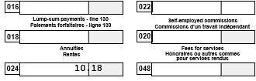

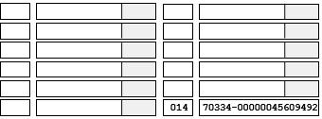

- how to identify colour cell
- How to identify data in cell if data is available if not i want make seperater | .

In the above scenario there is no date in second cell and 3ed cell.
I want display like below
|018| |

- How to identify space between cells.

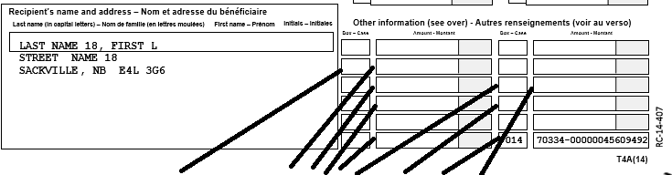

- How to identify cell with in cell
