Picture in line with the text.
This is a picture in line with the text. It was inserted without further formatting.

Picture with square wrap.
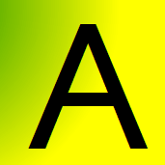
The picture was inserted and then set to (German) “Quadrat”. The text is on the right side of the picture. In the extended Layout it was set to (German) “Verankern” with Position horizontal and vertical to (German) “absolute”.
In OOo this should become a wrap with text right or with optimal wrap. The picture should be in foreground.
A few dummy paragraphs to come beneath the picture.

Picture with (German) “Hinter dem Text”
The picture was inserted and then set to the wrap (German) “Hinter dem Text” and the position “absolute” and no option checked. The text is showed over the picture.
In OOo this should be a wrap “Text through” with position in background.
A few dummy paragraphs to come beneath the picture

The document has been newly created in German Word 2007.

