Anchor to paragraph. In Line with Text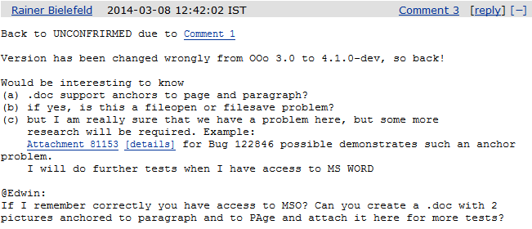

Anchor to page. Position in Middle Left with Square Text Wrapping

