Term 3 2009  
July 20th – September 25th

Dear Carolyn and Eva,

**This term we will be focusing on the theme of Sustainability.**

We will be looking at choices we make about

* products we use and the long term effects on our world
* making and keeping friends and other relationships we have
* how we look after our bodies through exercise and food choices.

**We can make choices that have little impact on the environment, or choices we make that will help look after our world.**

**We can make choices about ourselves that are helpful or harmful.**

**What is sustainability and how can we make choices to create a sustainable world?**

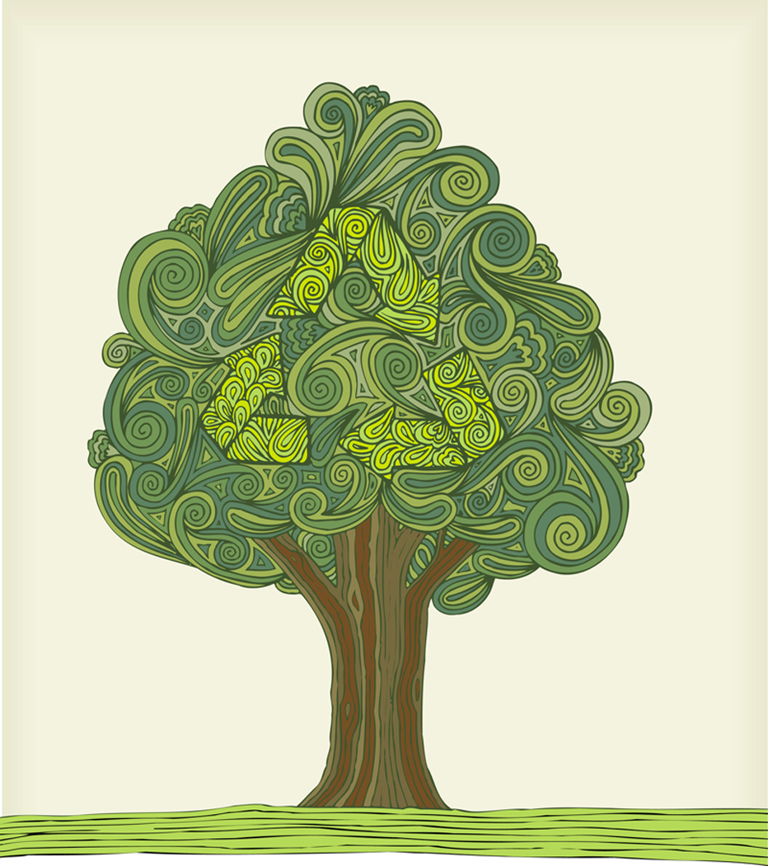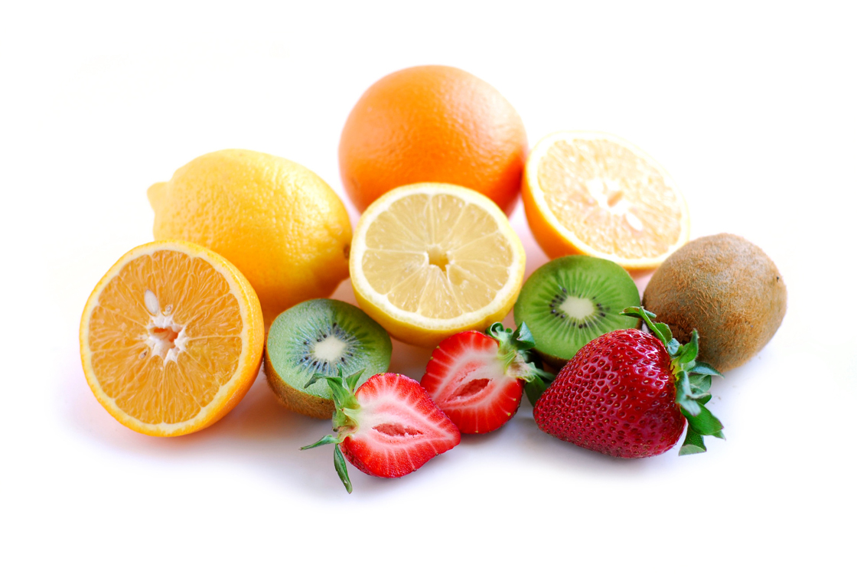

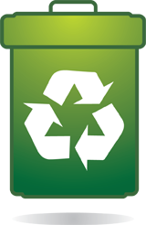

MCj04376690000[1]

**You will receive learning material listed below:**

* + **English ENG213 (writing a report) 214,(visual language, signs) 215 (listening, interviewing)**
  + Guided reading - topics related to sustainability Journal Pt3-1-03 Zookeeper For a Day

Discuss questions on Conservation/ Zoos on the Invitation to prepare for Zoo Event 18th Sept (please send back consent form )

* + **Science** SCL319 Plastics  
    Physical world – Trees, weather, compost, water Journal story “Plastic Fantastic”
  + **Social Studies**   
    Economic world – People working together
  + **Technology** PYPK11 packaging  
    Recycling
  + **Health HED 215 Looking After My Body**  
    Keeping well and what you eat
  + **Mathematics XNU41P Hunting Hundreds (Numeracy)**

**MXL201 (revision Level1 place value)**

**MXL 202 (measurement) MXL 215 Geometry.**

* + **The Arts - painting, collage about the Zoo**
  + **PE**  - balance and skipping

**Here are some questions for you and your supervisor to talk about as you learn about sustainability.**

1. **When I buy something do I think about how it will affect my world? How will I dispose of it? Is it safe to dispose of?**
2. **What do I do to help or improve my environment? Is there anything I can improve on?**
3. **Is there something I think about often that I would like to help with to make our world a better place to live in?**

**What else you will need:**

A ***Sustainability Journal****,* for example a scrapbook, clear file, photo story or power point to keep a record of your learning about sustainability from the start to the end of the term.

**You could use words, pictures and photos to record**

* what you know now,
* what you learn,
* what you do, and what your family and other people do.
* interviews

**Have a wonderful term learning about all the ways we can live in a sustainable way.**