

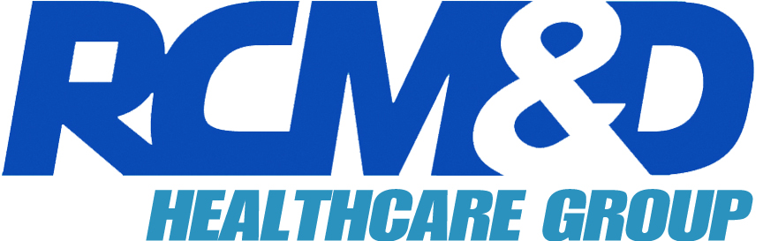

Date: May 29, 2009

Time: 10:30 a.m. – 11:30 a.m.

Speakers: Beth Strapp, VP & Worldwide Product Manager - Chubb
Lea Bowers, Sr. Underwriting Officer - Chubb
Laura Shimshidian, AVP/EPL Claims Supervisor - Chubb
Claudette Kellner, AVP, HC Sr. Specialist - Chubb
Linda Jones, Sr. VP-Healthcare – RCM&D
John McElroy, Sr. VP-Healthcare – RCM&D

RSVP: Angela Stoddard
astoddard@rcmd.com

Questions: 800.441.6227, x1585
Please join us for a webinar discussion of D&O, Fiduciary Liability and Employment Practices Liability coverage for healthcare organizations. We will also present coverage highlights, claims examples, emerging trends and loss prevention services.

