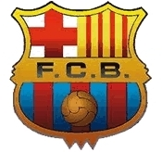
Image 1: FC Barcelona - famous club
Image 2: Celtic Glasgow - famous club
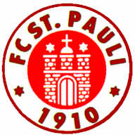
Image 3: FC St. Pauli - famous club

