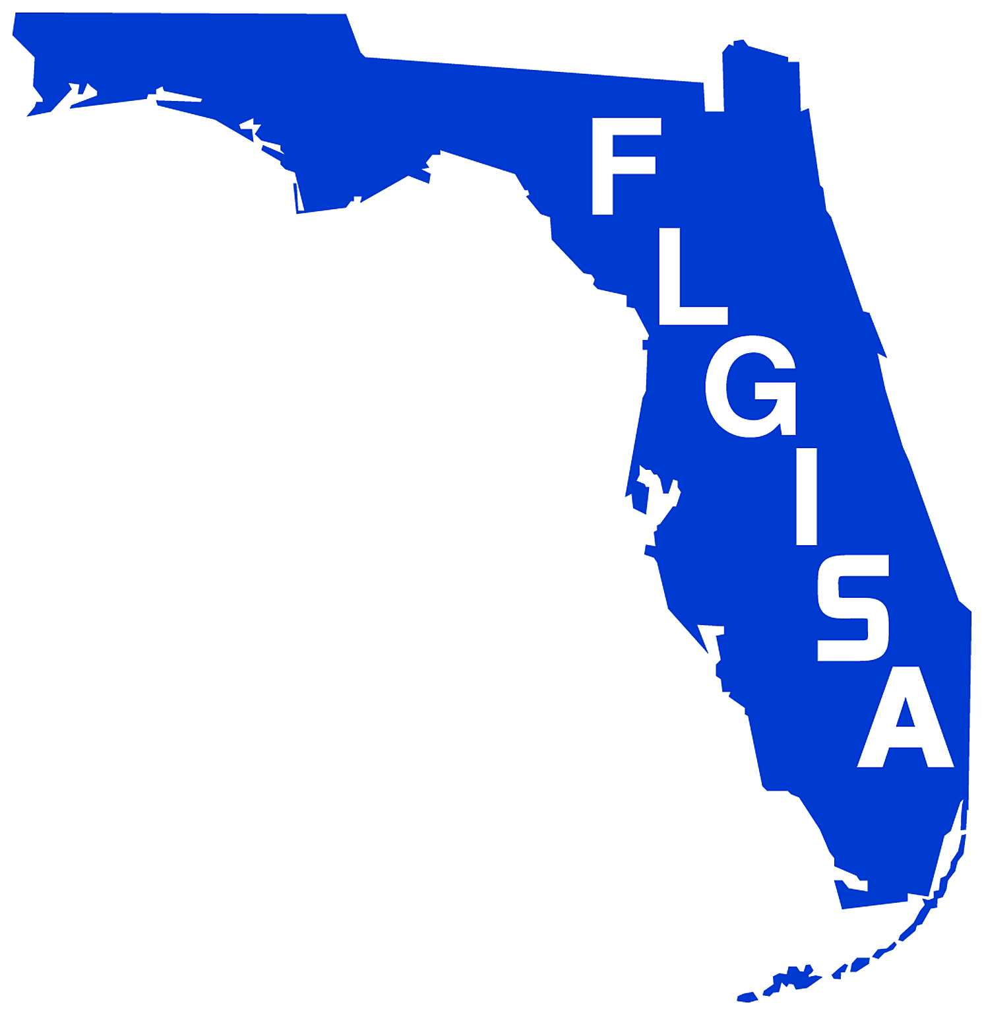
FLORIDA LOCAL GOVERNMENT INFORMATION
SYSTEMS ASSOCIATION

125 E Colonial Dr Orlando, FL 32801
Phone 407-367-1850 Fax 407-425-9378
www.flgisa.org

April 14, 2009

Mr. Richard Butgereit,
GIS Administrator
Florida Statewide GIS Steering Committee
Florida Division of Emergency Management
2555 Shumard Oak Boulevard.
Tallahassee, Florida 32399-2100

Dear Mr. Butgereit:

I have reviewed the "Florida's Strategic Plan for Statewide Geographic Information Systems" (GIS) coordination and am heartened to see such a thoughtful and plan.

The Florida Local Government Information System Association (FLGISA) was formed to provide a venue for local governments to develop leadership around the use of technology across our state. One of the areas of our focus was around GIS – the spreadsheet of government – and its uses for local government. We strongly support Florida's current effort to develop and implement a Strategic Plan for Statewide GIS Coordination. We congratulate the State's GIS Steering Committee's initiative and effort which has resulted in completion of the Strategic Plan , a plan which will be vital to effective program coordination, With the vision and goals clearly established in the Strategic Plan, the subsequent work now required to implement the Plan is imperative. We believe that Florida's effort to improve geospatial coordination will have the following benefits:

Our membership is committed to advancing the development and use of geospatial resources that assist us in meeting our agencies responsibilities technology resources and coordinating these efforts with federal, state and local partners.

I speak for more than 140 Cities, Counties and local government agencies across the state who congratulate you and the steering committee for the care and thought that went into the development of the strategic plan and wish you continued success.

Sincerely,

Kevin Kryzda
President, FLGISA
President
KEVIN KRYZDA, CCIO
Chief Information Officer
Martin County
Vice President
ROBERT BEACH, CCIO
Director
Seminole County

Secretary
MELINDA MILLER, CCIO
Director, IS
Town of Jupiter
Treasurer
LES AUERBACH
Director of IT
City of Gainesville
Past President
HAROLD SCHOMAKER, CCIO
IT Manager/CIO
City of Largo
Northwest District Director
CHAD MORRIS, CCIO
IS Manager
City of Niceville
Northeast District Director
KEVIN G. SMITH
Director, Information and Telecomm
Alachua County

Central West District Director
MUSLIM GADIWALLA, CCIO
Chief Information Officer
City of St. Petersburg
Central East District Director
NED HUHTA, CCIO
Manager, Information Technology
City of Ormond Beach

Southwest District Director
BARRY AXELROD
Director, IT
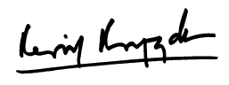
Collier County

Southeast District Director
KAREN LANKE
IT Director
City of Aventura

