- 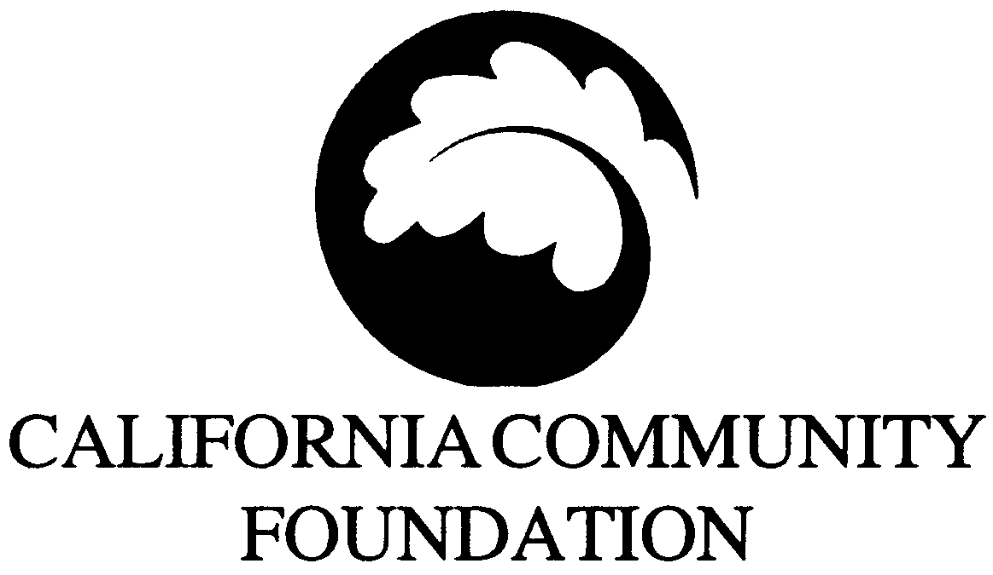The FEDCO
Administered by the
- Charitable
- Foundation

FEDCO Classroom Enrichment Fund
K–12 Teacher Grants 2005–2006
Request for Applications

Grants for teachers in ABC/Cerritos, Culver City, Norwalk La Mirada,
- Pasadena and Los Angeles Unified school districts

The FEDCO Charitable Foundation provides grants to full-time public school teachers serving students in grades kindergarten through 12 in the ABC/Cerritos, Culver City, Norwalk La Mirada, Pasadena and Los Angeles Unified school districts. Grants support hands-on, classroom or “real-world” field trip projects that bring learning to life and increase student academic achievement. Grants are designed to encourage experiential learning, enhance student understanding and boost student achievement with respect to the curriculum standards in one of the core subject areas.

Proposed projects must be submitted by a full-time teacher and may involve museum or field trips, environmental or science projects, artistic or cultural experiences, civics or community service projects, and the creation of a final student product that promotes student learning. Grant funds may be used for transportation, pre- or post-field trip materials or other expenses specific to the proposed project. Grant funds may not be used for the following: computer hardware, salaries, video cameras, trips to theme parks, sectarian purposes, substituting existing funds that are available to support similar services or third party payments.

Total Available: $200,000

Grant Amount: $500 per teacher

Applications accepted from Sept. 6, 2005 through Mar. 20, 2006.
- Apply online at www.calfund.org/6/fedco.php

Background

The FEDCO Charitable Foundation was created when the FEDCO chain of stores closed its doors in 1999. After creditors and employee benefits were paid in full, the remaining assets of more than $7 million established an endowment for the FEDCO Charitable Foundation, a supporting organization of the California Community Foundation, whose staff is coordinating the grant distribution process.

Funding Priorities

The goal of the grant program is to bring learning to life inside or outside the classroom and to increase student learning in one of the core subject areas: language arts, mathematics, science or social studies. Highest priority will be given to projects that incorporate classroom-linked or community-based experiential learning connected to the core curriculum standards. (

See examples on page three.)

- Eligibility

- Teachers may apply individually for grants of up to $500, or collaborate with other teachers in their school and submit a joint application with a total sum of no more than $500 per teacher (two teachers can apply for up to $1,000; three for up to $1,500 and so on). Joint applications should be from a team of similar grade-level or subject area teachers at the same school. To ensure that grant dollars are distributed to a wide range of geographically diverse schools and teachers across the targeted districts, the foundation will not award schoolwide grants. However, small groups may apply. Teachers are encouraged to apply early, before the March 20, 2006 deadline, as grant dollars may be fully expended before then. Please note the following requirements:

- Eligible teachers must currently teach full time in a public school in the ABC/Cerritos, Culver City, Norwalk La Mirada, Pasadena or Los Angeles Unified school district and serve students between the ages of five and 18 (kindergarten through 12th grade).
- The school principal or administrator must understand and fully support the project, as evidenced by signing the statement of support on the application form and final grant agreement. Applicants submitting an application online must indicate the principal’s approval by checking the appropriate box.
- Teacher(s) must propose a class project that is aligned with and supports the curriculum standards and includes all students in the class.

- Selection Criteria

- Project is likely to increase student understanding and achievement connected to the curriculum standards in language arts, mathematics, science or social studies.
- Project goals and learning objectives are clearly defined and tied to students’ academic needs. The expected impact on student learning is described for all participants.
- If a field trip is involved, well-planned pre- and post-trip activities tied to classroom learning objectives are explained. If possible, reservations have been made.
- Activities, a timeline and logistics are clearly described. Grant funds must be expended by June 2006.
- The budget categorizes and shows item by item the use of grant funds. The project costs less than $500 per teacher, or sufficient funding is in place for the project to be completed.
- For those working collaboratively on a joint project with other teachers or classrooms, the collaborative effort is explained (the foundation recommends small sized teams of similarly focused teachers, by grade level or subject area).
- The school administrator fully understands and supports the project as evidenced by a signed statement on the cover sheet, or for applications submitted via our website, by checking the appropriate box on the online application.

Examples

- The following are examples of projects teachers have submitted. Teachers may be innovative and develop projects that suit their students’ learning needs and interests.
- One fifth grade teacher requests $500 to engage students in the study of the environment, conservation and how various animals adapt to their “biomes” in order to survive. Students will take a field trip to the West Basic Water Recycling Plant, the Roundhouse Marine Lab & Aquarium and Redondo Beach, and create follow-up research books.
- Four kindergarten teachers request $2,000 to improve 95 kindergarteners’ knowledge and understanding of life science and plants through the use of “see-inside” classroom incubators, math and writing assignments related to the chicks hatching, and a field trip to Tierra Rejada Farm in Moorpark.
- Two 11th grade teachers request $1,000 to deepen student understanding of World War II history and tolerance issues by integrating U.S. history, American literature and composition and the arts. Students will visit museums (Museum of Tolerance, Japanese American National Museum), meet a Holocaust survivor, engage in discussions about diversity and write about lessons learned from war.

Review Process

- California Community Foundation program staff will review all applications as they are received until all funds are expended or the March 20, 2006 deadline, whichever occurs first. If you need additional information not provided on our Web site at www.calfund.org/6/fedco.php, please call the FEDCO Charitable Foundation hotline at (213) 452-6206, or contact Cathy Choi, Program Associate or Pamela Rubin, Program Officer via e-mail at fedcofund@ccf-la.org.

- Use of Funds and Final Report

The California Community Foundation expects to award approximately $200,000 in teacher grants in Los Angeles County from September 2005 to March 2006.

When developing project budgets, applicants should consider and research all costs needed to complete the project. Funds should be expended by June 30, 2006, and a brief final progress report will be required for all grants.

- Because the community foundation is interested in increasing student engagement and learning,
- a two-page narrative report, including a summary of the students’ accomplishments and an expense report are requested as the final progress report. Enclosing a few photos or samples of student work documenting the project is highly encouraged. We reserve the right to reproduce photos and students’ work in publications and on the foundation’s Web site.

Grant Limitations

Grant funds may not be used for the following:

- Field trips for only a select group of students within a classroom
- Staff or substitute teacher salaries

- Existing obligations, or to replenish other resources used to pay for such expenses
- Computer hardware or equipment such as digital or video cameras
- Sectarian purposes

How To Apply

- Applications submitted via our Web site are encouraged! Teachers should apply early, well ahead of the deadline, as grants will be made on a rolling basis until funds are expended and field trips often require planning and reservations far in advance.

- There are three different ways to apply for a FEDCO Classroom Enrichment Fund grant:
- Online at www.calfund.org/6/fedco.php
- By e-mailing a complete application to fedcofund@ccf-la.org
- By mailing or faxing a hard copy of the application to the address below

- Choose only one method to submit your application. Online applications are encouraged. Make sure to include administrator approval, with a signature if applying by fax or mail.

- Applications should include:
- Complete answers to all six questions
- Administrator approval
- Project budget showing how the funds will be spent, item by item
- Collaborating teachers’ information

- Application tips:
- Do not include more than four pages. Applications exceeding four pages will be disqualified.
- Use a font size of at least 12 points.
- Do not use a binder, folder or special cover (they are not easily filed and will be discarded).
- Choose only one way to submit (online, by e-mail or by fax or mail).

- Submit your application as soon as it is complete,
- no later than Monday, March 20, 2006, via one of the following ways:

- Web site: www.calfund.org/6/fedco.php
- E-mail: fedcofund@ccf-la.org
- Fax: (213) 629-4782
- Regular mail: Senior Program Assistant
- FEDCO Classroom Enrichment Fund
- California Community Foundation
- 445 S. Figueroa Street, Suite 3400
- Los Angeles, CA 90071-1638

For More Information: If you have questions regarding the application, please contact Cathy Choi, Program Associate or Pamela Rubin, Program Officer at (213) 413-4130.

The FEDCO

Charitable Foundation

2005–2006 APPLICATION COVER SHEET

Deadline: Friday, March 20, 2006
- Please attach to the front of your responses to Questions 1–6 or apply online.
- Teacher’s First Name: |  | - Last Name:
- School Name:
- School Address:
- City: | - State: | - Zip:
- Applicant’s E-Mail:
- School District Name: |  | - Local District (if LAUSD):
- School Phone:
- Home Phone:
- School Fax:

- Type of School: | - K-5 Grades 6-8 Grades 9-12 Grades Multi-level
- No. of Students Participating in Project:
- Grade Level of Participating Students: |  | - Subject Taught:
- Amount Requested ($500 per teacher max.): | - $ | - Track Taught (if year-round):
- No. of Teachers Applying: |  | - Total No. of Students in School:

- Names, positions and signatures of teachers involved: | - Signatures:

- Summarize Purpose of Proposed Project:

- Curriculum standards and learning objectives addressed:
- Administrator’s Approval: I have read and understand the attached grant application for the FEDCO Classroom Enrichment Fund. The proposed grant complies with school goals and regulations, and I fully support this project should it receive funding.
- ____________________________________ _____________
- Signature Date
- _____________________________________________________________
Administrator’s Printed Name and Title

- Apply online at www.calfund.org/6/fedco.php, e-mail fedcofund@ccf-la.org or fax (213) 629-4782.

The FEDCO

Charitable Foundation

TEACHER GRANT APPLICATION QUESTIONS

- Applications are limited to a total of four pages in length (including the cover sheet and budget) with standard one-inch margins, single-spaced, using a 12-point font. Do not attach any additional information or use a folder. Applications that are incomplete or exceed four pages will not be considered. Please include your name on the top left-hand corner of each page.

Project Description

Responding to the questions below, clearly describe your classroom project.
- Why are you choosing to do this project? What specific student needs will the project address?
- Who and how many students will participate? (Include grade level and other demographic information.)
- When and where will your project take place? (Include a timeline.)
- What activities or materials will the project include?

Learning Objectives

Identify the classroom learning objectives or curriculum standards that this project will address. Explain how this project will connect to or support these objectives and improve the education of your students.

Assessment/Evaluation

How will you assess the impact of the project related to your teaching and learning objectives?

Additional Information

Please include any other relevant information about your project that you would like to share. For example, is this a new project or the continuation of an existing project? If you are collaborating with other teachers, what is the nature of the collaboration? Will you share your project with other teachers or classrooms?

- Budget
- What materials will the project require and at what cost? Please show item by item how the requested amount will be spent. If the project cost exceeds the request, please tell us how you will fund the remaining portion.

- Administrator Support (signed by the principal or administrator)
- A signature from the school administrator is required to show he/she has read, understands and fully supports the grant application should it receive funding. If submitting the application via the Web site, indicate the administrator’s authorization by checking the appropriate box. Principals will also be asked to sign the final grant agreement.

