GPS Advertising



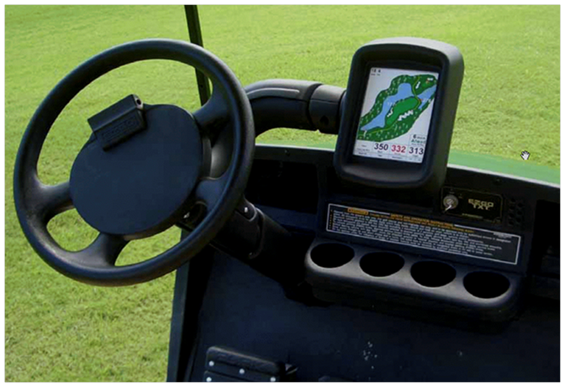

**Your**

**Ad**

**Here!!**

LaGrange, GA

Lagrange, GA

Information:

Janel Starnes

404-867-4893

h