

Writer Guide
Chapter 11
Using Mail Merge:
Form letters, mailing labels, and envelopes

Copyright
This document is Copyright © 2005 by its contributors as listed in the section titled Authors. You can distribute it and/or modify it under the terms of either the GNU General Public License, version 2 or later (http://www.gnu.org/licenses/gpl.html), or the Creative Commons Attribution License, version 2.5 or later (http://creativecommons.org/licenses/by/2.5/).
All trademarks within this guide belong to their legitimate owners.

Authors
Iain Roberts
Peter Kupfer
Agnes Belzunce
Alan Madden
Jean Hollis Weber
Dick Detwiler

Feedback
Maintainer: Iain Roberts
Please direct any comments or suggestions about this document to:
authors@user-faq.openoffice.org

Publication date and software version
Published 22 October 2006. Based on OpenOffice.org 2.0.4.
Contents

Copyright i
Authors i
Feedback i
Publication date and software version i
What is mail merge? 1
Creating the data source 1
Registering a data source 2
Creating a form letter 5
Printing mailing labels 8
Printing envelopes 12
Setting up envelopes for printing 12
Merging and printing the envelopes 14
Using the Mail Merge Wizard to create a form letter 15
Step 1: Select starting document 15
Step 2: Select document type 16
Step 3: Insert address block 17
Selecting the data source (address list) 17
Selecting the address block 18
Matching the fields 20
Step 4: Create salutation 21
Step 5: Adjust layout 21
Step 6: Edit document and insert extra fields 22
Step 7: Personalize documents 24
Step 8: Save, print or send 24
Saving as a file rather than printing 25
Editing a saved file of mailing labels 26
Removing blank lines in addresses 27
Removing blank lines in addresses on form letters 27
Removing blank lines in labels 29
Removing blank lines from envelope addresses 31

What is mail merge?
OpenOffice.org (OOo) Writer provides a very useful feature to
:
- Create and print multiple copies of a document to send to a list of different recipients (form letters).
- Create and print mailing labels.
- Create and print envelopes.

- This chapter describes the entire process. The steps include:
- How to create and register a data source.
- How to create and print form letters, mailing labels, and envelopes.
- Optionally, how to save the output in an editable file as an alternative to printing it directly.

Creating the data source
Although you can create and print mailing labels and envelopes without using a data source, in most cases using a data source is the most expedient approach. This chapter assumes that you are using a data source.
A data source is a file, spreadsheet or database, which contains the list of names and addresses the letter is to be sent to.
For this example, we will use the following column headers: First name, Last name, Address 1, Address 2, Town/City, State/County, Country, Postal Code, Gender, Points. A sample data source is shown in Figure 1.
OOo can access a wide variety of data sources, including spreadsheets, text files and databases such as MySQL, Adabas, and ODBC. If the information to be used in the mail merge is currently in a format that OOo can not access directly, you need to convert it, for example by exporting it to a comma-separated file.
 | You can now enter the data for the mail merge as part of the new Mail Merge Wizard. However, if you have more than a few records, you probably should use an external data source.

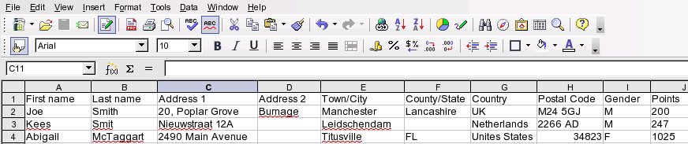Figure 1: Spreadsheet data source

Registering a data source
Before any OOo documents can use a data source, it must be registered.
To register a data source:
- Click File > Wizards > Address Data Source.
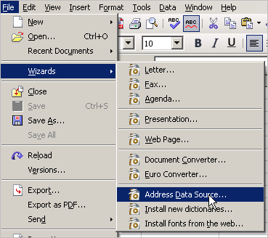
Figure 2: Starting the Address Data Source wizard
- Select the appropriate type of data book (in this case, Other external data source). Click Next.
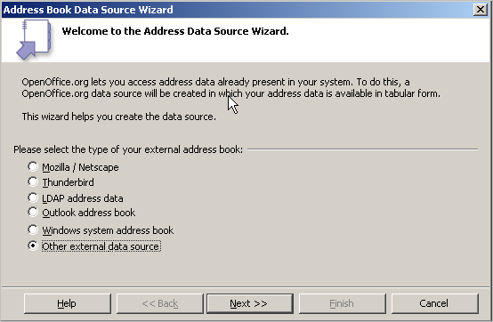
Figure 3: Select type of external address book
- On the next page of the Wizard (Figure 4), click Settings.
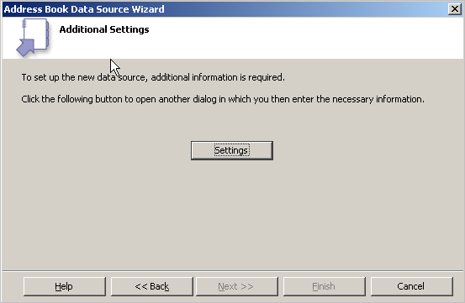
Figure 4: Starting the Settings part of the Wizard
- On the Data Source Properties dialog (Figure 5), select the Database type (in this case, Spreadsheet). Click Next.
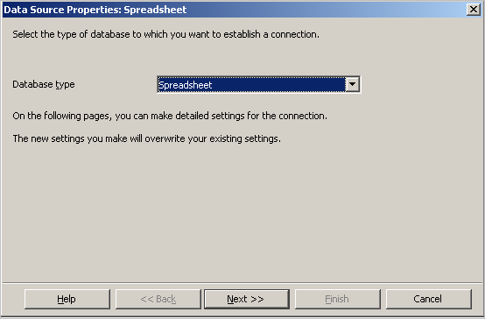
Figure 5: Selecting the database type
- On the next dialog (Figure 6), click Browse and navigate to the spreadsheet that contains the address information. Select the spreadsheet and click Open to return to this dialog.
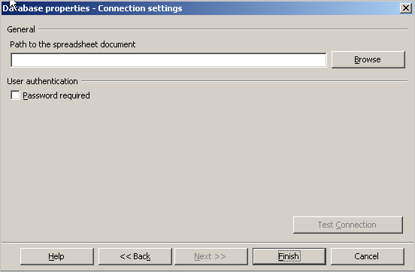
Figure 6: Selecting the spreadsheet document
- Click Finish.
- On the following dialog (Figure 7), click Next. (Do not click Field Assignment.)
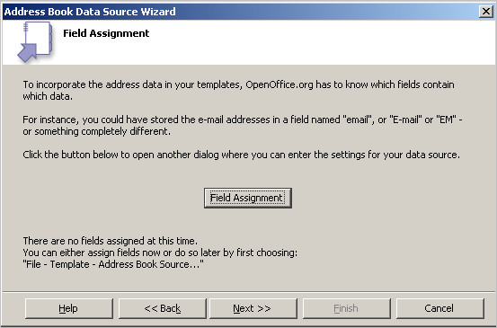
Figure 7: Because this is a spreadsheet, do not click Field Assignment.
- Name the file in the location field. The default will be ...\Addresses.odb; you can replace Addresses with another name if you wish. You can also change the name in the Address book name field. In our example, the name “Points” was used for both.
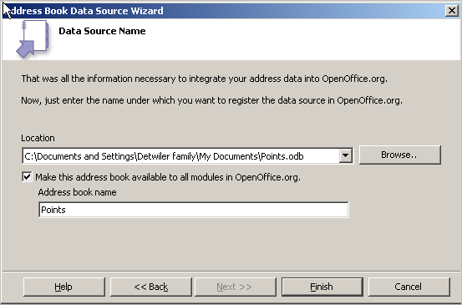
Figure 8: Name the .odb file and the address book.
- Click Finish. The data source is now registered.

Creating a form letter
Example: Sending a letter to your customer base
A mail order company organized a campaign to assign credit points to their customers according to the quantity of goods they buy during one year.
At the end of the year, they want to send a letter to each customer to show the total of credit points collected.
You can use the Mail Merge wizard to create a form letter, or you can create the letter manually. See “Using the Mail Merge Wizard to create a form letter” on page 17 for instructions on using the Wizard.
This section describes how to create a form letter manually.
- Create a new text document: File > New > Text Document.
- Display the registered data sources: View > Data sources (or press F4).
- Find the data source that you wish to use for the form letter, in this case Points. Expand the Points folder, expand the Tables folder, and select Sheet1. The data file is displayed. (See Figure 9.)
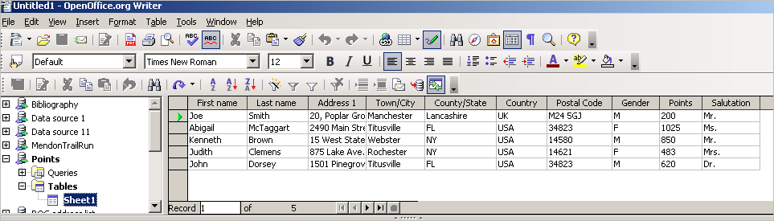
Figure 9: Selecting the data source.
- Now create the form letter by typing in text, punctuation, line breaks, and so on that will be present in all of the letters, and adding fields where needed by clicking in the field heading and dragging to the appropriate point in the letter. (See Figure 10.)
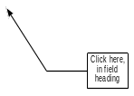
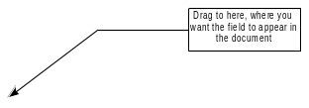
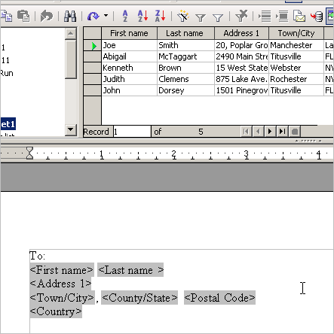
Figure 10: Dragging fields to the body of the form letter
- Continue until you have composed the entire document. (See Figure 11 for an example.)
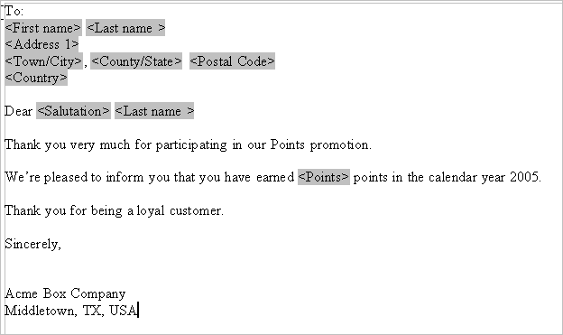
Figure 11: The completed form letter
- The document is now ready to be printed. Click File > Print.
- The following dialog appears. Answer Yes. Do not select the checkbox.
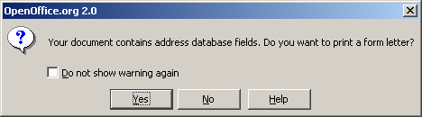
- In the Mail Merge dialog (Figure 12), you can choose to print all records or selected records. To select records to be printed, use Ctrl+click to select non-contiguous records. To select a contiguous block of records, select the first record in the block, scroll to the last record in the block, and Shift+click on the last record.
- Click OK to send the letters direct to the printer. If you wish to check the letters before printing, see “Saving as a file rather than printing” on page 28 for instructions.
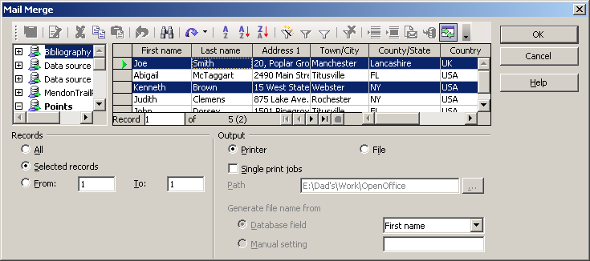
Figure 12: The Mail Merge dialog

Printing mailing labels
Before beginning this process, check to see what brand and type of labels you have.
To print mailing labels:
- Click File > New > Labels.
- On the Labels dialog, go to the Options tab and uncheck Synchronize contents if it is checked (Figure 13).
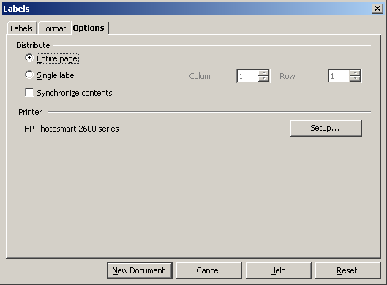
Figure 13: Uncheck Synchronize contents
Note | If you need to suppress blank lines in some of your labels, read “Removing blank lines in labels” on page 32.
- On the Labels tab (Figure 14), select the Database and Table. Select the Brand of labels to be used, and then select the Type of label.
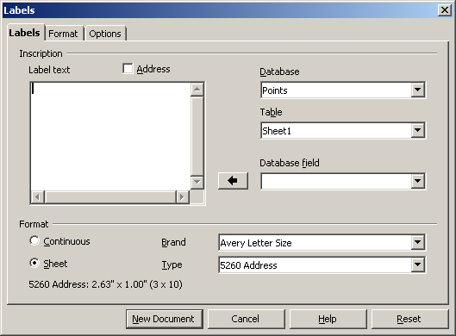
Figure 14: Select Database, Table, label Brand, and label Type.
- Click the dropdown arrow under Database field. Select the first field to be used in the label (in this example, First name). Click the left arrow button to move this field to the Label text area (Figure 15).
- Continue adding fields and inserting desired punctuation, spaces, and line breaks until the label is composed. Figure 16 shows the completed label.
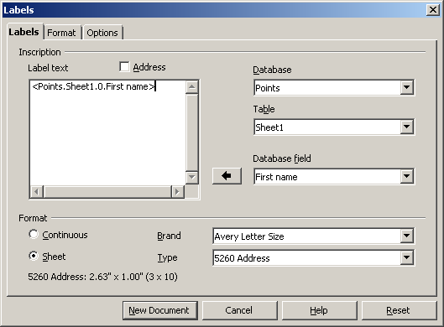
Figure 15: Move fields from Database field list to Label text area.
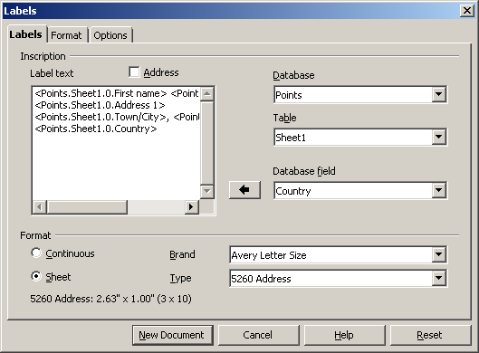
Figure 16: The completed label.
- Click New Document.
- Click File > Print. The following dialog appears. Click Yes. Do not select the checkbox.
- In the Mail Merge dialog (Figure 17), you can choose to print all records or selected records. To select records to be printed, use Ctrl+click to select non-contiguous records. To select a contiguous block of records, select the first record in the block, scroll to the last record in the block, and Shift+click on the last record.
Figure 17: Mail Merge dialog
- Click OK to send the letters direct to the printer. If you wish to check the labels before printing, see “Saving as a file rather than printing” on page 28 for instructions.

Printing envelopes
Instead of printing mailing labels, you may wish to printing directly onto envelopes. Printing envelopes involves two steps: setup and printing.

Setting up envelopes for printing
To set up envelopes to be printed with your letters:
- Click Insert > Envelope from the menu bar.
- In the Envelope dialog box, start with the Envelope tab (Figure 18). Verify, add, or edit the information in the Addressee and Sender boxes (Sender is the “from” on the envelope). You can use the right-hand dropdown lists to select the database or table from which you can draw the envelope information. Use the same method as described in “Creating a form letter” on page 6, in particular Figure 10.
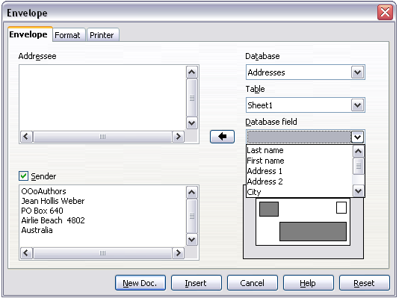
Figure 18: Choosing addressee and senderinformation for envelopes
- On the Format tab (Figure 19), verify or edit the positioning of the addressee and the sender information. The preview area on the lower right shows the effect of your positioning choices.
To format the text of these blocks, click the Edit buttons to the right.
- In Character, you can choose fonts, sizes, underlines or color, rotating/scaling, backgrounds and more.
- In Paragraph, you can choose indenting, alignment, flow, tabs and more.
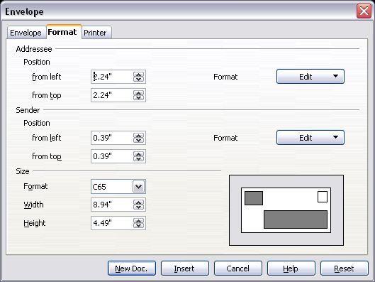
Figure 19. Choosing positioning and size of elements for an envelope
- In the lower left of this tab, choose the envelope format from the dropdown list. The width and height of the selected envelope then show in the boxes below the selected format. If you chose a pre-existing format, just verify these sizes. If you chose User defined in the Format list, edit the sizes.
- After formatting, select the Printer tab (Figure 20) to choose printer options such as envelope orientation and shifting. You may need to experiment a bit to see what works best for your printer.
You can also choose a different printer or alter the printer setup (for example, specify the tray that holds envelopes) for this print job.
- When you have finished formatting, click either the New Doc or Insert button to finish. New Doc makes only the envelopes or starts a new document with the envelopes. Insert inserts the envelopes into your existing document as page 1.
To not proceed with this envelope, click Cancel or press the Esc key. You can also click Reset to remove your changes and return to the original settings when the dialog box opened.
- To remove blank lines from the addresses, use the technique described in steps 1 through 5 in “Removing blank lines in addresses” on page 29.
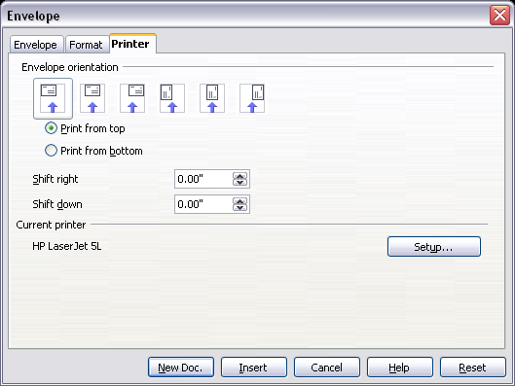
Figure 20. Choosing printer options for an envelope

Merging and printing the envelopes
To merge addresses and print the envelopes:
- Choose File > Print. The following dialog appears. Click Yes. Do not select the checkbox.
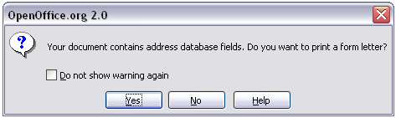
Figure 21: Confirmation dialog for merging database fields
- The Mail Merge dialog (Figure 22) appears. As with form letters and mailing labels, you can choose to print envelopes for one, several or all address records in the database.
- Make your selections and then click OK to print direct to the printer. If you wish to check the envelopes before printing them, see “Saving as a file rather than printing” on page 28 for instructions.
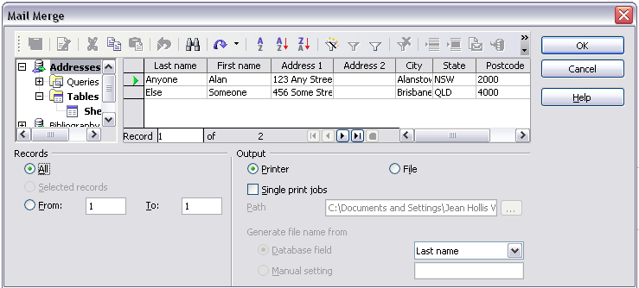
Figure 22: Choosing records to use when printing envelopes
Using the Mail Merge Wizard to create a form letter
To start the Mail Merge wizard
,
select Tools > Mail Merge Wizard. The wizard opens, as shown in Figure 23.
The Mail Merge Wizard does not exist in OOo version 1.x; it is a new feature in version 2.0. If you are using version 1.x, refer to the Mail Merge chapter for that version.

Step 1: Select starting document
The wizard gives various options to select your starting document:
- Use the current document.
- Create a new document.
- Use a template.
- Use an existing document.
You can write the letter later on in the wizard, but it is easier to use a draft you prepared earlier. For this example, select Use the current document and click Next.
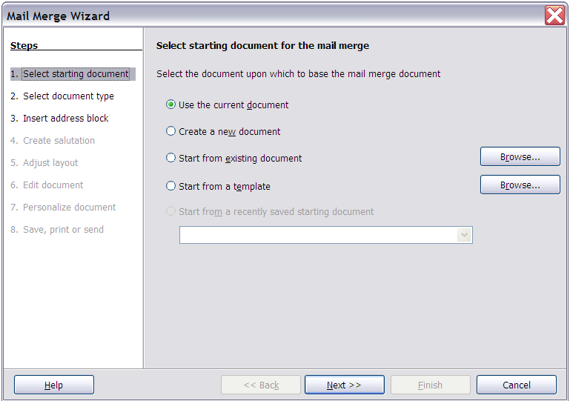Figure 23: Select starting document

Step 2: Select document type
The wizard can produce letters or, if a Java Mail connection exists, email messages. You can see these options in Figure 24. In this example, we are producing a letter. Select Letter and click Next.
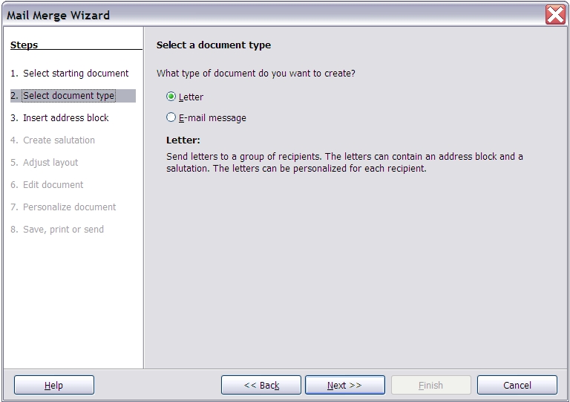Figure 24: Choose document type

Step 3: Insert address block
This is the most complex step in the wizard. In this step (Figure 25) you will do three things:
- Tell the wizard which data source to use. The data source must be a file; in this example it is the spreadsheet created earlier.
- Select the address block to use in the document. This means choosing which fields appear (for example, whether the country is included) and how they look.
- Make sure that the fields all match correctly. This is very important. For example, the wizard has a field called <Last Name>. If your spreadsheet has a column called “Surname”, you need to tell the wizard that <Last Name> and “Surname” are the same thing. This is described in “Matching the fields” on page 22.
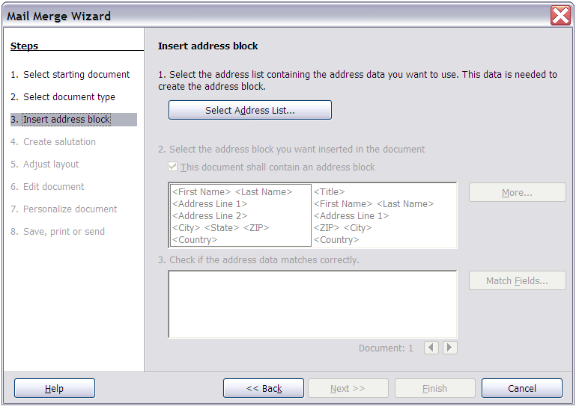Figure 25: Ins

Selecting the data source (address list)
- Click Select Address List in section 1. This opens the Select Address List dialog box (Figure 26) for choosing a data source.
- If you have not already created the address list, click Create to do so now. If you have an address list, as we have in this example, click Add and select the file.
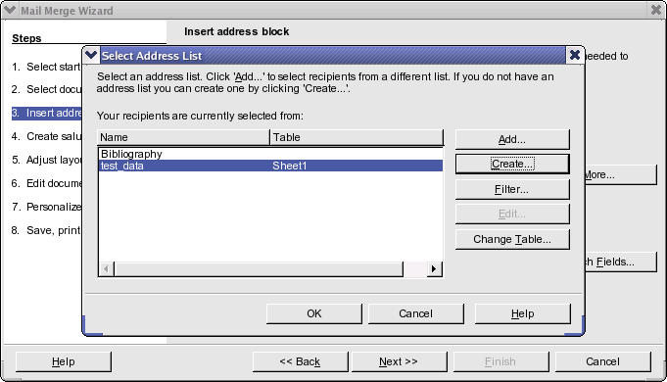
Figure 26: Select address list dialog
- Select the spreadsheet file and click OK to return to step 3 of the wizard. For this example, the preceding steps are all you need to do. The wizard can also exclude certain records; click Filter to choose them.

Selecting the address block
- In step 3 of the wizard (shown in Figure 25), look at section 2. This is where you select the address block to appear on the letter, and define its appearance and the fields it contains. The main page gives two examples. If neither of those is exactly what you want, click More to see more choices, in the Select Address Block dialog box (shown in Figure 27).
- The Select Address Block dialog offers six choices for the format of the addresss block (scroll down to see the last two choices). You can also optionally include or exclude the country (for example, only include the country if it is not USA). The six formats provided are relatively common, but they might not exactly match your preference. If this is the case, select the address block that is closest to what you want and click Edit, which opens the New Address Block dialog box.
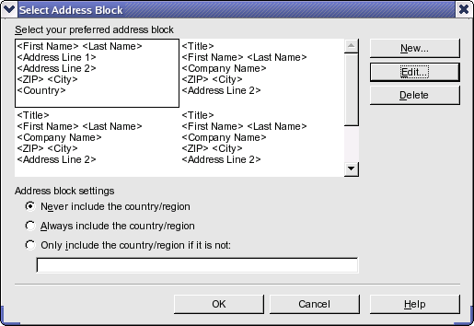
Figure 27: Select address block
- In the New Address Block dialog (Figure 28), you can add or delete address elements using the arrow buttons on the left. To move elements around, use the arrow buttons on the right. For example, to add an extra space between first and last names in Figure 28, click <Last Name> and then click the right arrow button.
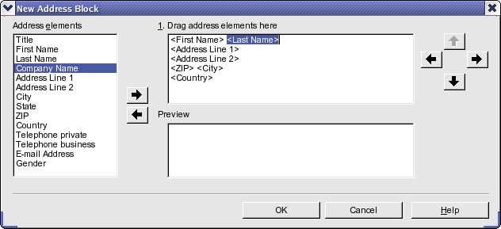
Figure 28: New address block

Matching the fields
Finally, it is time to match the wizard’s fields with the spreadsheet fields, so that items like <Last Name> and “Surname” match correctly.
- Look at section 3 of step 3 of the wizard (shown in Figure 25 on page 17). The box at the bottom displays one record at a time, using the address block format you selected. Use the right and left arrow buttons below that address box to step through the addresses, checking that they display correctly. Do not assume that all the records display correctly, just because one or two do. Check them all if you can, or at least a good proportion.
- If the addresses do not display correctly (and they probably will not right away), click Match Fields. The Match Fields dialog box opens, as shown in Figure 29.
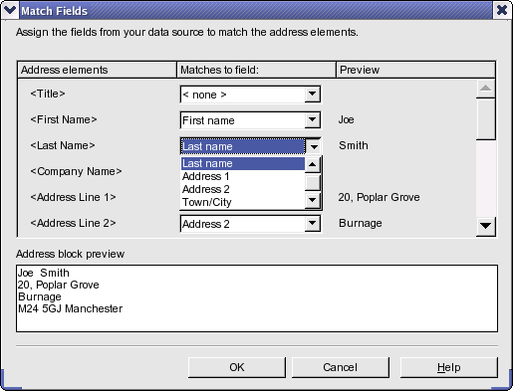
Figure 29: Match fields dialog
The Match Fields dialog has three columns.
- Address Elements are the terms the wizard uses for each field, such as <First Name> and <Last Name>.
- The Matches to Field column allows you to select, for each address element, the field from your data source that matches it.
- The Preview column shows what will be shown for this field from the selected address block, so you can double-check that the match is correct.
- When you have matched all the fields, click OK to return to step 3 of the wizard. Now, when you use the arrow buttons to look at all the addresses, they should all look correct. If not, go back and change anything you’re not happy with, before clicking Next to move to step 4.

Step 4: Create salutation
The salutation is the initial greeting, for example, Dear Mr Jones. In step 4, select the salutation that will appear in the letter.
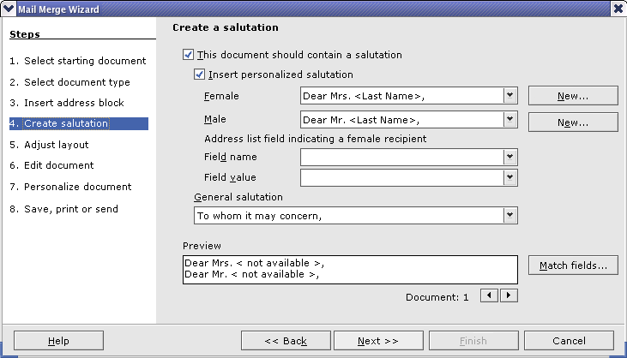
Figure 30: Create a sal
You can use a different greeting for men and women. To do this, Writer must have some way of knowing whether a person is male or female. In our spreadsheet we had a column called Gender. In the section Address list field indicating a female recipient, set the field name to Gender and the field value to F. The male salutation is then printed for all men and the female salutation for all women.
Note | You do not need to tell OOo who is a male, because it assumes that all non-female records are males.
If you do not select Insert Personalized Salutation, you can use a more general salutation without referring to the recipient directly, such as “To whom it may concern”.
As in step 3, step 4 of the wizard has a preview pane at the bottom. You should check more than one record to ensure that other records look the way you expect.

Step 5: Adjust layout
In step 5, you can adjust the position of the address block and salutation on the page. You can place the address block anywhere on the page. The salutation is always on the left, but you can move it up and down the page. Use the buttons shown in Figure 31 to move the elements.
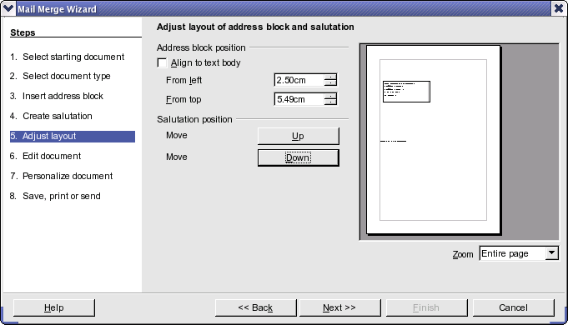
Figure 31: Adjust layout

Step 6: Edit document and insert extra fields
In step 6 you have another opportunity to exclude particular recipients from the mail merge, as shown in Figure 32.
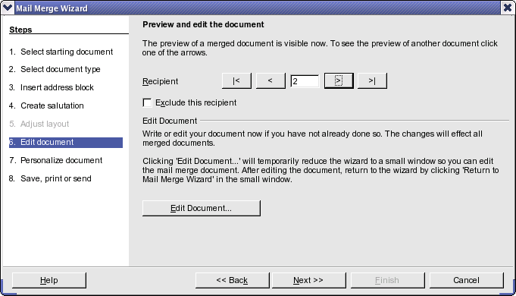
Figure 32: Edit document

You can also edit the body of the document. If you started with a blank document, you can write the whole letter in this step. Click Edit Document to shrink the wizard to a small window (Figure 33) so you can easily edit the letter.
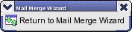
Figure 33: Minimized mail merge wizard
You need to perform another important task in this step. The wizard only inserts information from the name and address fields, but you may wish to add additional data. In our example, we want to tell each person how many points they had accumulated during the year; that information is in the spreadsheet.
To do this:
- Click Edit Document in step 6 of the wizard.
- Select Insert > Fields > Other. The Fields dialog box opens, as shown in Figure 40.
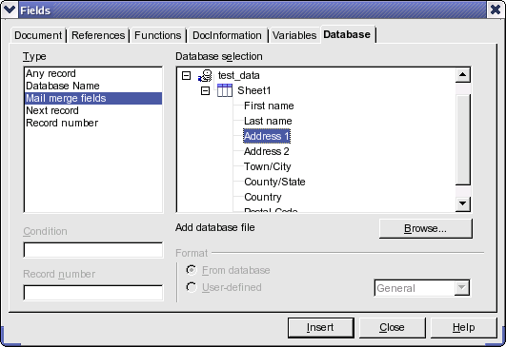
Figure 34: Insert mail merge fields dialog
- Click the Database tab.
- On the left hand side, select Mail merge fields.
- Under Database selection find your data source (in this example, it is a spreadsheet). Expand it to see the fields.
- Click the field you want to insert, then click Insert to insert the field.
You can insert any number of fields any number of times into your mail merge document.
- Click Close when you are done.
Figure 35: Insert mail merge fields dialog
Note | The Database selection lists the data source you selected in step 3. All the information you need for the letter must be contained in that data source.

Step 7: Personalize documents
In step 7, OOo creates all your letters, one per recipient.
Clicking the Edit Document button here is similar to step 6. The difference is that you now edit a long file containing all of the letters, so you can make changes to a particular letter to one person. In step 7 of the Mail Merge wizard (Figure 35), click Find to open a dialog box that allows searches within the document.
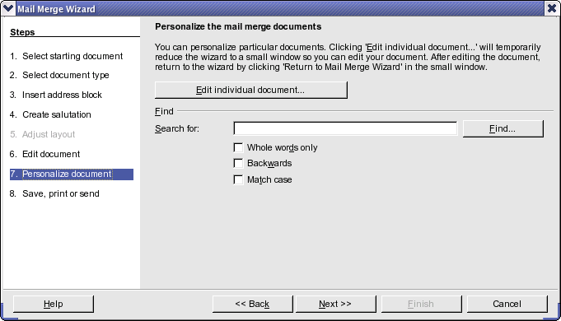
Figure 36: Personalize document
As with step 6, when editing the document, the wizard shrinks to small window. Click on this window (see Figure 33 on page 23) to expand the wizard to its full size.

Step 8: Save, print or send
You have now completed the mail merge process. The last step is to do something with it. In step 8, you can save the original sample letter, save the merged document, print the letters right away or, if you created email messages, send them.
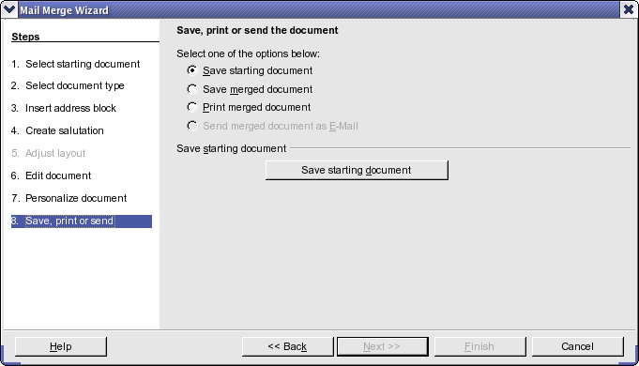
Figure 37: Save,print or send
You probably want to save the starting document and the merged document. The merged document can be saved as one big file or one file for each letter.
When you have saved the merged document, you can print the final letters now or later; and you can still manually check and edit the letters if necessary.

Saving as a file rather than printing
You can save the output of a form letter, mailing labels, or envelopes as a file, rather than printing it directly. Saving as a file is useful for several reasons. For example, you may want to view the file to make sure it is correct before printing a large number of form letters or mailing labels, or you may want to edit the file (change the typeface, the type size, indentation, and so on).
To save as a file rather the printing directly, select the Mail Merge Wizard at the point where File > Print would normally be selected.
Thus, after selecting New Document, instead of selecting File > Print, do this:
- Select Tools > Mail Merge Wizard.
- In Step 1 of the wizard (Figure 23), select Use the current document.
- Then select step 8 (Save, print, or send). In step 8, you can save the original sample letter, save the merged document, or print the letters right away. In the example below, Save merged document and Save as single document are selected. You can also save as individual documents, which means that there will be a separate document for each record. In most instances, saving as a single document is more desirable.
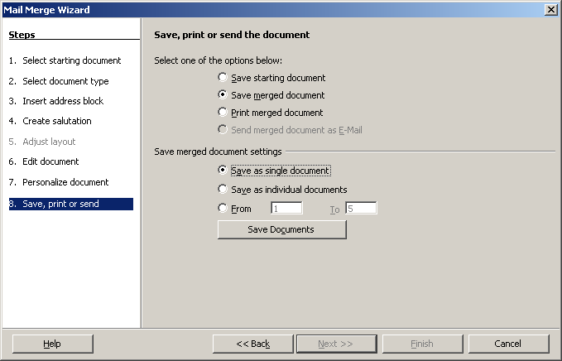
Figure 38: Step 8: Save, print or send
- Click Save Documents. You will be prompted to give the document a name. You then return to the above dialog, where you can choose another option (for example, save the starting document), or click Finish.

Editing a saved file of mailing labels
You can edit individual records in the normal fashion, by highlighting and changing the font name, for example. However, you cannot edit globally (changing the font name for all records, for example) by selecting the entire document.
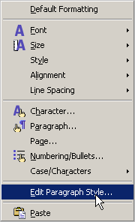
To make global changes, you must edit the style:
- Right-click any correctly spelled word in a label record. Select Edit Paragraph Style from the popu-up menu. (Note: If you click on a misspelled word, a different context menu will appear.)
- Then from the paragraph style dialog, you can make change to the font name, the font size, the indents, etc.

Removing blank lines in addresses
A common situation is that some addresses may have no information in some fields. For example, you may have an “address1” field and an “address2” field to deal with multi-line addresses, or a “company name” field that may be blank in some cases. When you print a form letter, address label, or envelope, you will not want a blank line to appear when the field is empty. This section describes how to suppress blank lines.
Note – Very Important!
Be sure your field names (or column headings in a spreadsheet) do not contain spaces or the technique described here does not work.
Normally you would enclose a field name in quotation marks if the name contains a space. However, a quoted string is not acceptable in the Condition box for a hidden section (see Figure 40 and Figure 42) and an un-quoted string stops on the first space in the field name, effectively making the condition always True and causing the section to be hidden even if the field has data in it..

Removing blank lines in addresses on form letters
- Figure 38 shows a typical address block with field highlighting on. The field <ad2> is the second address line, which may be blank for some addresses, so you want to have that whole line hidden if the field is blank.
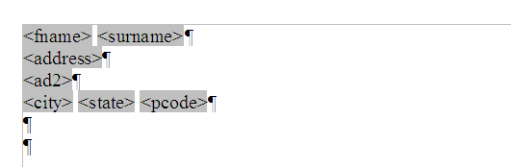
Figure 39: Typical address block
- Select the <ad2> field, and then select Insert > Section from the menu bar. In the Insert Section dialog (Figure 40), select the Hide checkbox. In the With Condition box, type the field name (ad2 in this case) and EQ "" (which means “equals a blank record”). Click Insert.
Back in the document, if you have section markers showing, you will see something similar to Figure 39.
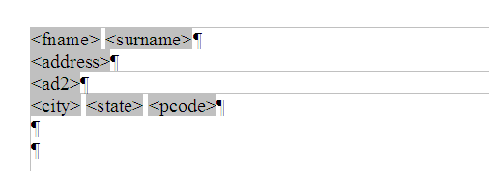
Figure 40: Section containing second address line
Now, when you do a mail merge using this document, the line inside the section (including its paragraph marker) will be hidden if the field <ad2> is blank.
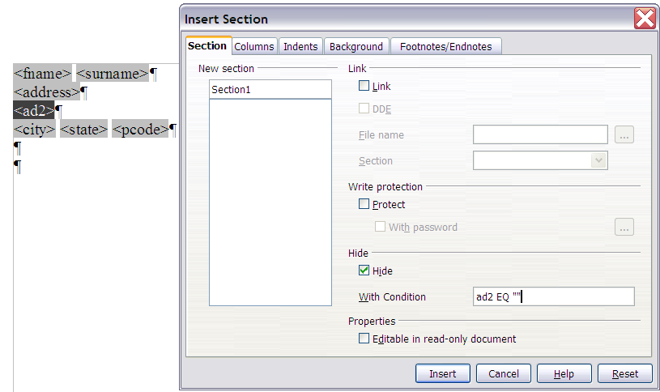Figure 41: Setting a condition for a hidden section

Removing blank lines in labels
The process for removing blank lines in labels is a bit different.
- When setting up your labels (as described in “Printing mailing labels” starting on page 10), select the Synchonise contents checkbox on the Options tab of the Labels dialog (Figure 13). Continue as described in that section.
- When you click New Document, a page of labels is displayed, showing the field names. If you do not already have paragraph markers showing, display them now. (Click the Nonprinting Characters icon, which looks like a backwards P.) Notice there is only one paragraph mark in each label, at the end of the last line (Figure 41).
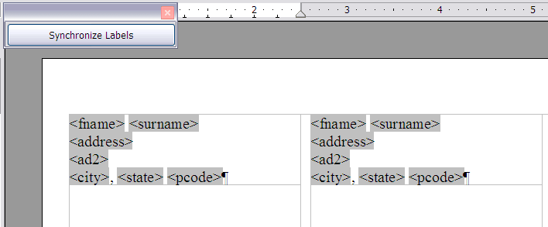
Figure 42: Labels showing only one paragraph mark each
- To make this technique work, you need to have a paragraph mark at the end of each line. To do this, go to the first label (upper left corner), place the cursor at the end of the first line, press Enter, and then press Delete. This inserts a paragraph mark at the end of the first line. Repeat for each of the other lines except the last. Do this only in the first label.
- Click the Synchronize Labels button in the upper left. Now all the labels have paragraph marks at the end of each line.
- In the first label on the page, select the field you wish to hide if it is blank. In our example, that is <ad2>. Click Insert > Section on the menu bar. In the Insert Section dialog (see Figure 42), select the Hide checkbox. In the With Condition box, type the field name (ad2 in this case) and EQ "". Click Insert.
The <ad2> line in the first label may disappear. Do not be concerned if this happens.
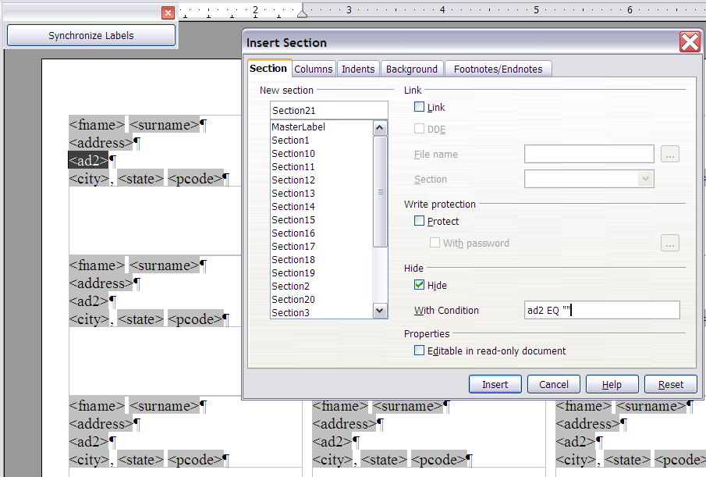
Figure 43: Setting the condition for a hidden section
- Click Synchronize Labels. Now all the labels look the same.
- Select Tools > Mail Merge Wizard. In Step 1 of the wizard (Figure 23), select Use the current document. Then select step 8 (Save, print, or send). A labels document is created, and the last page of the Mail Merge Wizard remains open (Figure 43).
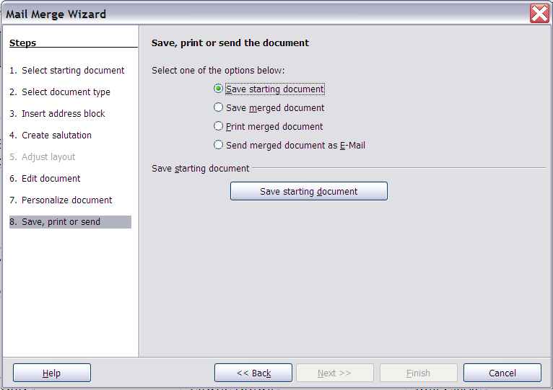
Figure 44: Saving the document you just created
- Select Save starting document and click the Save starting document button. This saves all your work setting up the labels.
- The dialog remains open. Select Save merged document and Save as single document, or select Print merged document. All the pages of labels are printed or saved.
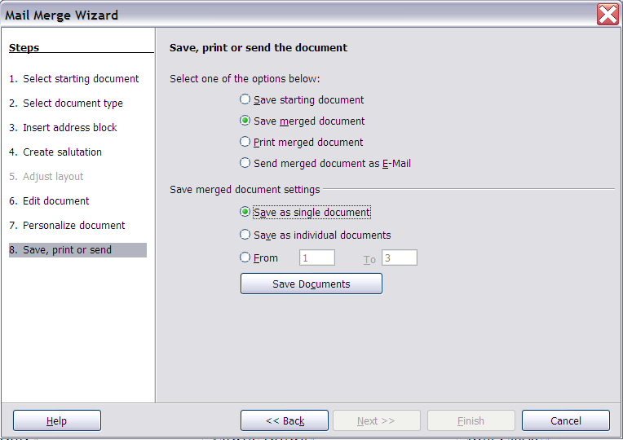
Figure 45: Saving or printing the merged labels

Removing blank lines from envelope addresses
After you set up the envelope (see “Printing envelopes” on page 14), use the technique described in steps 1 through 5 in “Removing blank lines in addresses” on page 29 to remove the blank lines. Then continue with printing the envelopes as described in “Merging and printing the envelopes” on page 16.

