Solver IS NOT CORRECT!!!!!!!!!!!!!!!!!!!!!!!!!!!!!!!!!!!!
THE EASY PROBLEM OF LP

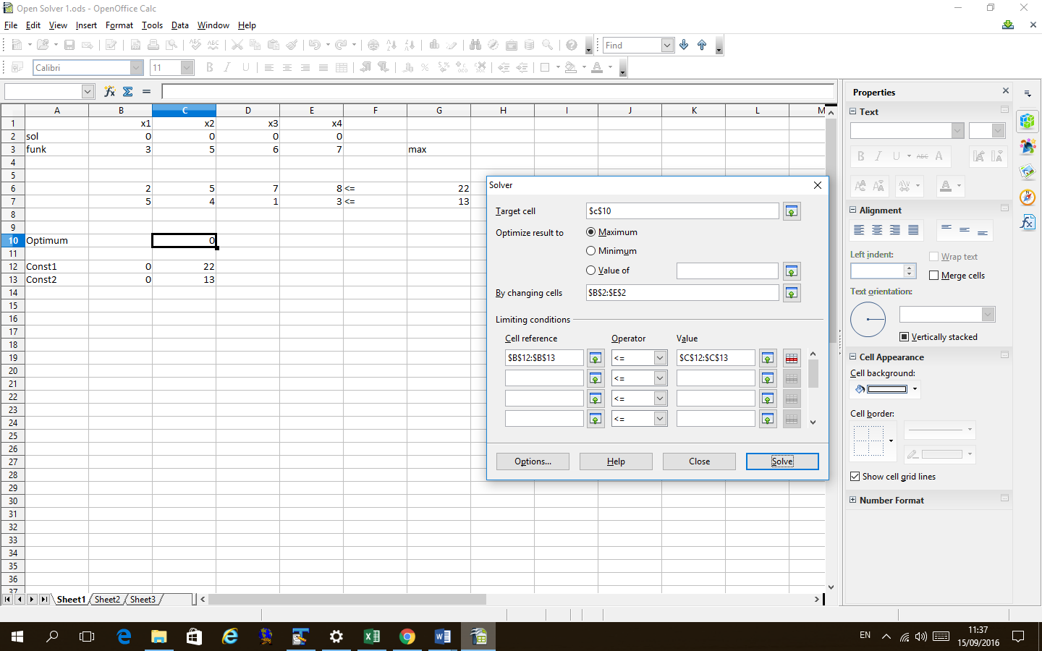

After solver

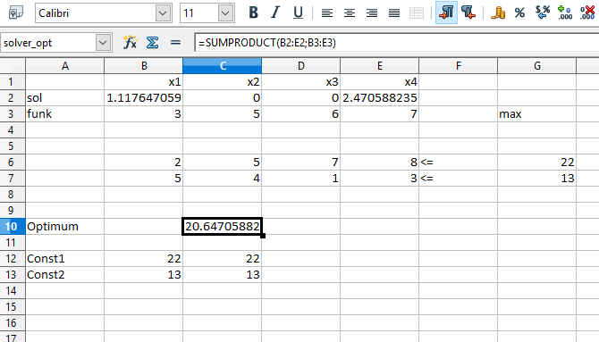
But the real solution is X1 = 0 X2 = 3 X3 =1 X4 =0 with maximum function value 22

