Issue 127031 - Index in formula in text gets trimmed when on last line of fixed line spacing text
Comments:
Attempt to recreate issue 127031 yielded the same results as previously reported using the attached steps. In my attachment, I have also included failed scenarios not originally reported for Paragraph spacing options “1.5 lines”, “Double”, “At Least” and “Leading”. Since Math Baseline Alignment cannot be used as a workaround due to manual formatting to reach desired position as previously mentioned, this was not replicated.
Scenario 1 – Fixed line spacing in Writer (w/ Math Baseline Alignment)
- In OpenOffice, click File > New > Text Document.
  - Expected Result: Text Document Opens.
- Go to Tools>Options>Writer>Formatting aids.
  - Expected Result: Math Baseline Alignment box is checked.
- Go to Format>Paragraph, click dropdown for Fixed Line Spacing.
  - Expected Result: Paragraph line spacing changes to Fixed.
- Enter text and insert formula that includes secondary index on the last line.
  - Expected Result: Secondary Index in formula is not trimmed.
Results: Failed
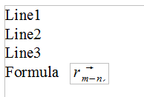
Scenario 2 – Single line spacing in Writer (w/ Math Baseline Alignment)
- In OpenOffice, click File > New > Text Document.
  - Expected Result: Text Document Opens.
- Go to Tools>Options>Writer>Formatting aids.
  - Expected Result: Math Baseline Alignment box is checked.
- Go to Format>Paragraph, click dropdown for Single Line Spacing.
  - Expected Result: Paragraph line spacing changes to Single.
- Enter text and insert formula that includes secondary index on the last line.
  - Expected Result: Secondary Index in formula is not trimmed.
Results: Passed
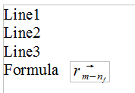
Scenario 3 – Proportional spacing in Writer (w/ Math Baseline Alignment)
- In OpenOffice, click File > New > Text Document.
  - Expected Result: Text Document Opens.
- Go to Tools>Options>Writer>Formatting aids.
  - Expected Result: Math Baseline Alignment box is checked.
- Go to Format>Paragraph, click dropdown for Proportional Line Spacing.
  - Expected Result: Paragraph line spacing changes to Proportional.
- Enter text and insert formula that includes secondary index on the last line.
  - Expected Result: Secondary Index in formula is not trimmed.
Results: Passed
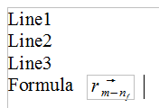
Scenario 4 – 1.5-lines spacing in Writer (w/ Math Baseline Alignment)
- In OpenOffice, click File > New > Text Document.
  - Expected Result: Text Document Opens.
- Go to Tools>Options>Writer>Formatting aids.
  - Expected Result: Math Baseline Alignment box is checked.
- Go to Format>Paragraph, click dropdown for 1.5-lines Spacing.
  - Expected Result: Paragraph line spacing changes to 1.5-lines.
- Enter text and insert formula that includes secondary index on the last line.
  - Expected Result: Secondary Index in formula is not trimmed.
Results: Failed
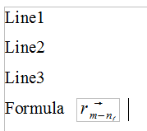
Scenario 5 – Double line spacing in Writer (w/ Math Baseline Alignment)
- In OpenOffice, click File > New > Text Document.
  - Expected Result: Text Document Opens.
- Go to Tools>Options>Writer>Formatting aids.
  - Expected Result: Math Baseline Alignment box is checked.
- Go to Format>Paragraph, click dropdown for Double Line Spacing.
  - Expected Result: Paragraph line spacing changes to Double.
- Enter text and insert formula that includes secondary index on the last line.
  - Expected Result: Secondary Index in formula is not trimmed.
Results: Failed
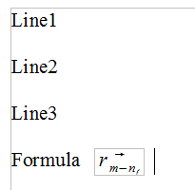
Scenario 6 – At Least line spacing in Writer (w/ Math Baseline Alignment)
- In OpenOffice, click File > New > Text Document.
  - Expected Result: Text Document Opens.
- Go to Tools>Options>Writer>Formatting aids.
  - Expected Result: Math Baseline Alignment box is checked.
- Go to Format>Paragraph, click dropdown for At Least Line Spacing.
  - Expected Result: Paragraph line spacing changes to At Least.
- Enter text and insert formula that includes secondary index on the last line.
  - Expected Result: Secondary Index in formula is not trimmed.
Results: Passed
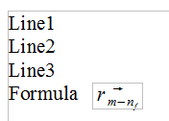
Scenario 7 – Leading line spacing in Writer (w/ Math Baseline Alignment)
- In OpenOffice, click File > New > Text Document.
  - Expected Result: Text Document Opens.
- Go to Tools>Options>Writer>Formatting aids.
  - Expected Result: Math Baseline Alignment box is checked.
- Go to Format>Paragraph, click dropdown for Leading Line Spacing.
  - Expected Result: Paragraph line spacing changes to Leading.
- Enter text and insert formula that includes secondary index on the last line.
  - Expected Result: Secondary Index in formula is not trimmed.
Results: Passed

