at a slower pace
Chew Magna Baptist Mon 1:00
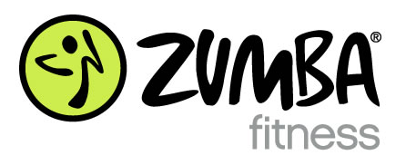
---------------------------------------------------------------------------------------------------------------------------------------------------------------------------------------------------------------------
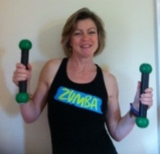
Chew Magna Church Hall
Mondays 6.30pm
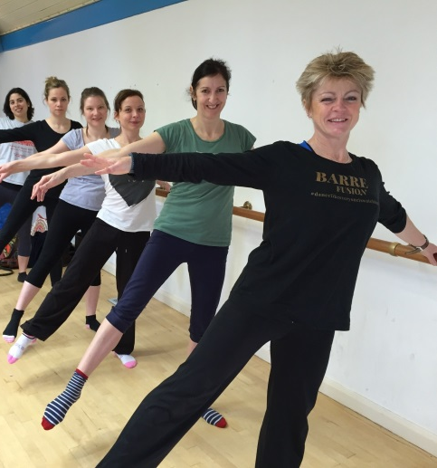
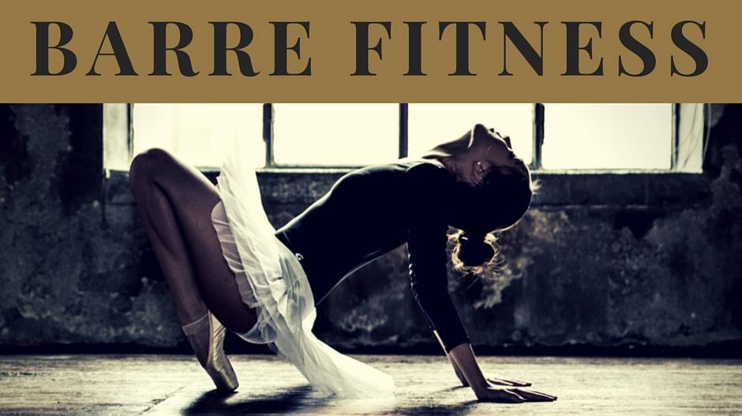

Chew Magna Millenium Hall Thursdays 9.30am
NEW!! Essential to pre-book your place
-----------------------------------------------------------------------------------------------------------------------------------------------------------------------------------------------------------------------------------------------------------------------------------------------------------------------------------------------------------------------------------------------------------------------------------------------------------------------------------------------------------------------------------------------------------------------------------------
Aerobics/Tone – Stay Forever Young!
Thursdays Yeo Valley HQ 7pm
----------------------------------------------------------------------------------------------------------------------------------------------
Lynne Joyner tel: 07748 963297
Email: lynne@thejoyners.co.uk
All Classes at Yeo Valley HQ now open to you!
Book your place on http://lynnejoynerfitness.co.uk

