WORK PARTY PROPOSAL

DOCUMENT NAME | ASH-2014-1 Replace two waymark posts on Greenway Lane
DATE SUBMITTED*
PARISH Name: | Shurdington
Warden(s): | David Gladstone
PROPOSER* Name: | David Gladstone
Email: | davegl@btinternet.com
Tel: | 01242 862564
LOCATION Name*: | See details below
Grid ref*: | SO 920179 / SO 921178
ROW no(s): | ASH/8/3 & ASH/10/2
LANDOWNER Name: | Highways
Address:
Contact details:
Permission given:
JOB DESCRIPTION* | On Greenway Lane in Shurdington at the end of ASH/8/3 map ref SO 920179, the finger post is of the old style and is leaning and the finger is blank due to weathering.  Also on Greenway Lane in Shurdington at the end of ASH/10/2 map ref SO 921178, the finger post also of the old style is almost obscured and the finger is broken. Walkers (or landowner ?) have created their own clear gap about 3 feet from the obscured finger post so it seems pointless to clear around the post. The new post might as well be repositioned at the side of the gap.  Note from DG 10/12/14:  I went last week and had another look at the 2 posts in greenway lane and I think all they need are new fingers and one of the posts made vertical.  The one post could be straightened with the aid of a tamper as I think the ground has subsided or been disturbed by a vehicle. The post feels solid in the ground and doesn't feel as if it's broken off below ground level. The finger on that one has lost any writing or symbols by fading.  The other post is vertical and solid and just needs a new finger which is broken. Somebody has been clearing around this post since I last looked at it and I now think its ok where it is as it is adjacent to the style which previously was all overgrown and unused because there is a gap in the hedge line about a metre away.
ACCESS | On roadside.
TIMING / URGENCY | Any time
ESTIMATE OF EFFORT | 2 wardens, 2 hours
SURVEY Date: | Sep 16 2014
Name(s): | David Gladstone
PROW
Approval req’d (Y/N): | No
Approval given: | No
MATERIALS REQUIRED | 2 x metal waymark posts with FP fingers
TOOLS REQUIRED | Put an “X” in one (or more) of the boxes below and/or record (additional) tools required:  Stile:  Kissing gate:  Bridge:  Walling:  x  Trailer required:  Record any (additional) tools required:  - Crowbar  - Graff  - Tamper  - Shoveholer  - Tool for fixing on FP fingers
ADDITIONAL NOTES
COMPLETION | Put an “X” in the box when job completed:  Date of completion:

Photographs

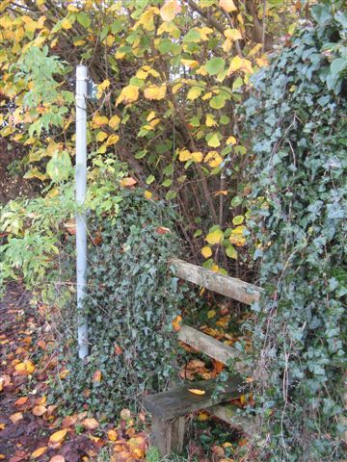 | 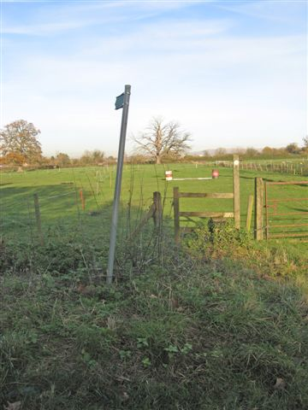
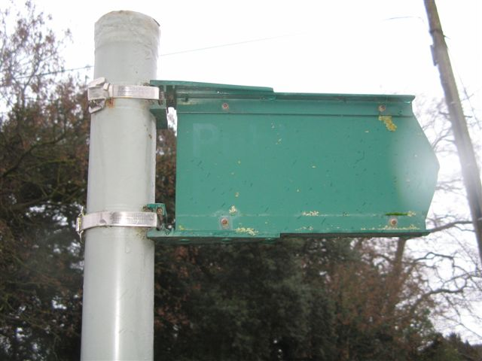 | 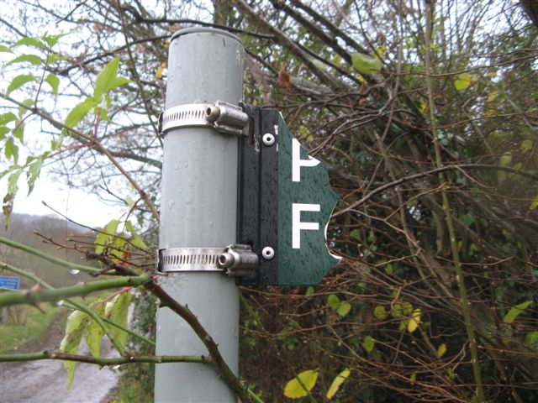

Location Map

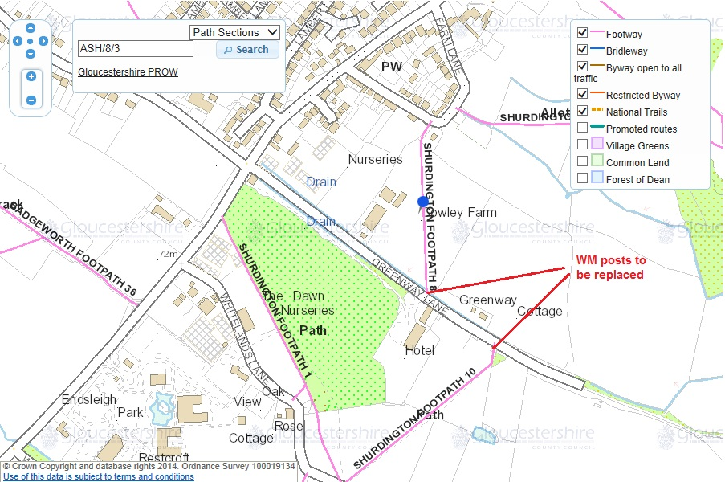

Site Risk Assessment

Weather: N/A

Terrain: N/A

Roads: By side of quiet road.

Equipment / Tools: As above

Livestock: N/A

Other: N/A

Who might be harmed by the hazards?

What precautions could be taken against the hazards? Wear hi-vis jackets. Erect Men at Work signs.

As a minimum, information should be provided for asterisked items when the proposal is first submitted.
There are standard lists of tools for large construction jobs. If appropriate, tick one box to indicate which tool list is appropriate. Also tick the trailer box if a trailer is likely to be required.

