- Open the OpenOffice writer and click on the tab insert as shown in the screenshot.
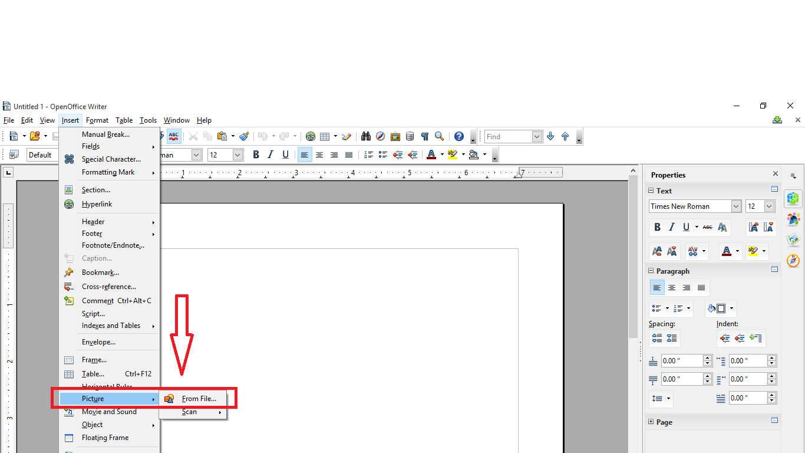
- Then, hover on to the Picture tab and click on the “From File” tab.

- Now select any image from your PC or laptop and click on open in order to insert the picture in the writer.
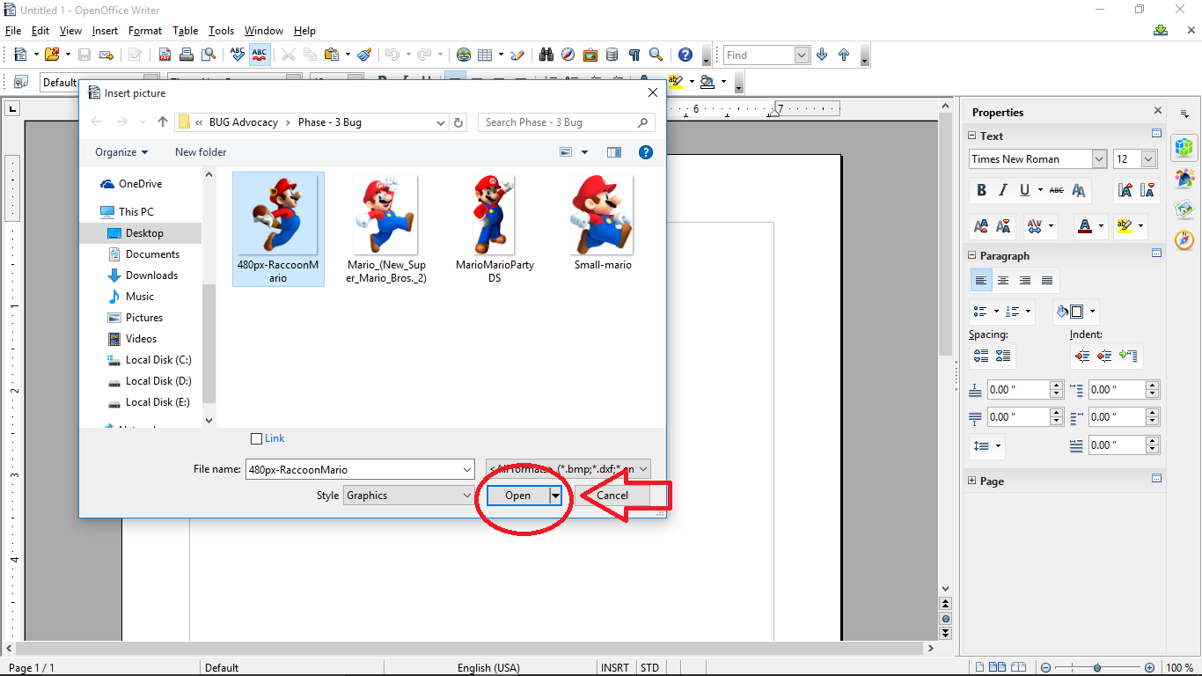

- After inserting the picture this is how your image will look.
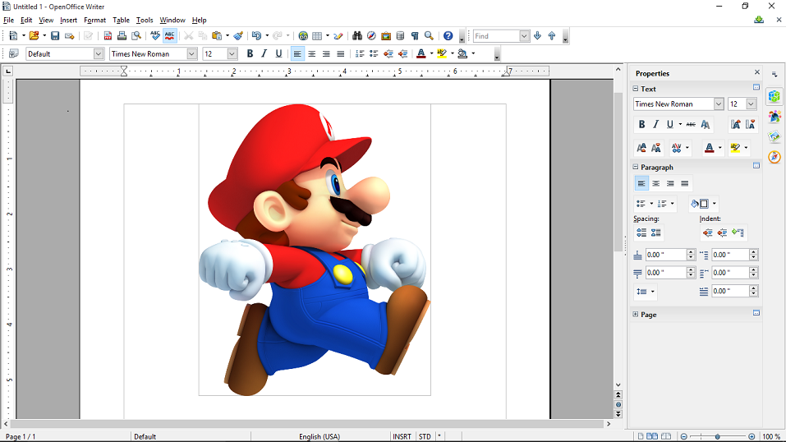

- After the step 4, click on any area on the screen apart from the picture and you will see the cursor will be on the next line. Now repeat the steps from 1 to 3 and you will see that the second image was overlapped.
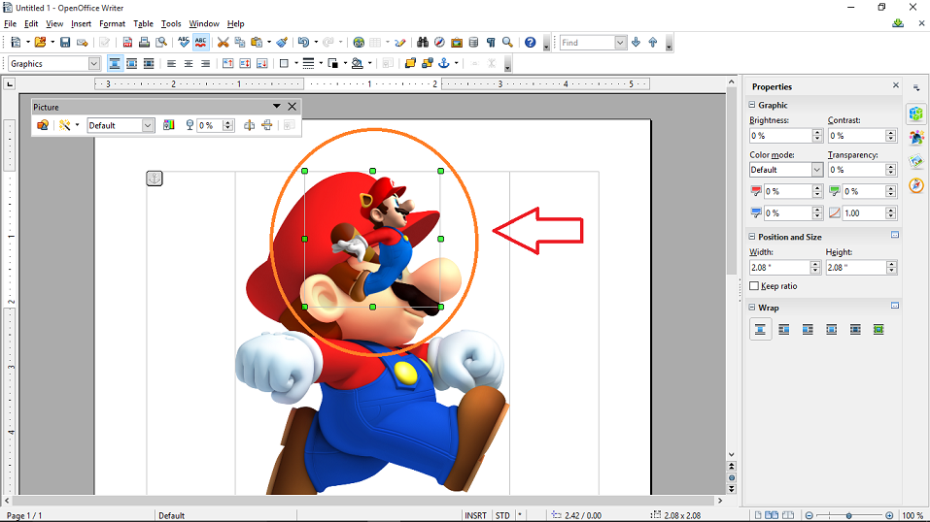
The orange colored circular part shows the overlapped image.
As a result, the bug was replicable. And the writer was not able to perform the expected function.

The following screenshot shows a follow up test which I performed:
After inserting the first image, if I hit “Enter” key a couple of times and try to insert the second image, it doesn’t gets overlapped.
