Lower byte of the following Chinese characters is 0x0d, and will be translated into new paragraph because it is the only character in the run.

Expected result:
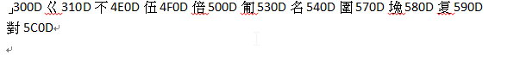
」300Dㄍ310D不4E0D伍4F0D倍500D匍530D名540D圍570D堍580D复590D對5C0D

