\\ncsmbp01\Home\My Documents\QA - QAA Testing Responsibilities - Auto Rate Revisions.doc

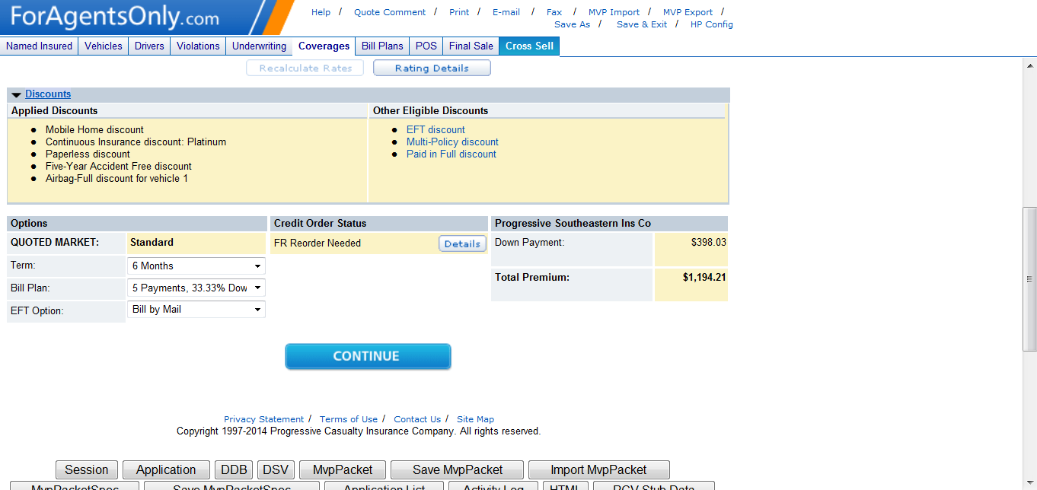

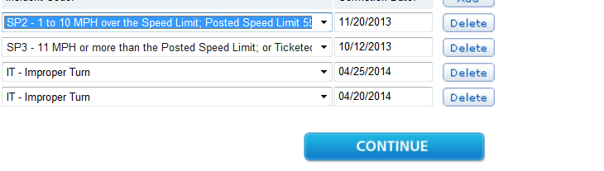

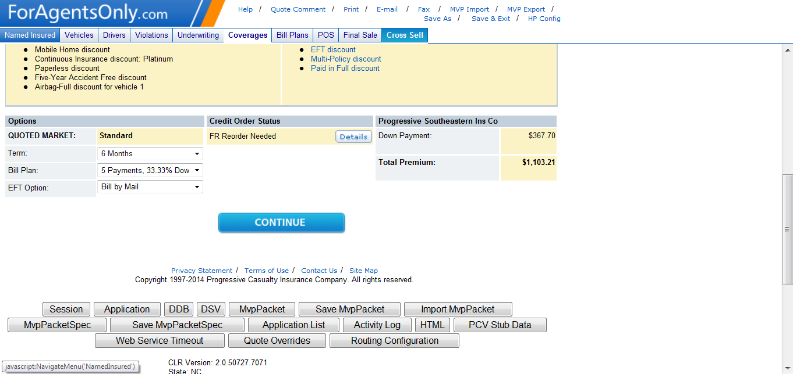

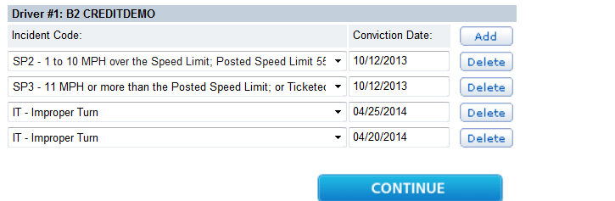

Figure 1

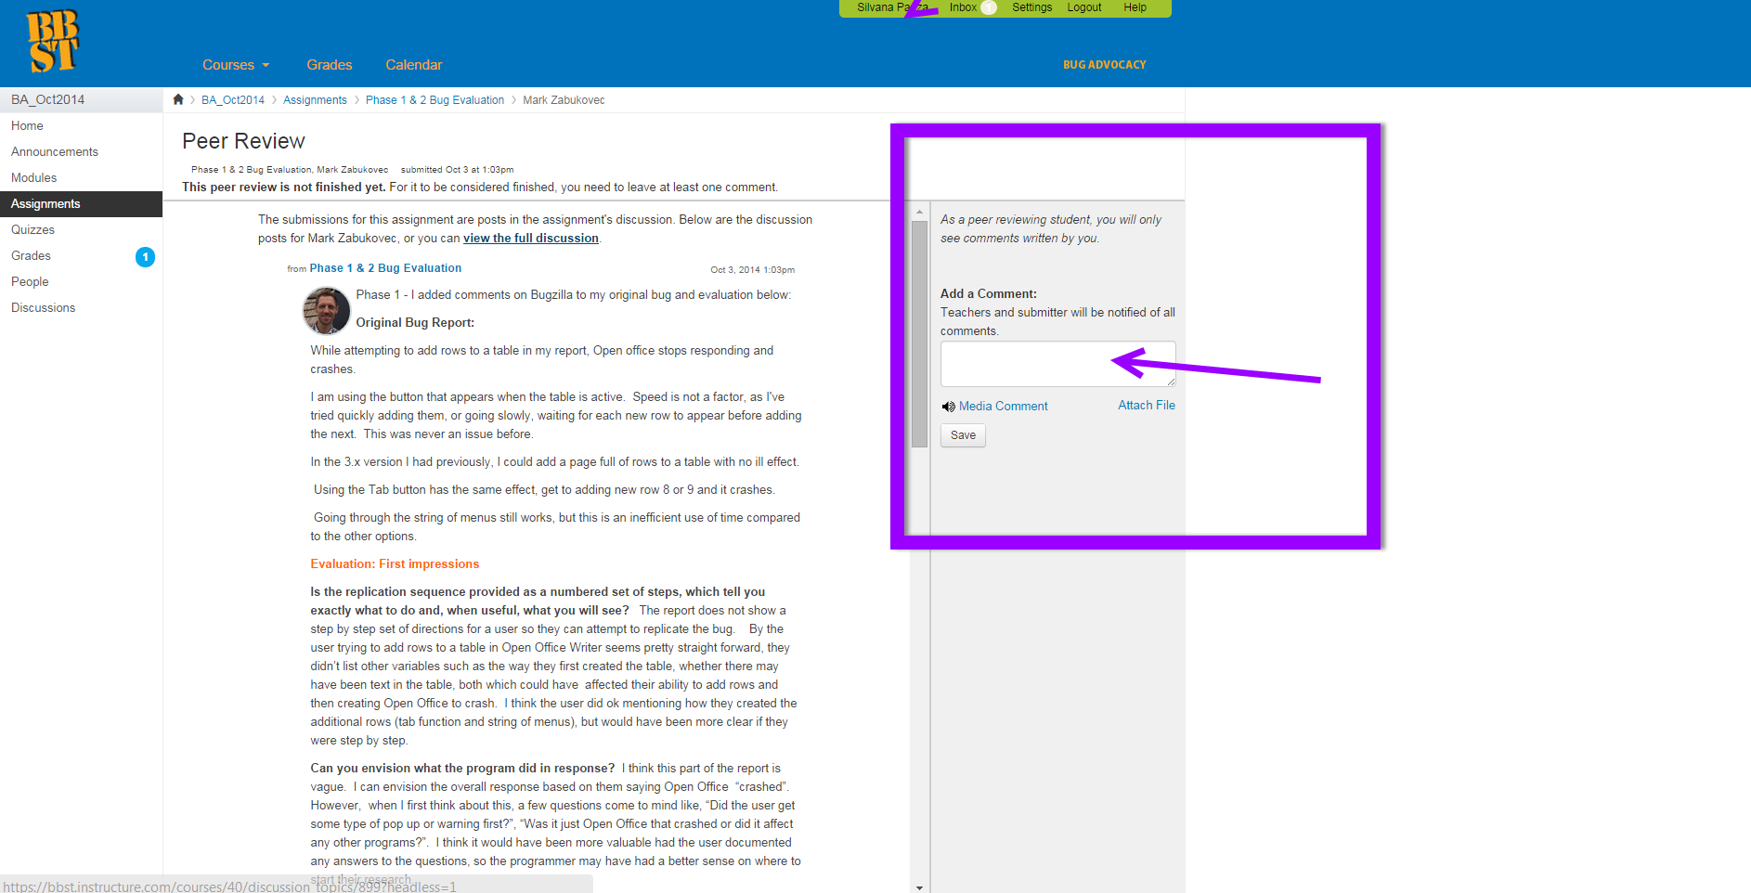

Cynthia D Badalamenti
[Type your address] [Type your phone number] [Type your e-mail address]
OBJECTIVE
[Type your objectives]

EDUCATION
[Type the school name] [Type the completion date]
- [Type list of degrees, awards, and accomplishments]

EXPERIENCE
[Type the job title] [Type the start date] – [Type the end date]
- [Type list of job responsibilities]

SKILLS
- [Type list of skills]

