REPLICATION OF .RTF

Before ‘save as’

- Table Format - Width>Relative not available to select.

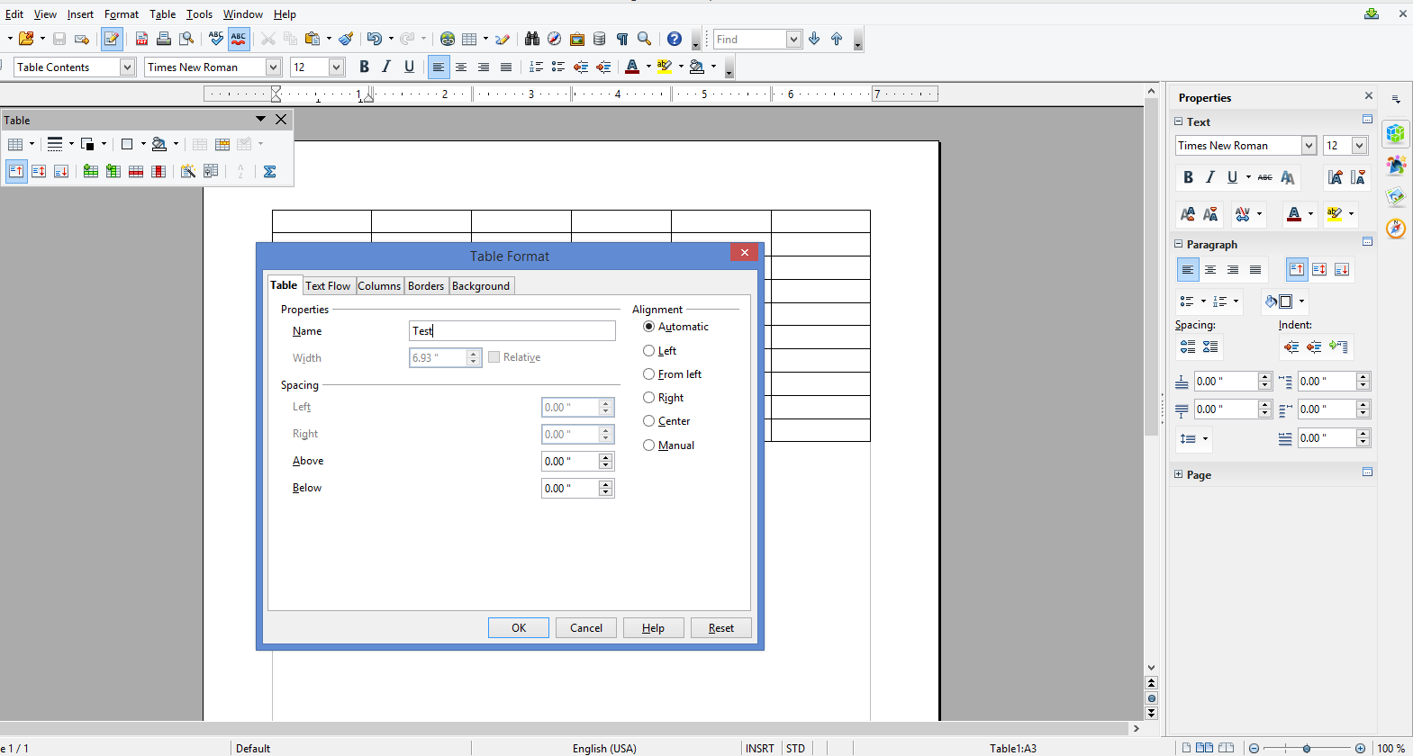
- Text flow >Repeat Heading option is selected
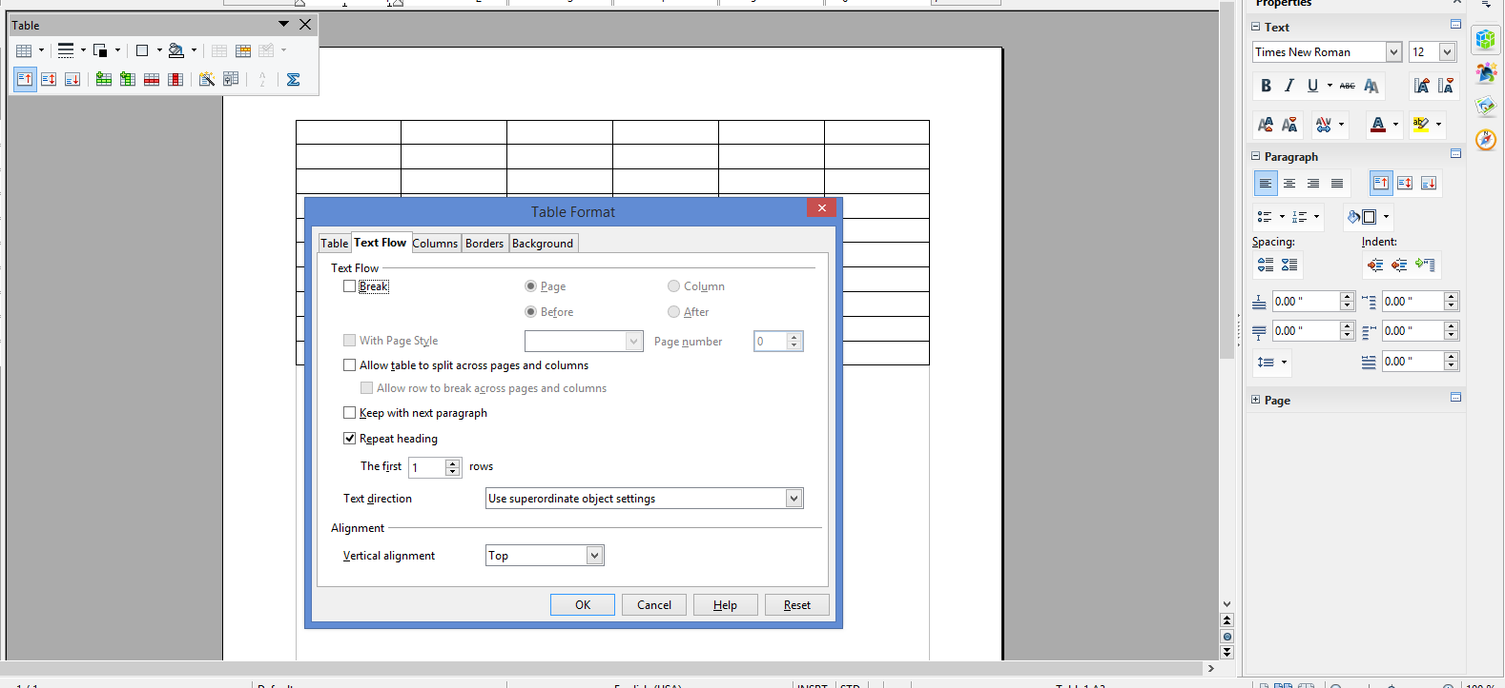
Results After Reopen
- Width>Relative available to select.
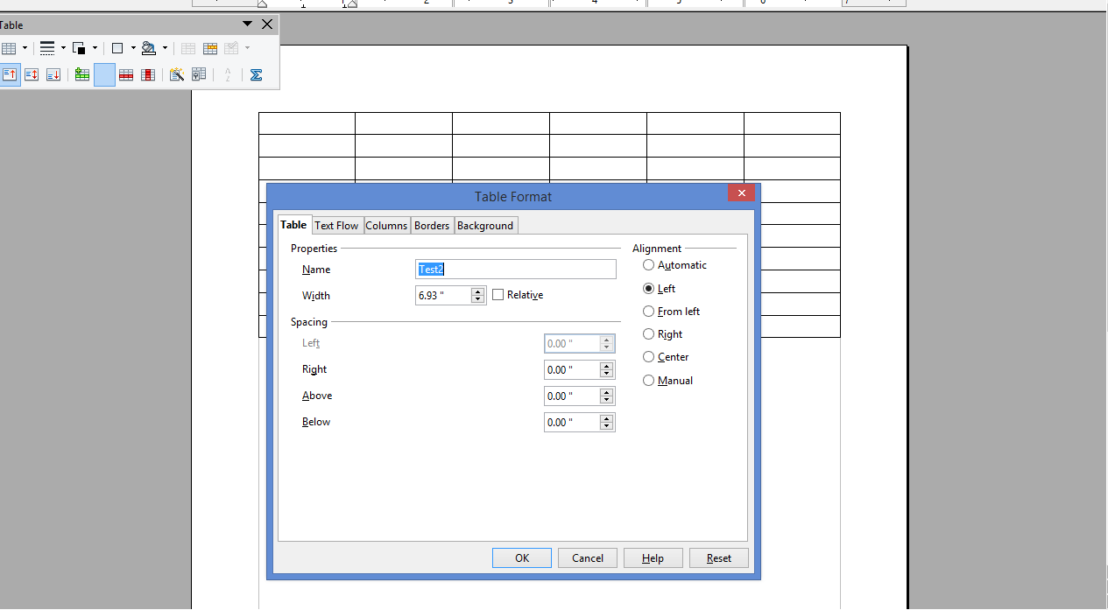
- Break, W/Pg Style, Allow table to split options retained. ‘Repeat Heading’ not retained. (Break, W/Pg Style options weren’t available …see screenshot #2 above )