**REPLICATION OF .ODT**

**.ODT BEFORE SAVE**

1. **Table> Width –Relative not available to select.**

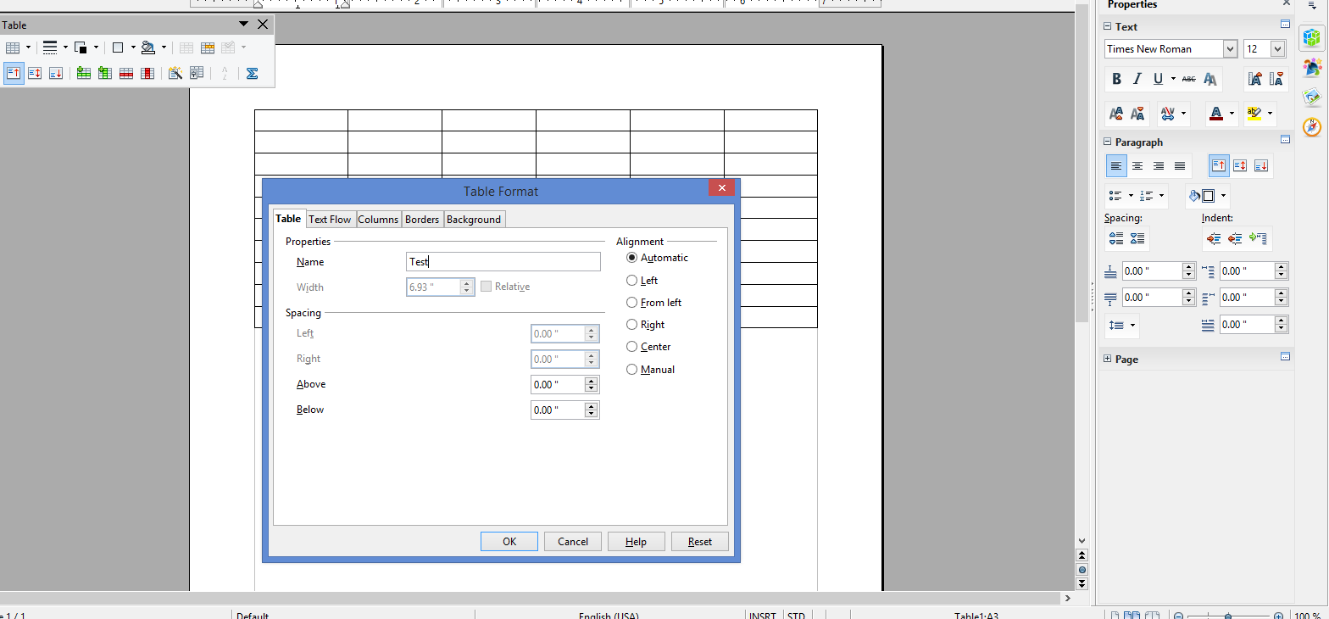

**2.Text Flow - Allow table to split options are selected. Repeat Heading not selected**.

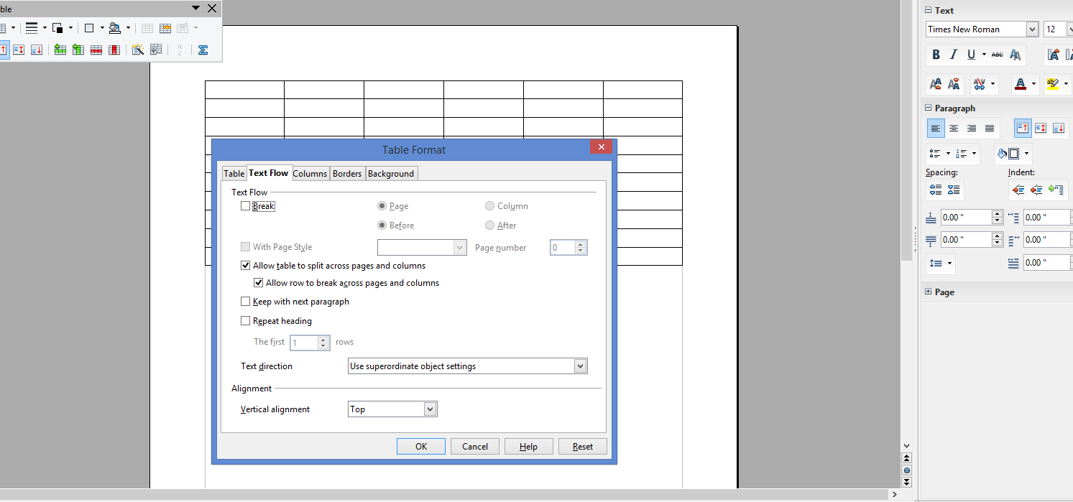

1. **‘Repeat Heading’ option is selected**

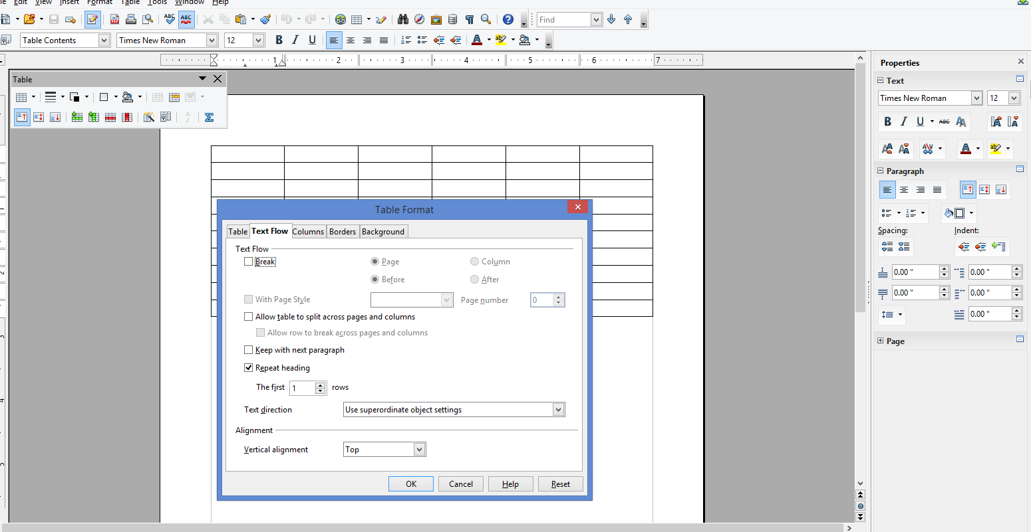

**RESULTS OF .ODT AFTER SAVED, AND REOPENED.**

1. **Table> width / relative options are still not available**

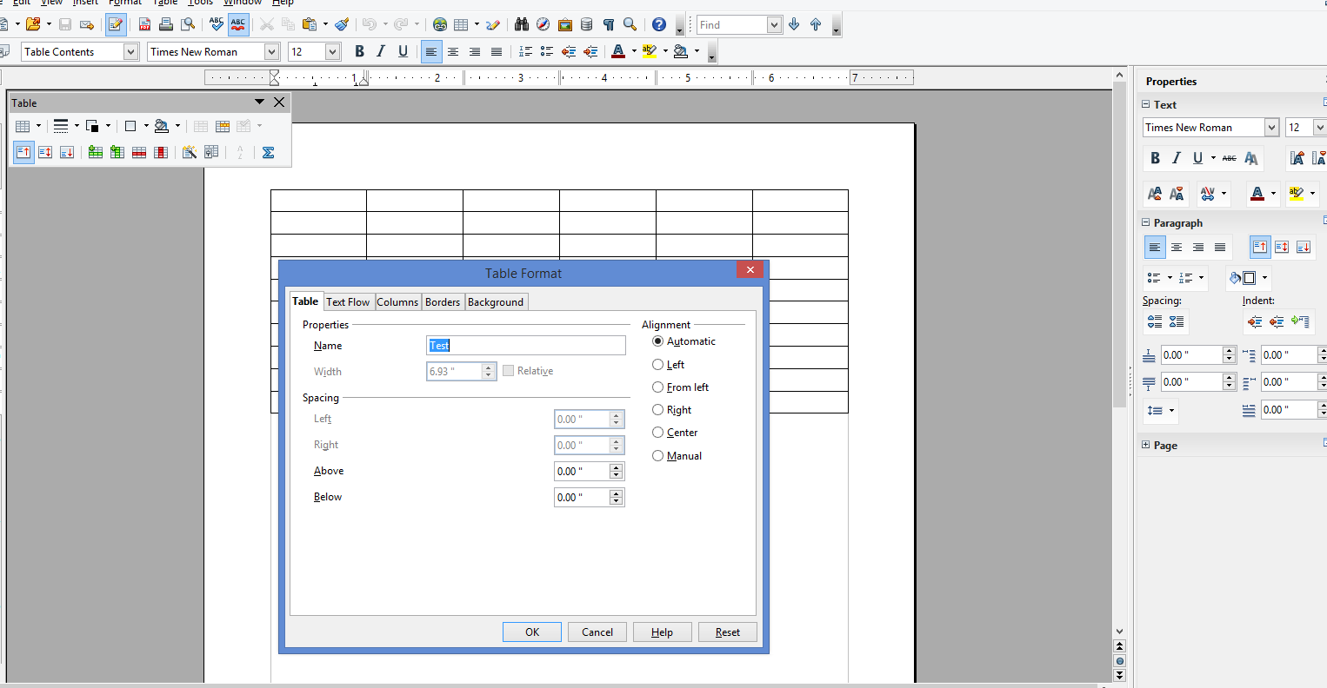

1. **‘Repeat Heading’ option is still selected**

