Test Execution results for Test Case:
Test Case ID AOOTest-355 :: Version : 1
Data-)Subtotals_Delete Subtotals on different subtotal ranges in one sheet.
Assigned to : majella
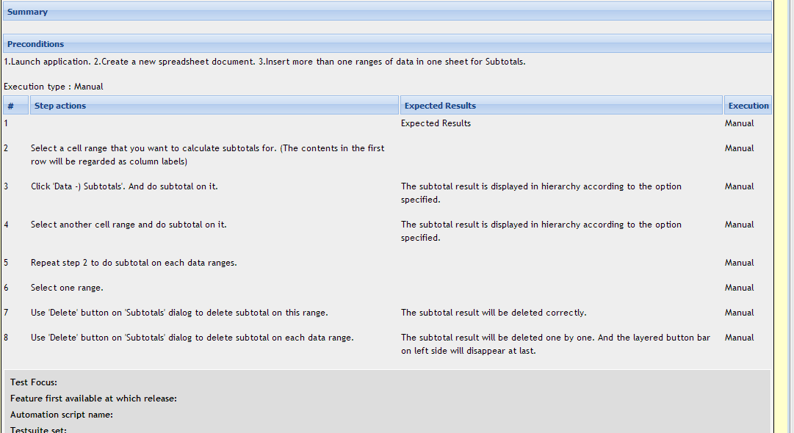
Step 1 thru step 4 – Work fine – PASSED
Issue is explained from Step 5:

Step 5:
Select 1st data range and click on Data Subtotals Select all Data titles under “Calculate subtotals for” click OK
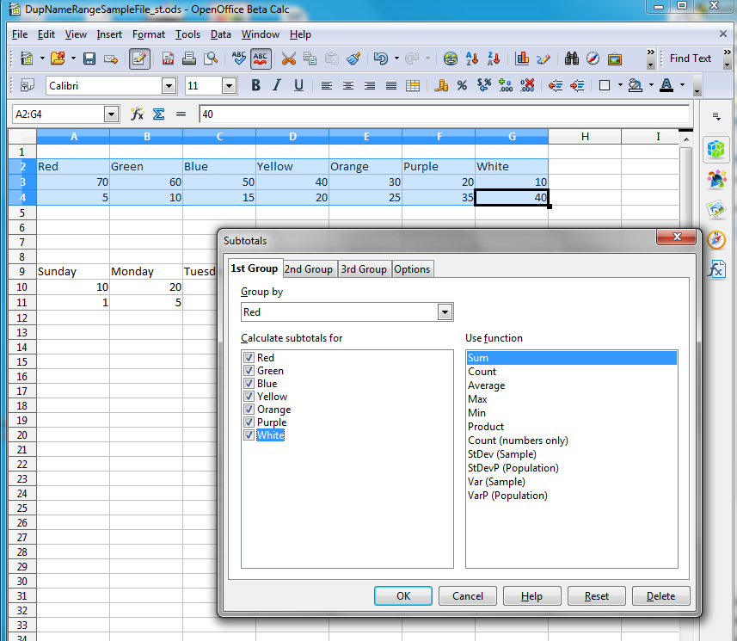

Subtotals and Grand totals appear for 1st data range with ‘Layered Button Bar’ on the left side
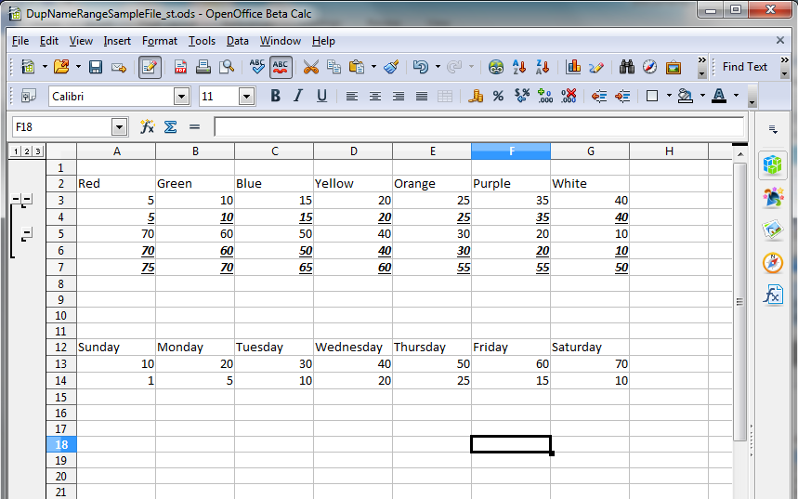
Similarly do subtotal for 2nd data range
Note that ‘Layered Button Bar’ is removed for 1st data range
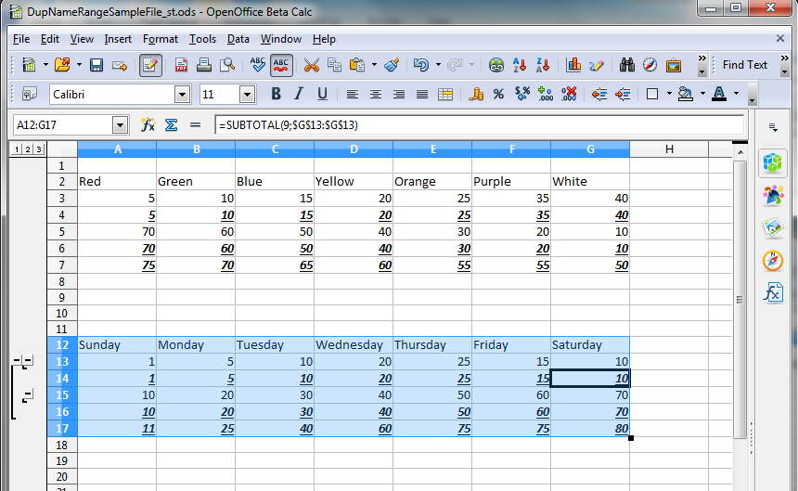
Step 6 and 7
Delete subtotal for 1st data range
Select data range Click Data (from main menu) subtotals Delete
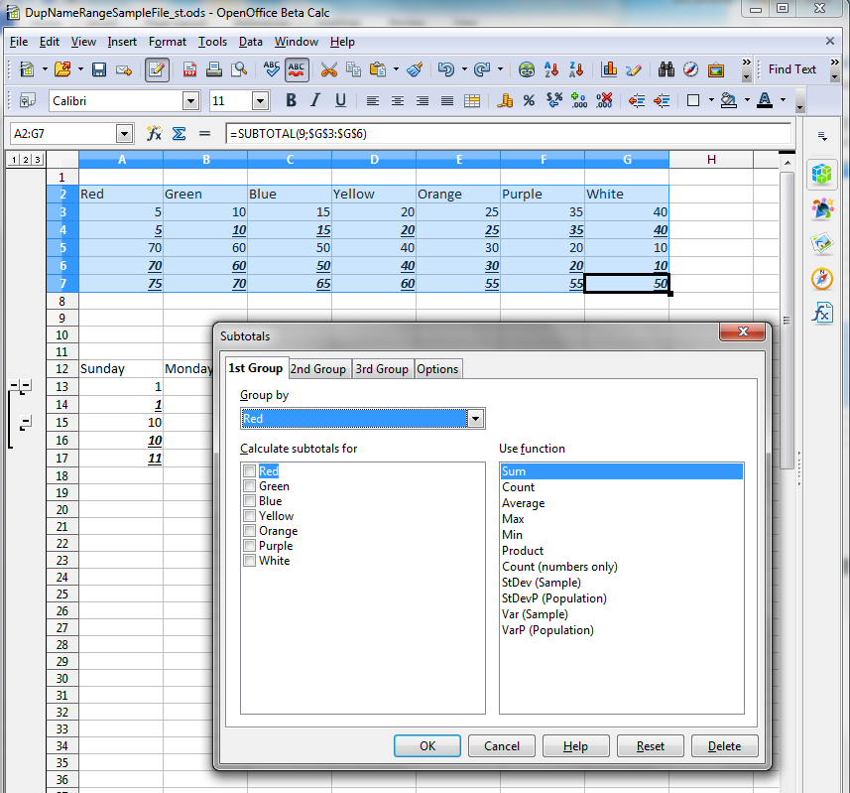

subtotals are deleted for 1st data range as per step 7 – result is PASSED
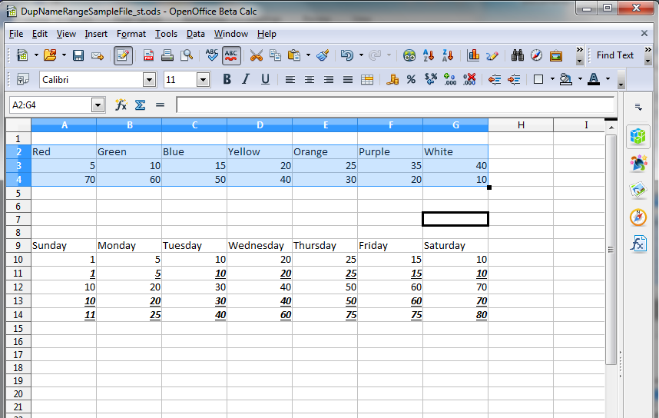

Step 8
Delete subtotals for 2nd data range
Select 2nd data range Click Data (from main menu) subtotals Delete
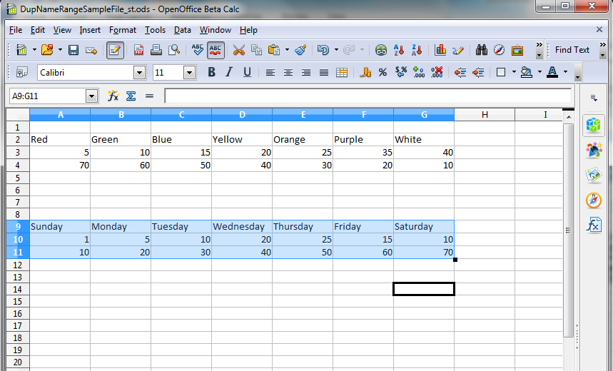
8 | Use 'Delete' button on 'Subtotals' dialog to delete subtotal on each data range. | The subtotal result will be deleted one by one. And the layered button bar on left side will disappear at last. | Manual

As per Test case step 8, the subtotal result is deleted one by one – correct and PASSED
Expected result - “And the Layered button bar on left side will disappear at last”
Actual result – Layered button bar is removed when sub-total is deleted for the 1st data range in step 7 itself. It did not “disappear at last” as mentioned above. See screenshot in step 7. – part of step 8 FAILED

