Bug 46729 -easy access to showing/hiding text sections
PreConditions:
- OpenOffice Writer is Open
- Navigator is displayed
- Document with Text is displayed and ready to use
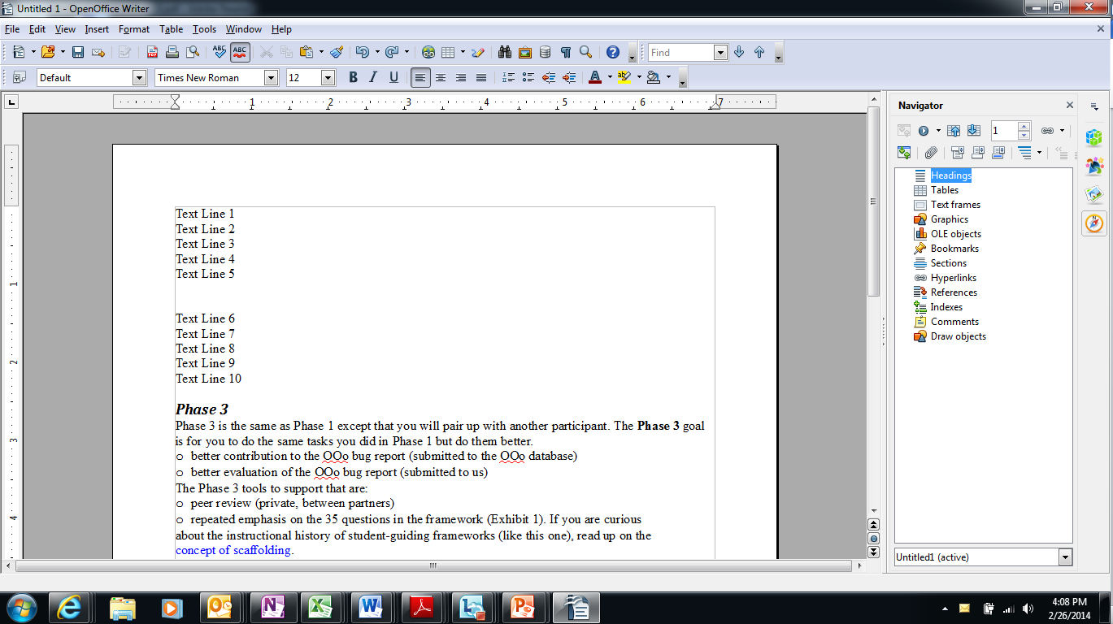
Select text
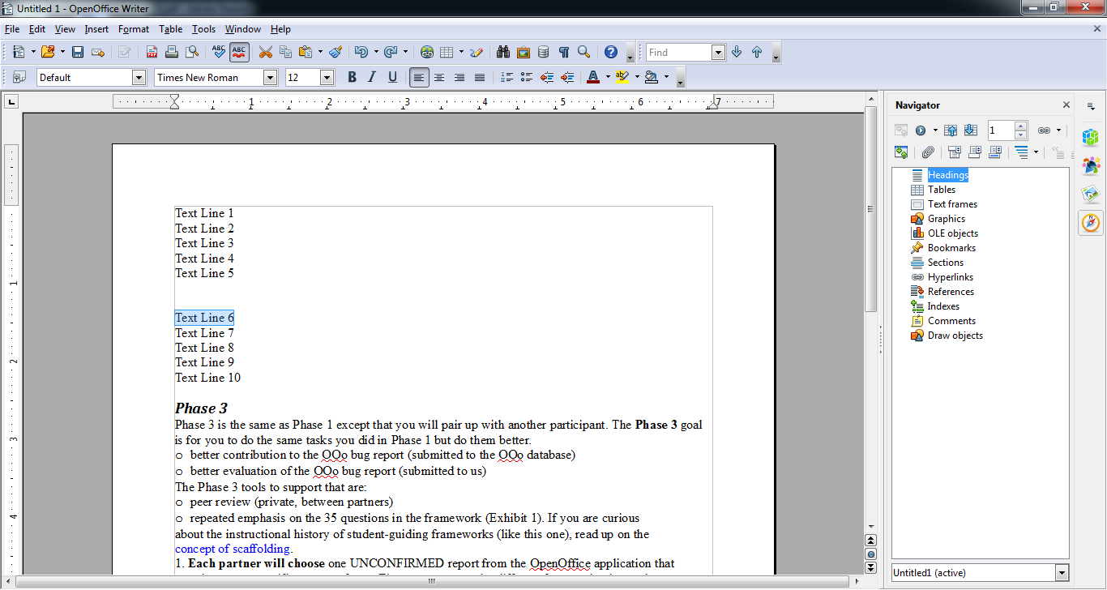
Select <Insert> from ToolBar
Select <Section>from Drop Down Menu
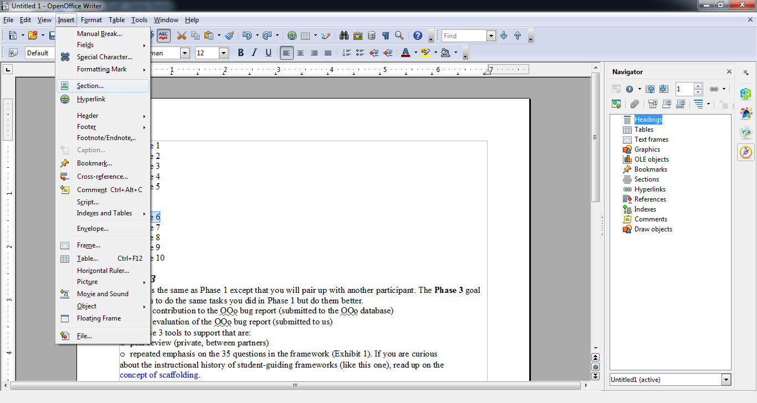

<Insert Section> dialogue box appears
Select <Hide> Checkbox
Click <Insert> Button
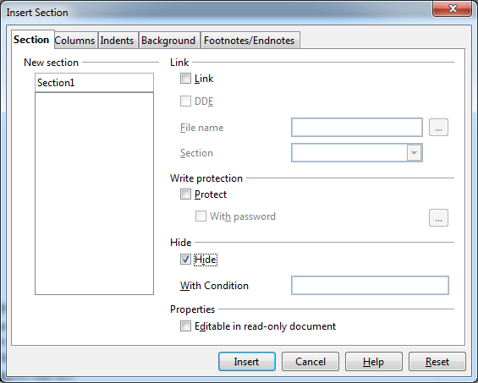
Selected Text is no longer visible on document.
