These screenshots are for the test case using Windows 7 Home Premium with AOO 4.0.1.
Start a test document.
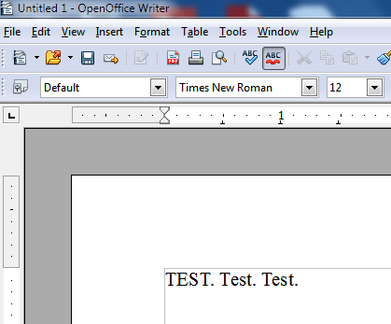
Go to File>Print or CTRL+P. Then click the Properties button on the General tab.
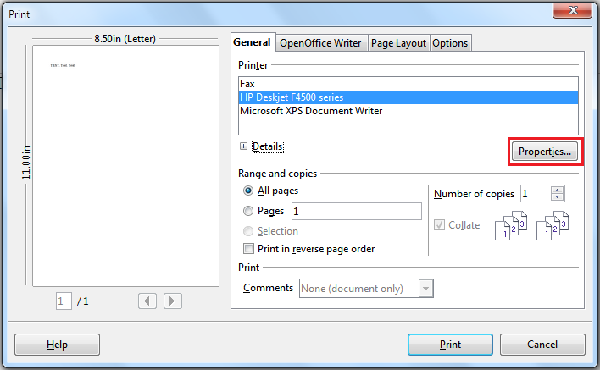
Default printer settings are displayed.
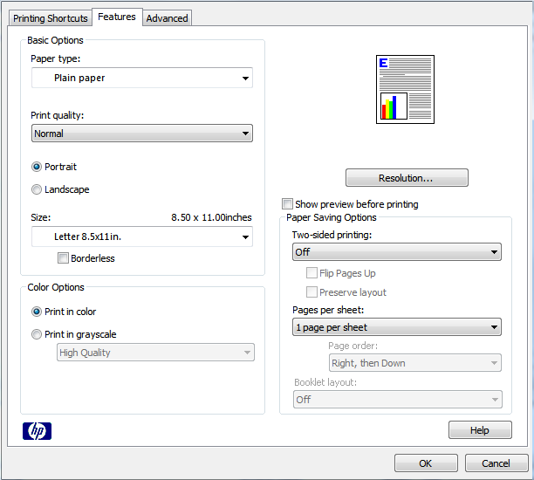

Make the changes highlighted in red, then click ok and print the document. Try printing again and the settings will return to the defaults shown in the image above (Note: Print in Grayscale is the only one that stays selected). The available tabs and settings will vary depending on the type of printer being used.
