- Start -> Programs -> Open Office 3.3.org -> Open Office.org Writer
- File Open -> Sample.odt
- Menu ‘Edit -> Find & Replace’ -> search for “WANT” -> Options = “Match case” and “Whole words only” displays with check boxes to left and below line displays “More Options” -> Select [Find]
- [OK] “Search key not found” or [Yes] for “….do you want to continue at the beginning?”
- Close dialog with ‘Close-X’ at top right corner of dialog
- Redo same search 3…5
- Redo same search 3…5, but change “Backwards” option (check if unchecked)
- All option still display via Windows 7 machine and Open Office 3.3.org Options -> “Match Case” and “Whole words only” displays with check boxes to left and below line displays “More Options”

Screenshot 1
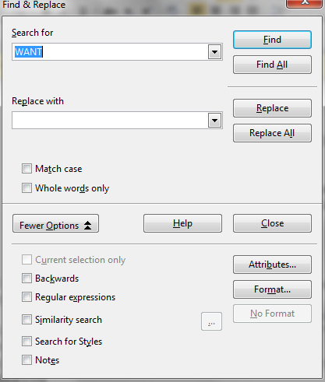
Screenshot 2
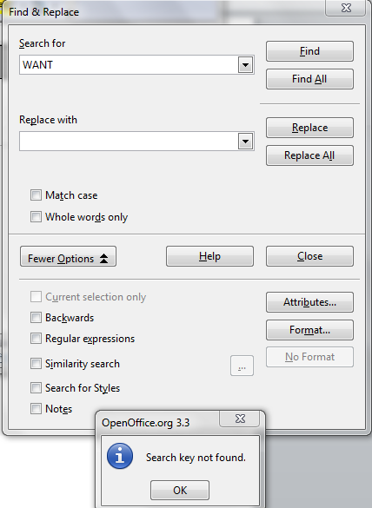

Screenshot 3
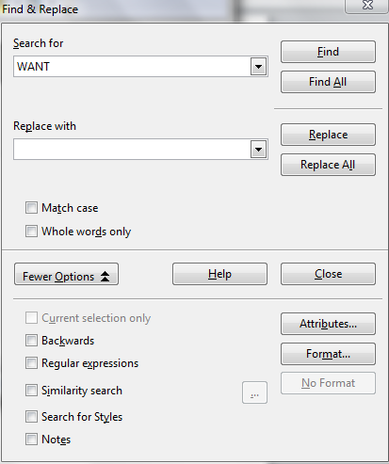

Screenshot 4
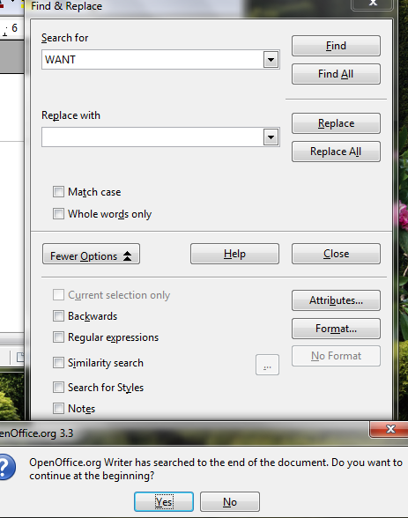
Screenshot 5
