SCREENSHOT OF HELP SEARCH BAR:
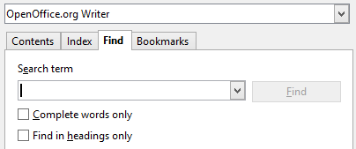
SCREENSHOT OF SEARCGBAR WHEN IT GOES BLANK:
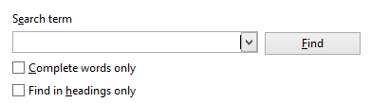
SCREENSHOT OF SEARCBAR AFTER I CLICK ENTER:

