Customize style – New created 3
Test Object | Customize style
Test Point:
Other Info: | Header Row: checked  Total Row: checked  Banded Rows: checked | First Column: checked  Last Column: unchecked  Banded Columns: checked

Example Table:
The Greek alphabet
Letter name | Uppercase | Lowercase | Letter name | Uppercase | Lowercase
Alpha | $$Α$$ | $$α$$ | Nu | $$Ν$$ | $$ν$$
Beta | $$Β$$ | $$β$$ | Xi | $$Ξ$$ | $$ξ$$
Gamma | $$Γ$$ | $$γ$$ | Omicron | $$Ο$$ | $$ο$$
Delta | $$Δ$$ | $$δ$$ | Pi | $$Π$$ | $$π$$
Epsilon | $$Ε$$ | $$ε$$ | Rho | $$Ρ$$ | $$ρ$$
Zeta | $$Ζ$$ | $$ζ$$ | Sigma | $$Σ$$ | $$σ$$
Eta | $$Η$$ | $$η$$ | Tau | $$Τ$$ | $$τ$$
Theta | $$Θ$$ | $$θ$$ | Upsilon | $$Υ$$ | $$υ$$
Iota | $$Ι$$ | $$ι$$ | Phi | $$Φ$$ | $$φ$$
Kappa | $$Κ$$ | $$κ$$ | Chi | $$Χ$$ | $$χ$$
Lambda | $$Λ$$ | $$λ$$ | Psi | $$Ψ$$ | $$ψ$$
Mu | $$Μ$$ | $$μ$$ | Omega | $$Ω$$ | $$ω$$

End

Screenshot in MS Word 2010:
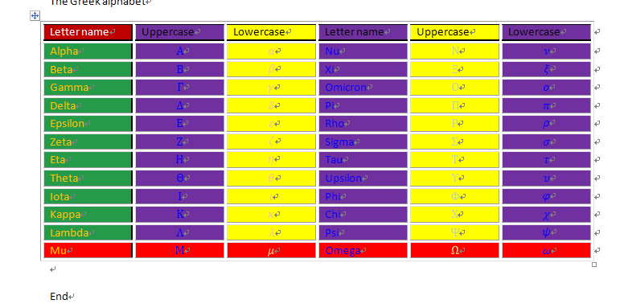

Customize style – New created 4
Test Object | Customize style
Test Point: | Customize style, after style applied , modified font and cell background
Other Info: | Header Row: unchecked  Total Row: checked  Banded Rows: unchecked | First Column: checked  Last Column: unchecked  Banded Columns: checked

Example Table:
Test | A | B | C | D | E | F
123 | 456 | test | G |  | test | 12
aa |  |  | 1 | H |  | 200
bb | fdsa |  | 22 | I
abc | 123 | x | aa | H | xyz | up

End

Screenshot in MS Word 2010:
