Contents
1 BuiltIn-Table Styles-Light Shadow 2
2 BuiltIn-Table Styles-Light Shadow – Accent 1 4
3 BuiltIn-Table Styles-Light Shadow – Accent 2 6
4 BuiltIn-Table Styles-Light Shadow – Accent 3 8
5 BuiltIn-Table Styles-Light Shadow – Accent 4 10
6 BuiltIn-Table Styles-Light Shadow – Accent 5 12
7 BuiltIn-Table Styles-Light Shadow – Accent 6 14
8 BuiltIn-Table Styles-Light List 16
9 BuiltIn-Table Styles-Light List – Accent 1 18
10 BuiltIn-Table Styles-Light List – Accent 2 20
11 BuiltIn-Table Styles-Light List – Accent 3 22
12 BuiltIn-Table Styles-Light List – Accent 4 24
13 BuiltIn-Table Styles-Light List – Accent 5 26
14 BuiltIn-Table Styles-Light List – Accent 6 28

BuiltIn-Table Styles-Light Shadow
Test Object | Built-in Table Styles
Test Point: | Light Shadow
Other Info: | Header Row: checked  Total Row: unchecked  Banded Rows: checked | First Column: checked  Last Column: unchecked  Banded Columns: checked

Example Table:
December
M | T | W | T | F | S | S
 |  |  |  |  |  | 1
2 | 3 | 4 | 5 | 6 | 7 | 8
9 | 10 | 11 | 12 | 13 | 14 | 15
16 | 17 | 18 | 19 | 20 | 21 | 22
23 | 24 | 25 | 26 | 27 | 28 | 29
30 | 31

End

Screenshot in MS Word 2010:
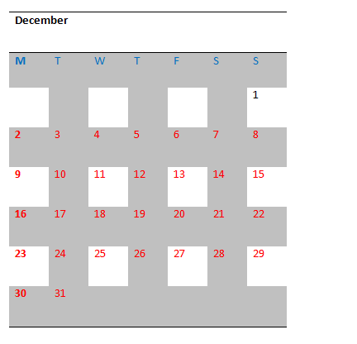

BuiltIn-Table Styles-Light Shadow – Accent 1
Test Object | Built-in Table Styles
Test Point: | Light Shadow – Accent 1
Other Info: | Header Row: checked  Total Row: unchecked  Banded Rows: checked | First Column: checked  Last Column: unchecked  Banded Columns: unchecked

Example Table:
May
M | T | W | T | F | S | S
 | 1 | 2 | 3 | 4 | 5 | 6
7 | 8 | 9 | 10 | 11 | 12 | 13
14 | 15 | 16 | 17 | 18 | 19 | 20
21 | 22 | 23 | 24 | 25 | 26 | 27
28 | 29 | 30 | 31

End

Screenshot in MS Word 2010:
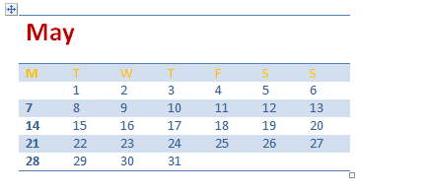

BuiltIn-Table Styles-Light Shadow – Accent 2
Test Object | Built-in Table Styles
Test Point: | Light Shadow – Accent 2
Other Info: | Header Row: checked  Total Row: unchecked  Banded Rows: checked | First Column: checked  Last Column: checked  Banded Columns: unchecked

Example Table:
December
Sun |  | Mon |  | Tue |  | Wed |  | Thu |  | Fri |  | Sat
 |  |  |  |  |  |  |  |  |  |  |  | 1
2 |  | 3 |  | 4 |  | 5 |  | 6 |  | 7 |  | 8
9 |  | 10 |  | 11 |  | 12 |  | 13 |  | 14 |  | 15
16 |  | 17 |  | 18 |  | 19 |  | 20 |  | 21 |  | 22
23 |  | 24 |  | 25 |  | 26 |  | 27 |  | 28 |  | 29
30 |  | 31

End

Screenshot in MS Word 2010:
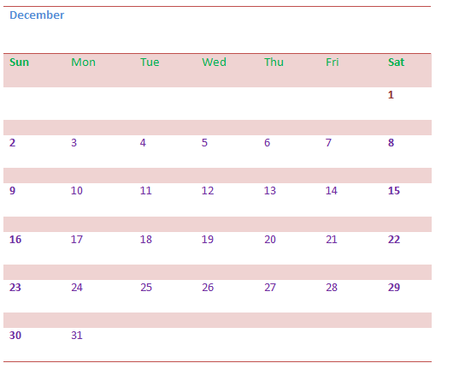

BuiltIn-Table Styles-Light Shadow – Accent 3
Test Object | Built-in Table Styles
Test Point: | Light Shadow – Accent 3
Other Info: | Header Row: checked  Total Row: unchecked  Banded Rows: checked | First Column: checked  Last Column: unchecked  Banded Columns: unchecked

Example Table:
May | Tuesday | Wednesday
 | 1 | 16
 | Wednesday | Thursday
 | 2 | 17
 | Thursday | Friday
 | 3 | 18
 | Friday | Saturday
 | 4 | 19
 | Saturday | Sunday
 | 5 | 20
 | Sunday | Monday
 | 6 | 21
 | Monday | Tuesday
 | 7 | 22
 | Tuesday | Wednesday
 | 8 | 23
 | Wednesday | Thursday
 | 9 | 24
 | Thursday | Friday
 | 10 | 25
 | Friday | Saturday
 | 11 | 26
 | Saturday | Sunday
 | 12 | 27
 | Sunday | Monday
 | 13 | 28
 | Monday | Tuesday
 | 14 | 29
 | Tuesday | Wednesday
 | 15 | 30
 |  | Thursday
 |  | 31

End

Screenshot in MS Word 2010:
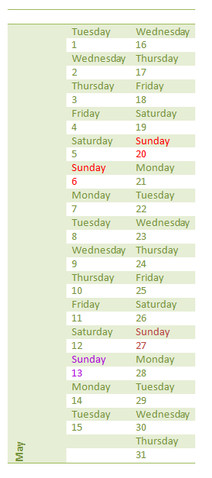

BuiltIn-Table Styles-Light Shadow – Accent 4
Test Object | Built-in Table Styles
Test Point: | Light Shadow – Accent 4
Other Info: | Header Row: checked  Total Row: unchecked  Banded Rows: unchecked | First Column: unchecked  Last Column: unchecked  Banded Columns: unchecked

Example Table:
The Greek alphabet
Letter name | Uppercase | Lowercase | Letter name | Uppercase | Lowercase
Alpha | $$Α$$ | $$α$$ | Nu | $$Ν$$ | $$ν$$
Beta | $$Β$$ | $$β$$ | Xi | $$Ξ$$ | $$ξ$$
Gamma | $$Γ$$ | $$γ$$ | Omicron | $$Ο$$ | $$ο$$
Delta | $$Δ$$ | $$δ$$ | Pi | $$Π$$ | $$π$$
Epsilon | $$Ε$$ | $$ε$$ | Rho | $$Ρ$$ | $$ρ$$
Zeta | $$Ζ$$ | $$ζ$$ | Sigma | $$Σ$$ | $$σ$$
Eta | $$Η$$ | $$η$$ | Tau | $$Τ$$ | $$τ$$
Theta | $$Θ$$ | $$θ$$ | Upsilon | $$Υ$$ | $$υ$$
Iota | $$Ι$$ | $$ι$$ | Phi | $$Φ$$ | $$φ$$
Kappa | $$Κ$$ | $$κ$$ | Chi | $$Χ$$ | $$χ$$
Lambda | $$Λ$$ | $$λ$$ | Psi | $$Ψ$$ | $$ψ$$
Mu | $$Μ$$ | $$μ$$ | Omega | $$Ω$$ | $$ω$$

End

Screenshot in MS Word 2010:
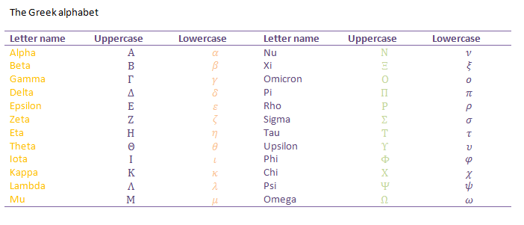

BuiltIn-Table Styles-Light Shadow – Accent 5
Test Object | Built-in Table Styles
Test Point: | Light Shadow – Accent 5
Other Info: | Header Row: checked  Total Row: checked  Banded Rows: checked | First Column: checked  Last Column: unchecked  Banded Columns: unchecked

Example Table:
City or Town | Point A | Point B | Point C | Point D | Point E
Point A | —
Point B | 87 | —
Point C | 64 | 56 | —
Point D | 37 | 32 | 91 | —
Point E | 93 | 35 | 54 | 43 | —

End

Screenshot in MS Word 2010:
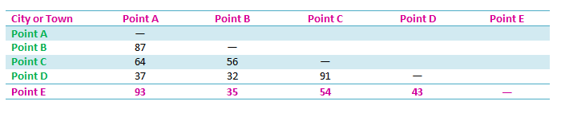

BuiltIn-Table Styles-Light Shadow – Accent 6
Test Object | Built-in Table Styles
Test Point: | Light Shadow – Accent 6
Other Info: | Header Row: checked  Total Row: unchecked  Banded Rows: unchecked | First Column: unchecked  Last Column: unchecked  Banded Columns: unchecked

Example Table:
ITEM | NEEDED
Books | 1
Magazines | 3
Notebooks | 1
Paper pads | 1
Pens | 3
Pencils | 2
Highlighter | 2 colors
Scissors | 1 pair

End

Screenshot in MS Word 2010:

BuiltIn-Table Styles-Light List
Test Object | Built-in Table Styles
Test Point: | Light List
Other Info: | Header Row: checked  Total Row: checked  Banded Rows: unchecked | First Column: unchecked  Last Column: unchecked  Banded Columns: unchecked

Example Table:
Enrollment in local colleges, 2005
College | New students | Graduating students | Change
 | Undergraduate
Cedar University | 110 | 103 | +7
Elm College | 223 | 214 | +9
Maple Academy | 197 | 120 | +77
Pine College | 134 | 121 | +13
Oak Institute | 202 | 210 | -8
 | Graduate
Cedar University | 24 | 20 | +4
Elm College | 43 | 53 | -10
Maple Academy | 3 | 11 | -8
Pine College | 9 | 4 | +5
Oak Institute | 53 | 52 | +1
Total | 998 | 908 | 90
Source: Fictitious data, for illustration purposes only

End

Screenshot in MS Word 2010:
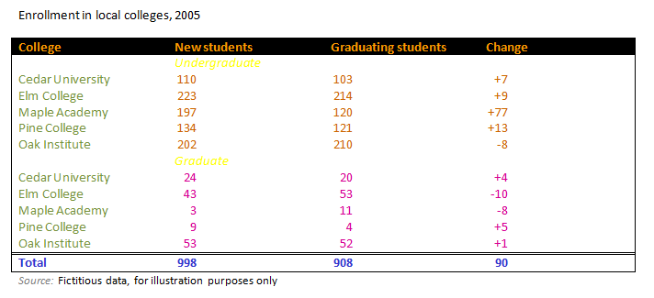

BuiltIn-Table Styles-Light List – Accent 1
Test Object | Built-in Table Styles
Test Point: | Light List – Accent 1
Other Info: | Header Row: checked  Total Row: checked  Banded Rows: checked | First Column: unchecked  Last Column: unchecked  Banded Columns: unchecked

Example Table:
Enrollment in local colleges, 2005
College | New students | Graduating students | Change
 | Undergraduate
Cedar University | 110 | 103 | +7
Elm College | 223 | 214 | +9
Maple Academy | 197 | 120 | +77
Pine College | 134 | 121 | +13
Oak Institute | 202 | 210 | -8
 | Graduate
Cedar University | 24 | 20 | +4
Elm College | 43 | 53 | -10
Maple Academy | 3 | 11 | -8
Pine College | 9 | 4 | +5
Oak Institute | 53 | 52 | +1
Total | 998 | 908 | 90
Source: Fictitious data, for illustration purposes only

End

Screenshot in MS Word 2010:
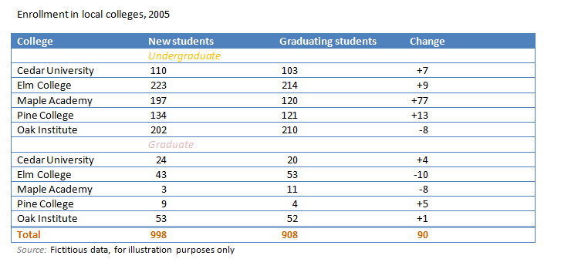

BuiltIn-Table Styles-Light List – Accent 2
Test Object | Built-in Table Styles
Test Point: | Light List – Accent 2
Other Info: | Header Row: checked  Total Row: unchecked  Banded Rows: checked | First Column: checked  Last Column: unchecked  Banded Columns: unchecked

Example Table:
国家 | 产品 | 客户 | 销售人员 | 日期 | 订单号 | 订单金额
USA | 产品一 | 中国移动 | 销售四 | 01年1月1日 | 1 | 9000
CHN | 产品二 | 中国联通 | 销售一 | 06年1月1日 | 2 | 9000
USA | 产品三 | 中国电信 | 销售四 | 01年1月1日 | 3 | 9000
CHN | 产品四 | 中国移动 | 销售二 | 03年1月1日 | 4 | 9000
USA | 产品一 | 中国联通 | 销售一 | 01年1月1日 | 5 | 9000
CHN | 产品一 | 中国电信 | 销售一 | 01年1月1日 | 6 | 9000
CHN | 产品五 | 中国电信 | 销售三 | 05年1月1日 | 7 | 9000
USA | 产品一 | 中国移动 | 销售一 | 04年1月1日 | 1238 | 9000
CHN | 产品四 | 中国联通 | 销售五 | 01年1月1日 | 9 | 9000
USA | 产品一 | 中国电信 | 销售四 | 01年1月1日 | 43 | 9000

End

Screenshot in MS Word 2010:
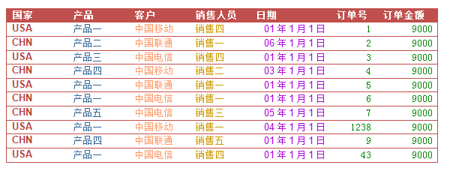

BuiltIn-Table Styles-Light List – Accent 3
Test Object | Built-in Table Styles
Test Point: | Light List – Accent 3
Other Info: | Header Row: checked  Total Row: unchecked  Banded Rows: checked | First Column: checked  Last Column: checked  Banded Columns: checked

Example Table:
Country/Region | Seller | Sale Price 1 | Order ID | Date | Count | Income0
England | Buchanan | 440 | 10248 | 7/16/03 18:11 | 38 | US$16,720.00
England | Suyama | 1863.4 | 10249 | 8/17/03 4:06 | 26 | US$48,448.40
United State | Peacock | 1552.6 | 10250 | 7/18/03 0:24 | 39 | US$60,551.40
United State | Leverling | 654.06 | 10251 | 7/19/03 11:10 | 58 | US$37,935.48
United State | Peacock | 3597.9 | 10252 | 9/20/03 0:10 | 46 | US$165,503.40
United State | Leverling | 356 | 10253 | 7/21/03 0:09 | 88 | US$31,328.00
England | Buchanan | 556.62 | 10254 | 7/28/03 2:08 | 21 | US$11,689.02
England | Dodsworth | 2490.5 | 10255 | 7/23/03 1:05 | 52 | US$129,506.00
United State | Leverling | 517.8 | 10256 | 5/24/03 0:00 | 30 | US$15,534.00
United State | Peacock | 1119.9 | 10257 | 2/25/03 9:07 | 46 | US$51,515.40
United State | Davolio | 1614.88 | 10258 | 6/26/03 5:20 | 5 | US$8,074.40
United State | Peacock | 100.8 | 10259 | 7/27/03 0:00 | 42 | US$4,233.60
United State | Peacock | 1504.65 | 10260 | 7/28/03 0:20 | 54 | US$81,251.10
United State | Peacock | 448 | 10261 | 7/19/03 0:10 | 81 | US$36,288.00
United State | Callahan | 584 | 10262 | 7/5/03 0:15 | 15 | US$8,760.00
England | Dodsworth | 1873.8 | 10263 | 7/31/03 0:00 | 42 | US$78,699.60
England | Suyama | 695.62 | 10264 | 8/1/03 11:00 | 40 | US$27,824.80
United State | Fuller | 1176 | 10265 | 1/2/03 10:07 | 12 | US$14,112.00
United State | Leverling | 346.56 | 10266 | 2/3/03 20:02 | 20 | US$6,931.20

End

Screenshot in MS Word 2010:
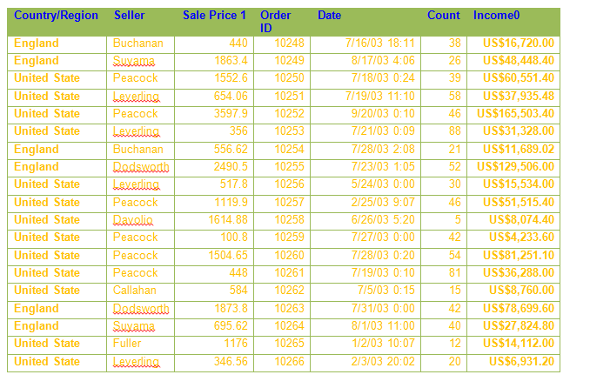

BuiltIn-Table Styles-Light List – Accent 4
Test Object | Built-in Table Styles
Test Point: | Light List – Accent 4
Other Info: | Header Row: checked  Total Row: checked  Banded Rows: checked | First Column: checked  Last Column: unchecked  Banded Columns: checked

Example Table:
Locale | Name | Date | Order Number | Amount | Detail Date
China | Kevin Wang | 2003／3／16 | 10248 | 440.00 | 03年3月15日08时19分
China | Joe Liu | 2003／4／10 | 10249 | 1863.40 | 03年2月5日09时36分
USA | Amy Zhao | 2003／4／12 | 10250 | 1552.60 | 03年3月31日14时23分
USA | Bill Zhang | 2003／4／15 | 10251 | 654.06 | 03年10月15日01时26分
USA | Amy Zhao | 2003／5／11 | 10252 | 1597.90 | 03年11月5日21时36分
USA | Bill Zhang | 2003／5／16 | 10253 | 1444.80 | 03年12月14日19时12分
China | Kevin Wang | 2003／5／23 | 10254 | 556.62 | 03年7月9日14时52分
China | Emmy Ma | 2003／5／15 | 10255 | 2490.50 | 03年10月25日12时00分
USA | Bill Zhang | 2003／6／17 | 10256 | 517.80 | 03年5月31日19时12分
USA | Amy Zhao | 2003／7／22 | 10257 | 1119.90 | 03年1月23日21时36分
USA | Anne Lee | 2003／7／23 | 10258 | 1614.88 | 03年6月1日21时07分
USA | Amy Zhao | 2003／7／25 | 10259 | 700.80 | 03年4月9日19时12分
USA | Amy Zhao | 2003／8／29 | 10260 | 1504.65 | 03年2月12日15时36分
USA | Amy Zhao | 2003／8／30 | 10261 | 448.00 | 03年8月23日20时00分
USA | Jerry Lu | 2003／8／25 | 10262 | 584.00 | 03年8月6日00时13分
China | Emmy Ma | 2003／8／31 | 10263 | 1873.80 | 03年2月15日19时12分
China | Joe Liu | 2003／9／23 | 10264 | 695.62 | 03年11月25日14时52分
USA | Harry Wu | 2003／9／12 | 10265 | 1176.00 | 03年3月21日00时00分
Total | 99999999

End

Screenshot in MS Word 2010:
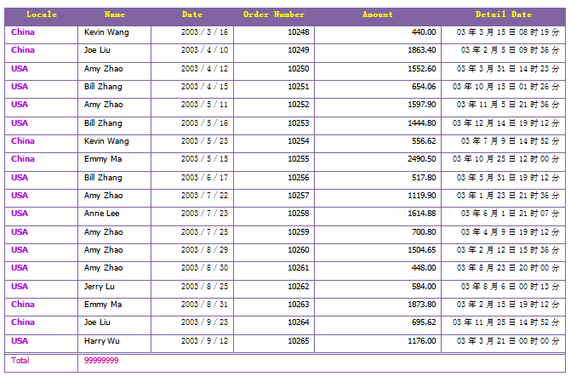

BuiltIn-Table Styles-Light List – Accent 5
Test Object | Built-in Table Styles
Test Point: | Light List – Accent 5
Other Info: | Header Row: checked  Total Row: checked  Banded Rows: checked | First Column: checked  Last Column: unchecked  Banded Columns: checked

Example Table:
Date | (empty) | Amy Zhao | Anne Lee | Bill Zhang | Emmy Ma | Harry Wu | Jerry Lu | Joe Liu | Kevin Wang | Total Result
07/10/2003 |  |  |  |  |  |  |  | 10249 |  | 10249
07/11/2003 |  | 10252 |  |  |  |  |  |  |  | 10252
07/12/2003 |  | 10250 |  |  |  |  |  |  |  | 10250
07/15/2003 |  |  |  |  | 10255 |  |  |  |  | 10255
07/16/2003 |  |  |  | 10253 |  |  |  |  | 10248 | 20501
07/17/2003 |  |  |  | 10256 |  |  |  |  |  | 10256
07/22/2003 |  | 10257 |  |  |  |  |  |  |  | 10257
07/23/2003 | 10254 |  | 10258 |  |  |  |  |  |  | 20512
07/25/2003 |  | 10259 |  |  |  |  | 10262 |  |  | 20521
07/31/2003 |  |  |  | 10266 | 10263 |  |  |  |  | 20529
08/02/2003
08/06/2003 |  | 10267 |  |  |  |  |  | 10272 |  | 20539
08/09/2003 |  |  |  |  |  |  |  |  | 10269 | 10269
08/12/2003 |  |  |  | 10273 |  | 10265 |  |  |  | 20538
08/23/2003
08/30/2003 |  |  |  |  |  |  |  | 10271 |  | 10271
(empty) |  | 20521 |  |  |  |  | 10268 |  |  | 30789
Total Result | 10254 | 71806 | 10258 | 41048 | 20518 | 10265 | 20530 | 30792 | 20517 | 235988

End

Screenshot in MS Word 2010:
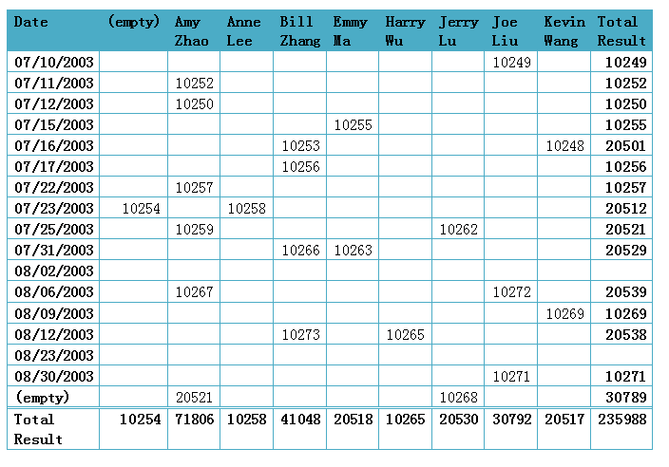

BuiltIn-Table Styles-Light List – Accent 6
Test Object | Built-in Table Styles
Test Point: | Light List – Accent 6
Other Info: | Header Row: checked  Total Row: unchecked  Banded Rows: checked | First Column: checked  Last Column: unchecked  Banded Columns: unchecked

Example Table:
Quarter | Acad. Year | Description | # Courses |  | {QCH)
2009-1 | AY2009-10 | Fall Quarter | 0 |  | {0}
2009-2 | AY2009-10 | Winter Quarter | 0 |  | {0}
2009-3 | AY2009-10 | Spring Quarter | 0 |  | {0}
2009-4 | AY2009-10 | Summer Quarter | 0 |  | {0}
2010-1 | AY2010-11 | Fall Quarter | 0 |  | {0}
2010-2 | AY2010-11 | Winter Quarter | 0 |  | {0}
2010-3 | AY2010-11 | Spring Quarter | 0 |  | {0}
2010-4 | AY2010-11 | Summer Quarter | 0 |  | {0}
2011-1 | AY2011-12 | Fall Quarter | 0 |  | {0}
2011-2 | AY2011-12 | Winter Quarter | 0 |  | {0}
2011-3 | AY2011-12 | Spring Quarter | 0 |  | {0}
2011-4 | AY2011-12 | Summer Quarter | 0 |  | {0}
2012-1 | AY2012-13 | Fall Quarter | 0 |  | {0}
2012-2 | AY2012-13 | Winter Quarter | 0 |  | {0}
2012-3 | AY2012-13 | Spring Quarter | 0 |  | {0}
2012-4 | AY2012-13 | Summer Quarter | 0 |  | {0}

End

Screenshot in MS Word 2010:
