BLACK BOX SOFTWARE TESTING SERIES: BUG ADVOCACY COURSE
ASSIGNMENT: REPLICATE AND EDIT BUGS
PHASE 3 :
Bug Evaluation Report
Issue 120368 - font size with decimal values don't have a consistent approximation
Status : UNCONFIRMED
Product : Open Office Writer version 4.1.1
Hardware : Windows 8 , Intel core i5
I was able to replicate the bug given by the author.
The bug was found in Mac OS and Windows 7 for the open office versions 3.4.0 and 3.4.1. But the same error was found in the version described above. The clearly states the font sizes which creates problem in the writer so I have tried putting the many of the values and found the same bug.
Follow up test 1 :
First of all write any character in writer as shown below with editing the size.
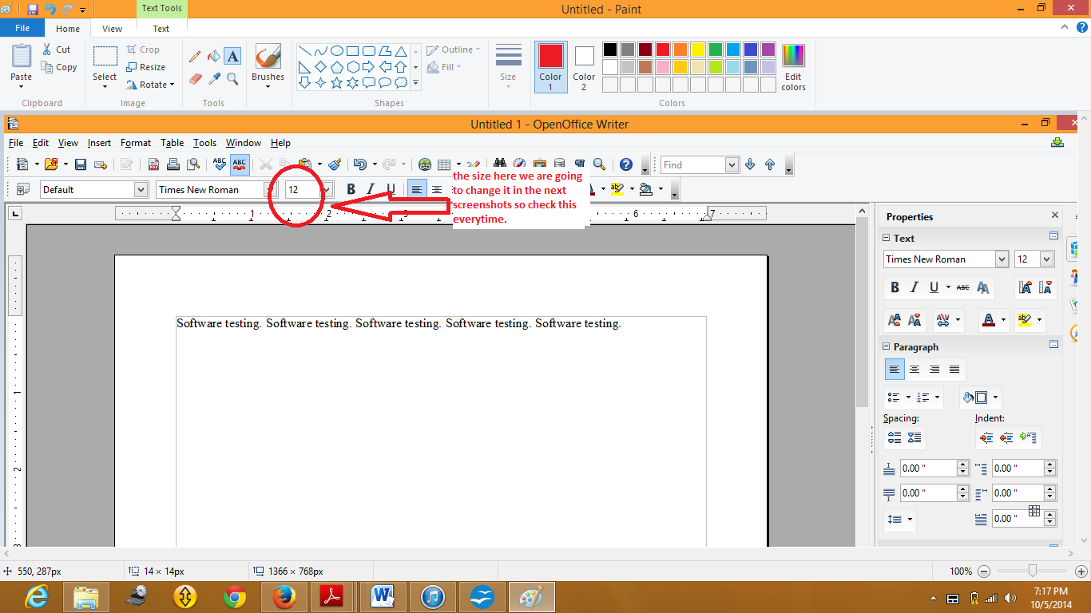

Now if I change the size to 12.2
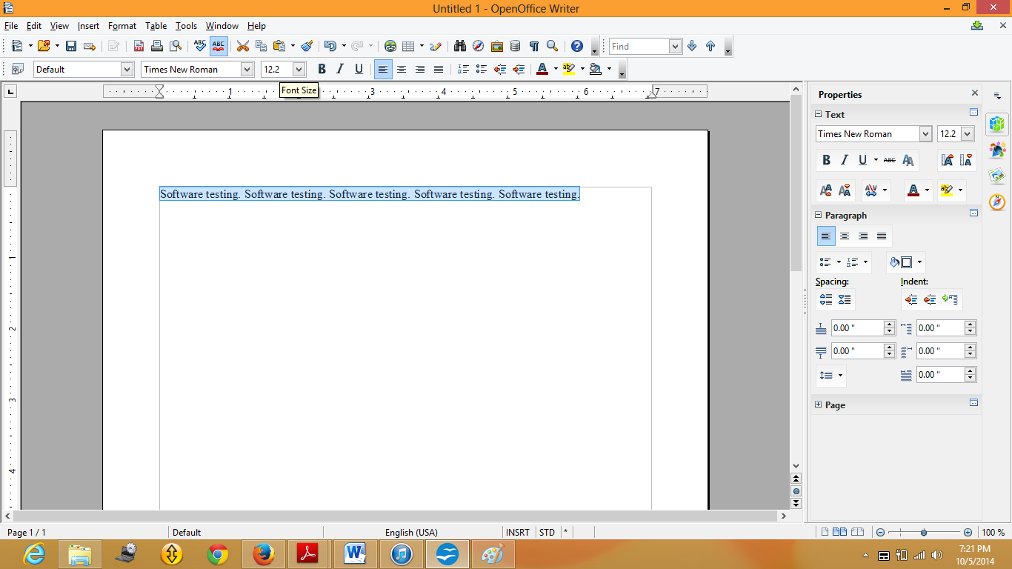
When we type 12.2 in the size and press enter it will change the size itself by 12.1
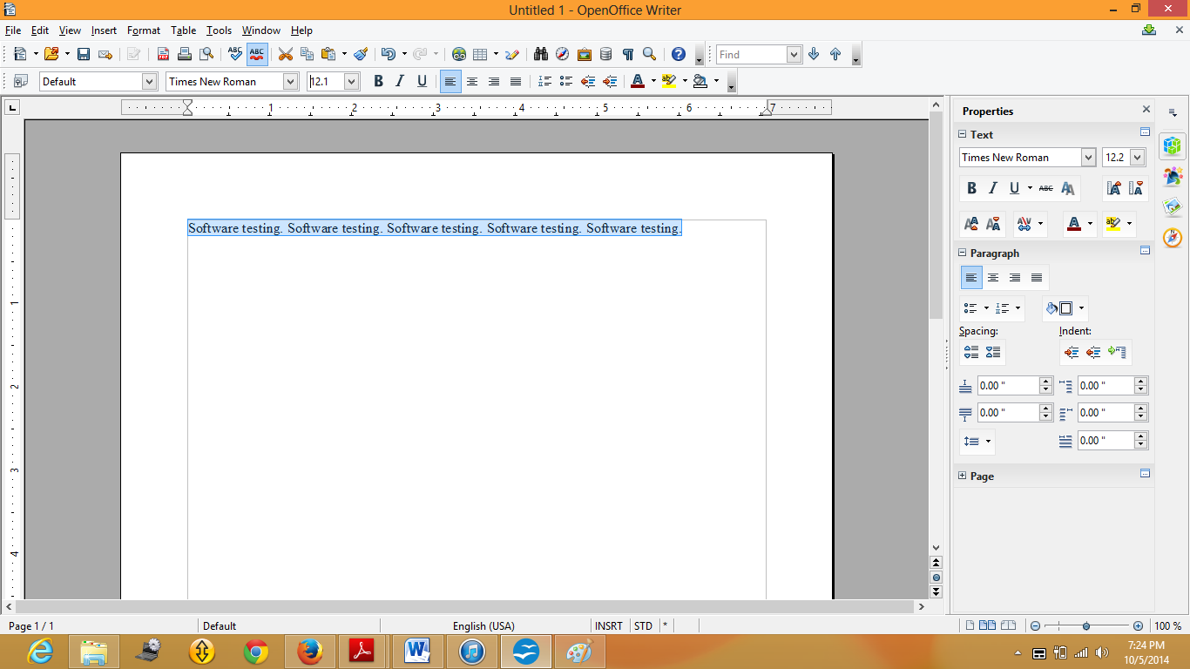
This thing happens when we enter
12.2 12.1
12.4 12.3
12.7 12.6
12.9 12.8
This thing happens with one, two, three digits. As soon as we type more than three digits as in 10000 999.9
For example : 2000 999.5
150000 999.5 etc.
All the digits value has the same bug and the decimals after the . sign remains the same. The .2 , .4 , .7 and .9 are the only digits where it changes the number and the error occurs.
For example : this thing happens same for 8.2, 8.4, 8.7, 8.9, 62.2, 62.4, 62.7, 62.9, 200.2, 200.4, 200.7, 200.9 etc.
Follow up test 2 :
The other way through by which we can try changing the font size is
Go to format option, click on character now edit the size of font as shown below and when you press enter to the value the size will change.
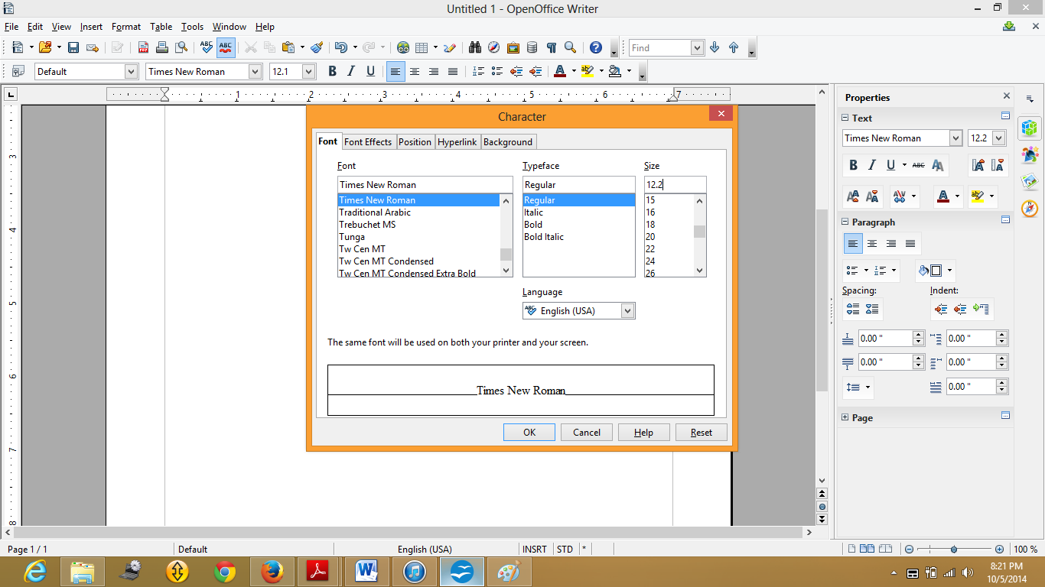
After putting ok to the window we get the below output :

This is how the above examples replicates the bug explained by the author in the given issue.

