Track Changes is a great feature of Word that allows you to see what changes have been made to a document. The tools for track changes are found on the Reviewing tab of the Ribbon.
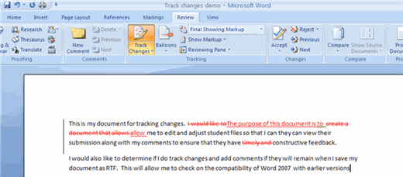
Begin Track Changes
To keep track of the changes you’ll be making to a document, you must click on Track Changes icon.
To start Tracking Changes:
- Click Review Tab on the Ribbon
- Click Track Changes
- Make the changes to your document and you will see any changes you have made.
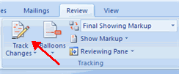

Comments
The New Comments icon also lets you add comments to the document. To add a new comment, put your cursor where you would like to add the comment and click on New Comment.
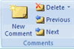
Document Views
There are four ways to view a document after you have tracked changes:
- Final Showing Markup: This shows the document with the changes displayed
- Final: This shows the changed document, without the changes displayed
- Original Showing Markup: The original document with the changes displayed
- Original: The original document without any changes.
To change the view, click the appropriate choice in the Tracking Group of the Review Tab on the Ribbon.
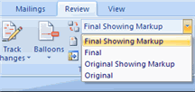
The Show Markup feature allows you to view different items (comments, formatting, etc.) and choose to view different authors’ comments.
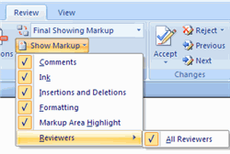
Accept or Reject Changes
When you view the changes in a document you can either choose to accept or reject the changes. This allows you to review the document by each change to accept or reject each change.
