Section Four: Design Specification

Conceptual Model (Process Flow)
Below is a high level flow chart of the Wells Fargo Bank Recon File Disbursements process
Wells Fargo Bank Recon File Disbursements
Flow Chart
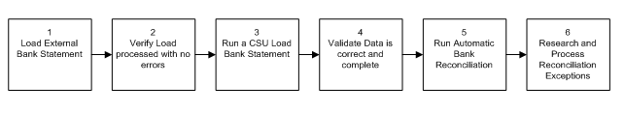
Steps
- Load Wells Fargo Statement file of Paid Checks into PeopleSoft Account Payables.
- Verify load processes with no errors.
- Run a CSU Load Bank Statement to validate PeopleSoft can read the Paid Checks file from Wells Fargo.
- Validate data is correct and complete using queries, reports and online pages.
- Run Automatic Bank Reconciliation to Reconcile PS system checks with Wells Fargo statement of paid checks.
- Research reconciliation exceptions and reconcile exceptions using PeopleSoft exception reconciliation processes or manual journals.
  - Test A bc
  - Testfds

Requirements and Design Details
Download a monthly file from Wells Fargo. This file will include only Paid Checks. It will be used to process the Bank Reconciliation for Disbursements in PeopleSoft.
- Fasdf
  - Fdas
  - FD
- sadf
  - sdf
See Appendix A: Bank Reconciliation File Specifications

