# Sequence – ROMAN – Label-1

|  |  |
| --- | --- |
| Test Object | Sequence |
| Test Point: | ROMAN– Label-1 |
| Other Info: | Exclude label from caption: Unchecked |

**Sample:**

Table I

|  |  |  |
| --- | --- | --- |
|  |  |  |
|  |  |  |

Table II

|  |  |  |
| --- | --- | --- |
|  |  |  |
|  |  |  |

Figure I

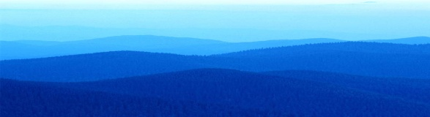

Figure II



Equation I

**C:\Program Files\Microsoft Office\MEDIA\CAGCAT10\j0216858.wmf**

Equation II

**C:\Documents and Settings\Administrator\Local Settings\Temporary Internet Files\Content.IE5\KXYFKTIJ\MC900339982[1].wmf**

**End**

**Screenshot:**

