Series V INTELLIMASS Performance Report
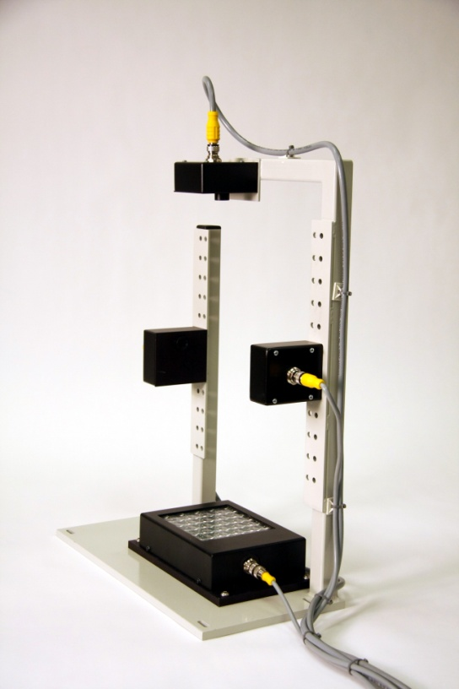

5/2/11

By: Ed Morgan
Denwood Ross III
Mark Moore
Don Buss
Jim Spayer
Jim Krejsa
This report presents the results of field data collected from Pepsi Orlando. It builds on and supports test results and data collected in our lab for the last year and Constar Havre de Grace test site. The purpose is confirm that the design of the new INTELLIMASS Base and Sidewall sensor modules meets or exceeds the goals of the Product Market Requirements (PMR) and that un-restricted shipments and installations can begin with confidence.
The INTELLIMASS inspection modules are designed to measure thermal energy transmission as it propagates through PET and other materials. The amount of energy transmitted through a region can be correlated to the mass of that region. Data in this report is based on a "Propel" bottles from Pepsi Orlando. At Orlando, two modules were configured to report the mass values of the base section, and the shoulder section of the bottle. CAD drawings of a fully configured INTELLIMASS structure is shown below. The bottles were sectioned using a hot wire cutter, and the actual section masses, measured on a calibrated electronic scale, were compared to the INTELLIMASS reported masses.

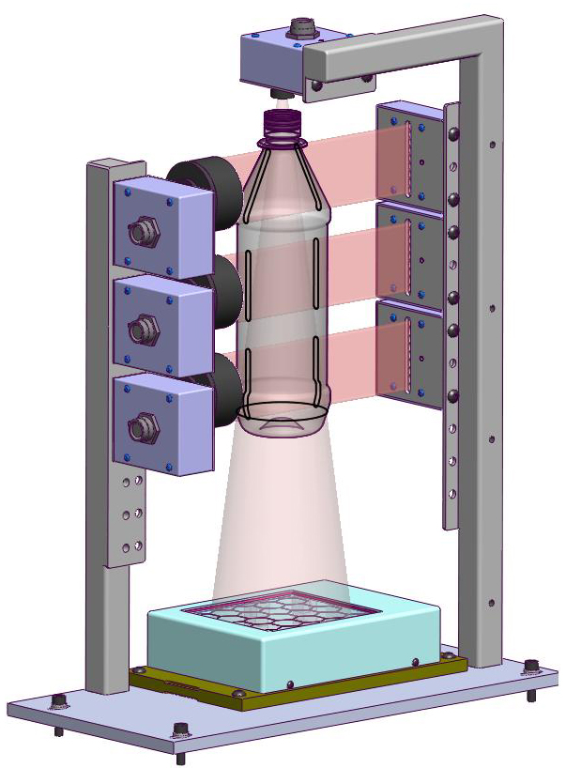 | 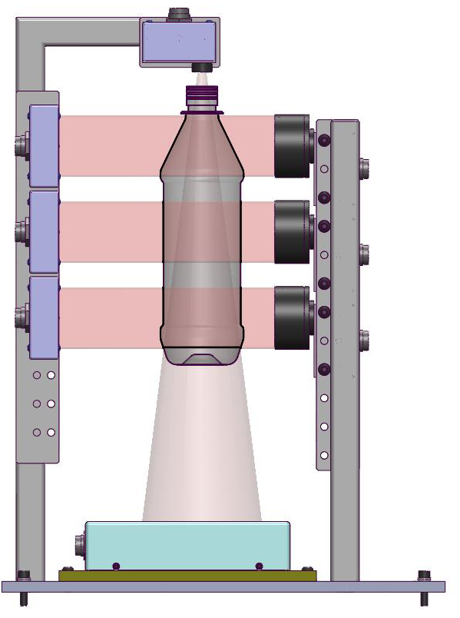

The Base and Sidewall sensors are identical except for a lens. The Base emitter utilizes 19 infrared LEDs arranged in 3 circular zones that are under software. There is a large Fresnel lens in the Base module located near the emitters to focus the emitted beam onto the Base sensor. The Sidewall emitter utilizes 9 infrared LEDs arranged in 3 linear zones. Each zone is separately controlled by software. The Sidewall sensor has a large collection lens at the sensor. The software controlled zones give flexibility in adjusting the intensity and shape of the emitted beams for special applications. Examples include bottles that have small bases, thick regions or narrow sections.

Sensor Range and Calibration:
Unlike the Series IV IMASS sensor module, the Series V INTELLIMASS sensor module was designed to only be calibrated at Pressco before shipment and require no calibration procedure by the customer. Each sensor is calibrated using a collection of 11 PET sheets of known thickness. These sheets range from 0.05mm to 3.04 mm in thickness. The sensors readings are stored on board in a flash memory. The sensor calibration curve is read by the INTELLIMASS software upon initialization. The software uses the calibration data to transform raw sensor reading into what we call Calibration Units. Series IV INTELLIMASS uses a linearized version of the transmission curve.
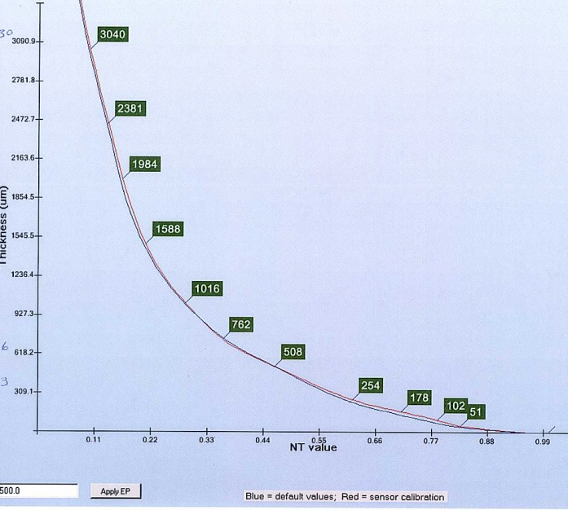
The new Series V emitter has the power and the sensor has the sensitivity to measure section weights from bottles with sections weights from 1.5g to 15.0g.
Unless the INTELLIMASS system has gone through the scaling process for a given bottle, the sensor readings are displayed and recorded in "Cal units".
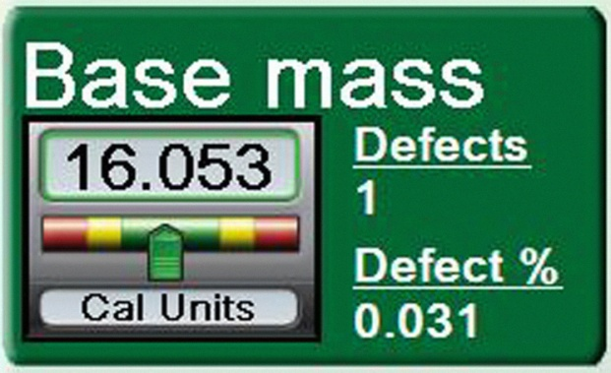Example Display in Cal units | 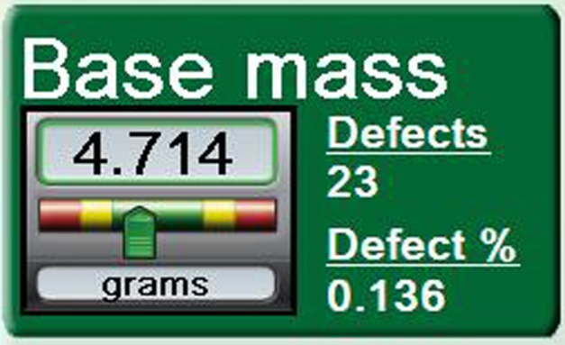Example Display in Scaled Units ~ grams
The scaling process requires users to section bottles and enter the section weights into the system. The recorded weights are used to develop a transformation so that sensor data can be displayed in mass units (grams).
Repeatability (based on calibrated samples):
Our repeatability specification was confirmed using lab measurements on stationary calibrated sheets of PET material. This eliminates bottle geometry, bottle cutting, motion, part tracking, etc . In a blow molder, repeatability cannot be measured because the we only get one shot at it moves past our sensor.
We will take a very conservative position for our INTELLIMASS repeatability specification. Using stationary plastic sheets the Series V sensors always returned the same number. The electronics are extremely stable. The sensor was so sensitive it could detect small variations of thickness in our calibrated PET standard sheets if the sheets were moved. The sensor returns a 12 digit binary number with values from 0 to 4096. We are confident (2-sigma - 95% confidence) in the sensor's ability to repeatedly read with less than 2 bits (4 values out of 4096 scale) of variation or 0.1%. This is 4X better than the PMR requirement
Repeatability measurements on static bottles with a variety of different geometries yielded a (2.576 -sigma - 99% confidence) a range of 0.4 % of reading. Repeatability measurements of moving bottles in Lab using a variety of bottle geometries from Constar, Pepsi and Niagara in our blow molder simulator (whirligig) were conducted. We were able to get 100 reading repeatability (2-sigma - 95%) performance in the range of 0.4 to 1.7%. Note that our simulator is very old and has more mechanical slop than a production blower. In general, the repeatability performance of Series V IMASS sensors compared to Series IV IMASS sensors on the same bottles had been consistently measured to be at least 3 times better for a wide range of test conditions.
Accuracy specification:
The accuracy specification will be quoted based on scaled on-line readings (grams) of real bottles and not from stationary flat sheets of PET or bottles. The accuracy of an INTELLIMASS module can only be empirically determined for a particular bottle. Proving the module's accuracy first involves scaling the system and then comparing the system reading and the corresponding section weight of a bottle as measured on a scale. The scaling operation is critical to accuracy. The sensors do not directly measure section weights. The software infers the section weight in grams based on sensor measurements and scaling data entered by the customer.
We have determined the on-line accuracy of Series V sensors should be:
Base or Sidewall Module Accuracy:
Based on a set of 20 samples, the average deviation of section weights will be less than +/- 0.15g or +/- 1.0% with a 95% confidence level (2 sigma) as long as the actual weight of the section is within a set of bounds that are 10% of their specified limits. The system's measurements are very accurate for good bottles.
Note: The system will be able to reliably detect and reject out-of-spec bottles. The accuracy measurements on bottles that are significantly outside of acceptable tolerances are less than the accuracy of measurements on acceptable bottles.
Accuracy specifications can be guaranteed when our recommended "Best Practices" are used for setup:
- The blowing recipe should be stable and producing bottles with section weights that are reasonably close to the desired specification. The measurements in the distribution charts should look like a normal distribution and have PCI and CPK values near or greater than 1.0.
- The speed of the blower needs to be stable for a particular bottle after scaling. Sensor sampling rate is adjustable and stored as part of the inspection program.
- Bottles used for computing accuracy were taken after about 1 minute of operation.
- The bottle geometry will affect the accuracy. Bottles with smooth sides and simple base geometries will be more accurate than bottles with complex structures. It is impossible to quantify but for bottles of the same weight the accuracy could vary as much as 50%.
- The operator is reasonably proficient at sectioning bottles and the hot wire cutter is in good condition. The bottle should be fixtured such it is stable during the cutting operation.
- The scale has a resolution of .01 gram and is zeroed between readings. It should be properly shielded from air currents. Uncontrolled drafts in a factory can cause a scale reading to vary substantially.
- The emitter covering has been recently cleaned (less than 1 hour of operation) and free from oil and debris. If the backlight were covered with oil and other debris when the sensor is setup, it could cause the sensor to be saturated between bottles and invalidate the readings.
- The bottles are consistently positioned in the Field of View of the sensor. The gripper fingers must have sufficient and consistent pressure such that bottle sway, and tilt are minimized.
- Bottles used for scaling the sensor to read in grams are no more than 10% outside the spec limits of the bottle. A proper scaling requires some bottles that are a little heavy and a little light but not extremely outside the specs. Sampled bottles with section weights that are out of tolerance are not used in the determination of scaling parameters.
- The scaling operation yields a linear correlation indicator (R²) greater than 0.75

Note: We found that when closing the loop with the Sidel Equinox software using INTELLIMASS data, the control algorithms needed to average 9 to 10 readings from each cavity. Averaging 9 readings improved the accuracy due to random error by a factor of 3 and eliminated unstable feedback control conditions. However, systemic error due to scaling errors (heavy bottles should read heavy and light bottles should read light) can be improved in the future by incorporating learning algorithms and better curve fitting models.
Stability and Frequency of Scaling:
The PMR required that the number of scaling checks should not exceed:
- Once following a mold change to a previously calibrated bottle
- One verification check per week
Field data at this time is insufficient to fully evaluate this specification, but anecdotal evidence is that both goals have been met. The same part program was recalled 3 weeks after its initial setup and it was still valid.
Conclusion:
We have found the performance of Series V INTELLIMASS modules to be at least 3X more repeatable and a factor of 3X more accurate than Series IV INTELLIMASS sensors. All the requirements of the PMR have been validated with lab and field tests.
The repeatability and accuracy of the new sensors have benefited from increased precision (using 12 bit vs 10 bit A/D converters), increased sampling rate (4X), increased samples per reading (31 vs. 4), solid state emitters, 2 stage TE cooler on sensor. All sampled data from the sensor is sent to the sensor for processing in the host after an intelligent data selection algorithm.
Initially, we experienced Part Tracker problems in our field test with correlation of cavities and INTELLIMASS readings. However, now that the bugs have corrected, PDX functionality will greatly reduced the frequency of cutting and weighing bottles for scaling the sensor readings.
INTELLIMASS modules are easy to install and setup. The modules use existing vision part tracking, power, and rejection. We have improved the ease of use by integrating Mass and Vision user controls on common display screens and consistent RetroSpec style controls for sensor settings.
We believe the design of the new Series V INTELLIMASS product is ready for unrestricted sales, installation, and production.

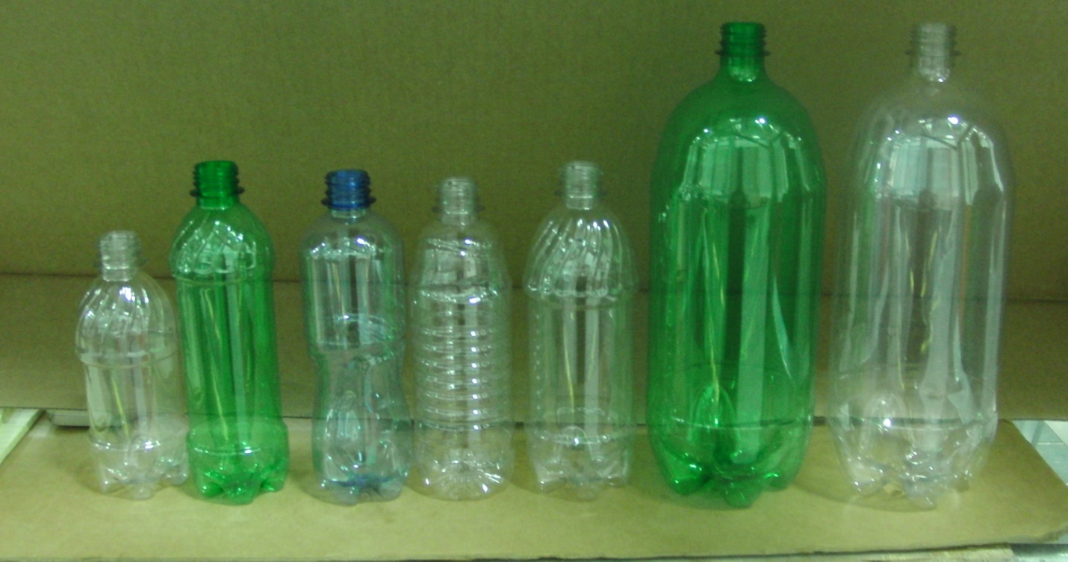
Range of bottles tested with INTELLIMASS at PBC - Orlando
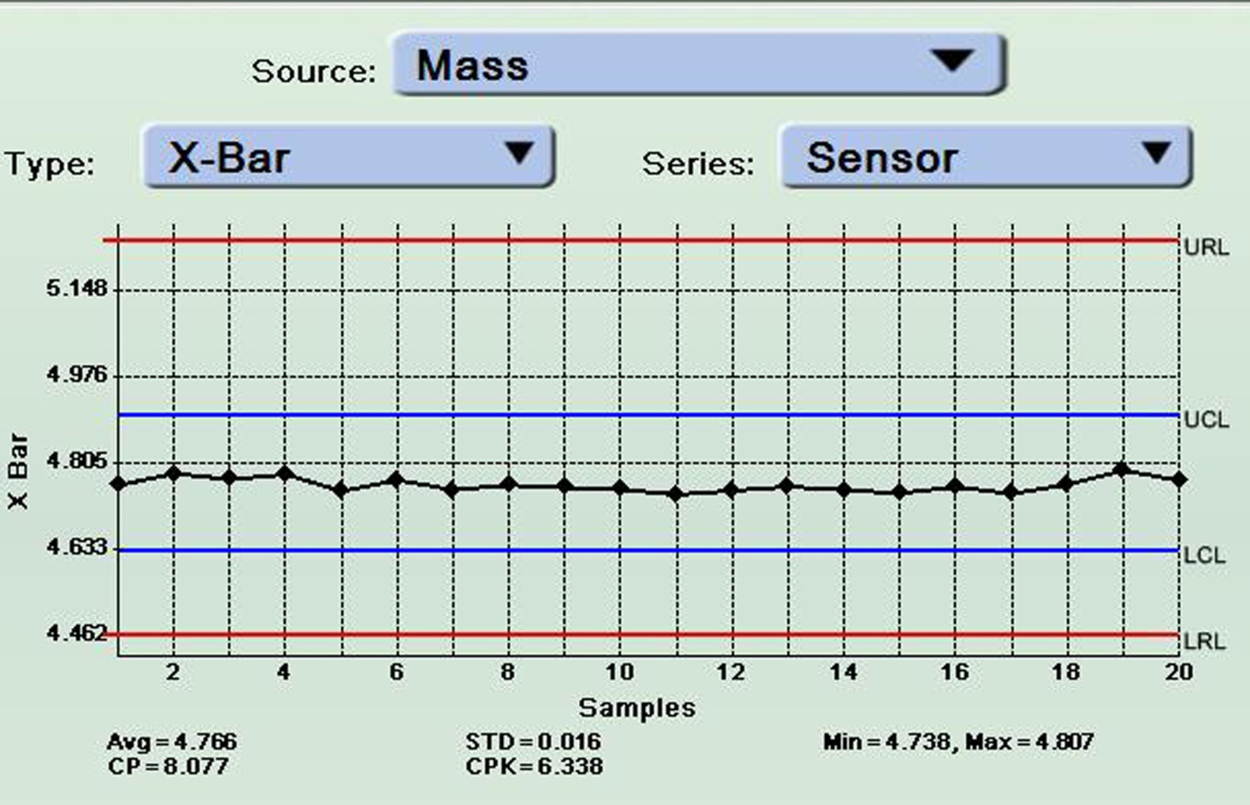
Stable blowing process - CPK 6.33
.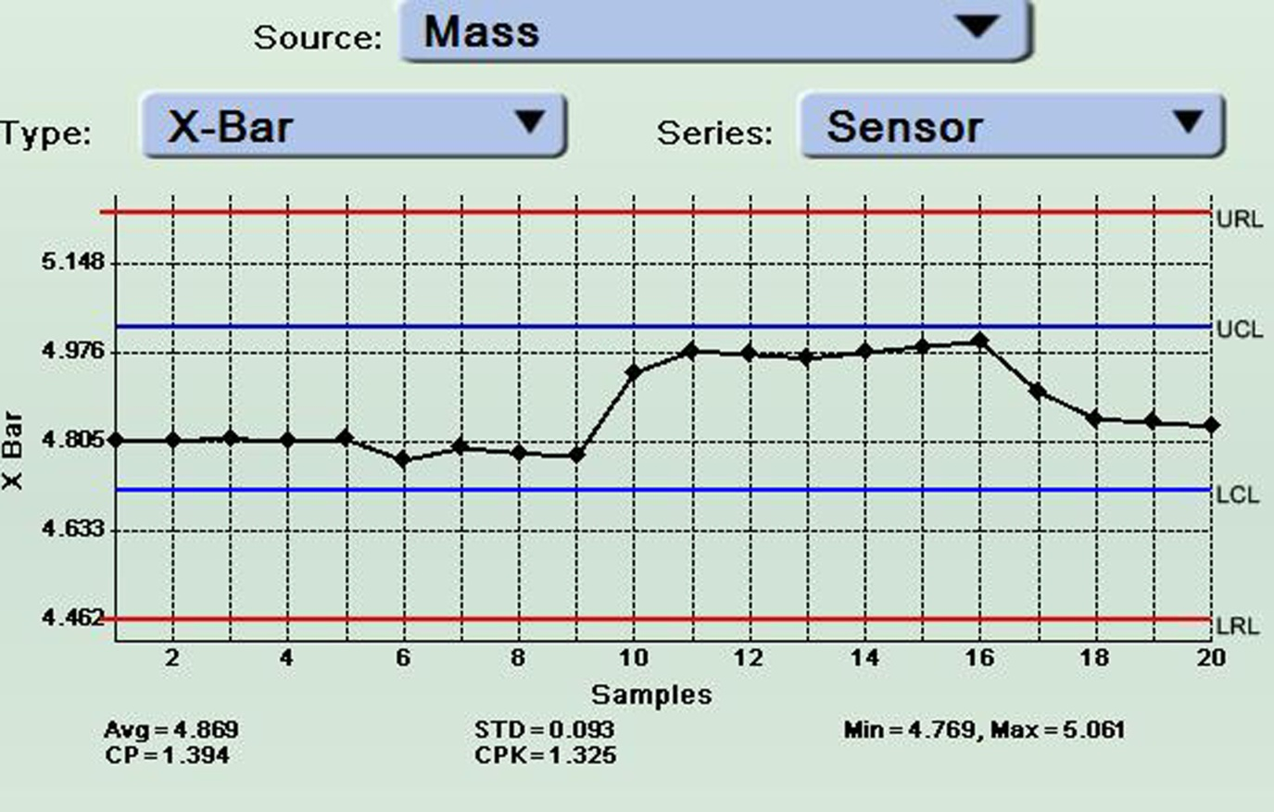
This chart shows why users should wait for about 1 minute before scaling or checking scaling.
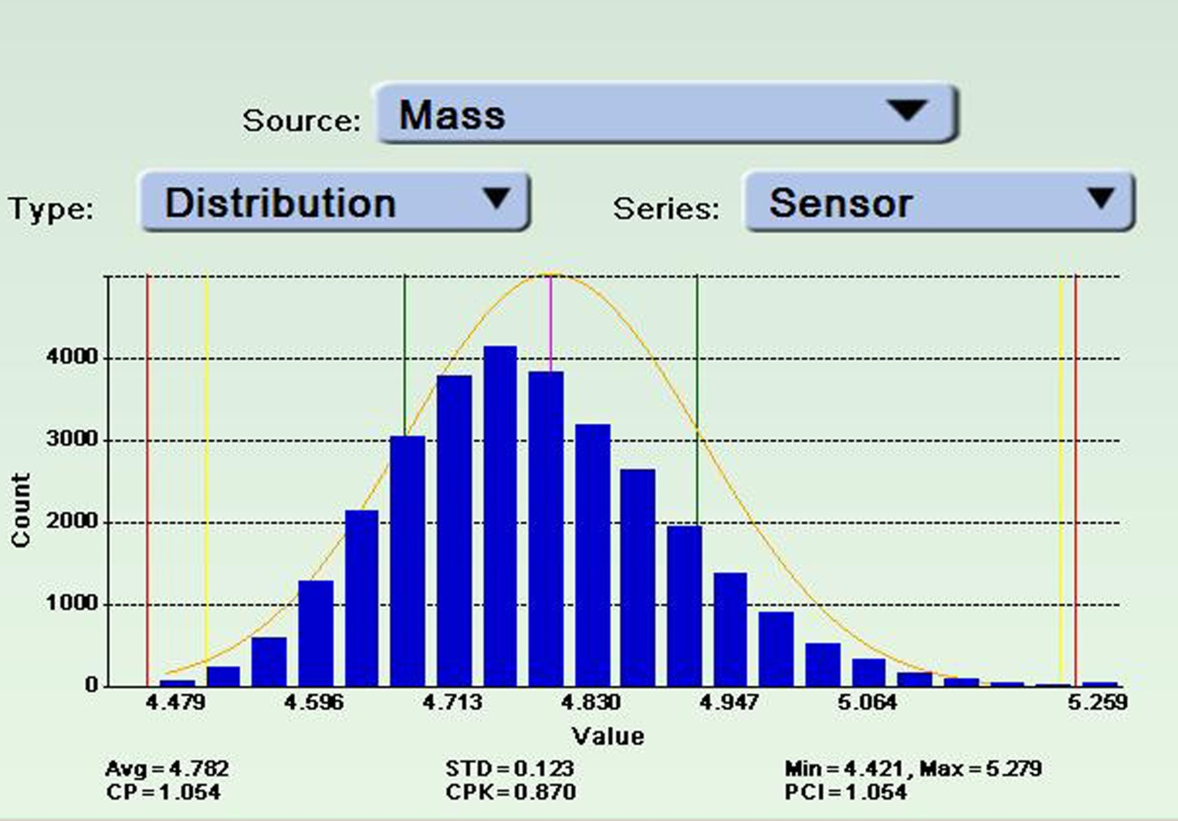
Kind of stable process (PCI >1.0; but skewed closer to the Lower Control Limit; but occasional heavy
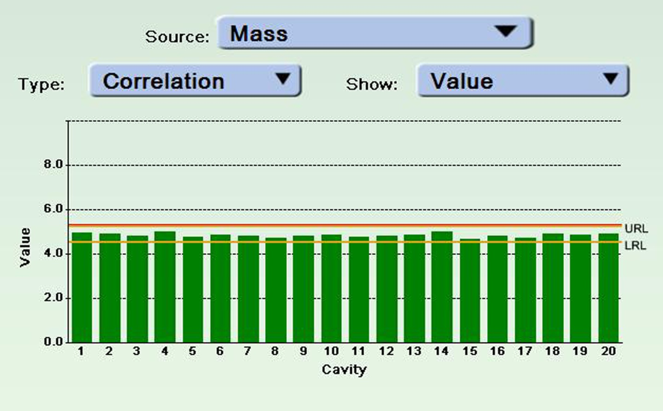
16.9 Oz Propel Bottle, 21.5g Nomal weight

20 cavity | Hot Wire Sectioning ~g |  |  |  | IMASS Reading |  | Base | Shoulder | 4/25/2011
dump | Base | Panel | Shoulder | Total Wt. g | Base | Shoulder | Error | Error | 8:37AM
Max | 4.92 | 10.46 | 6.49 | 21.51 | 5.03 | 6.46 | 0.10 | 0.10
Min | 4.49 | 10.18 | 6.29 | 21.35 | 4.68 | 6.30 | -0.24 | -0.05
Range | 0.43 | 0.28 | 0.20 | 0.16 | 0.35 | 0.16 | 0.34 | 0.15
Average | 4.73 | 10.31 | 6.40 | 21.43 | 4.78 | 6.38 | -0.06 | 0.02 | Avg. Error
St. Dev. | 0.11 | 0.08 | 0.05 | 0.05 | 0.08 | 0.04 | -1.2% | 0.3% | % Error
RE | 2.2% | 0.8% | 0.8% | 0.2% | 1.6% | 0.7%
20 cavity | Hot Wire Sectioning ~g |  |  |  | IMASS | IMASS | Base | Shoulder | 4/25/2011
dump | Base | Panel | Shoulder | Total Wt. g | Base | Shoulder | Error | Error | 12:12PM
Max | 4.88 | 10.46 | 6.50 | 21.61 | 4.91 | 6.45 | 0.11 | 0.14
Min | 4.54 | 10.18 | 6.33 | 21.32 | 4.59 | 6.28 | -0.16 | -0.04
Range | 0.34 | 0.28 | 0.17 | 0.29 | 0.32 | 0.17 | 0.27 | 0.18
Average | 4.72 | 10.30 | 6.40 | 21.42 | 4.74 | 6.36 | -0.02 | 0.04 | Avg. Error
St. Dev. | 0.10 | 0.09 | 0.04 | 0.07 | 0.09 | 0.06 | -0.5% | 0.6% | % Error
RE | 2.2% | 0.9% | 0.7% | 0.3% | 1.9% | 0.9%
16.9 oz. net weight Propel bottle, 21.5g nominal. 20 cavity dump, 1 bottle reading per cavity. Line sort of stable.
RE = (St.Dev./Average), and Perc. Err. = (Ave. Err./Average).

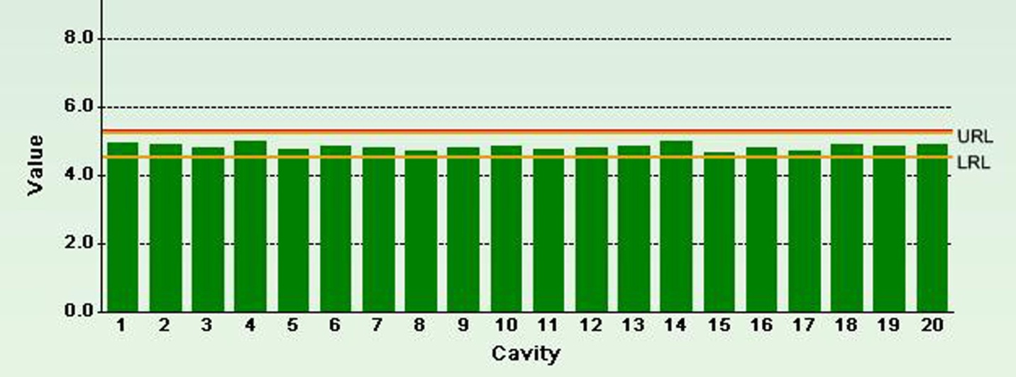
Accuracy data of 20 cavity dump includes variability due to 20 different cavity settings.

Typical Profile of data from Sidewall sensor placed at the flat panel area of bottle
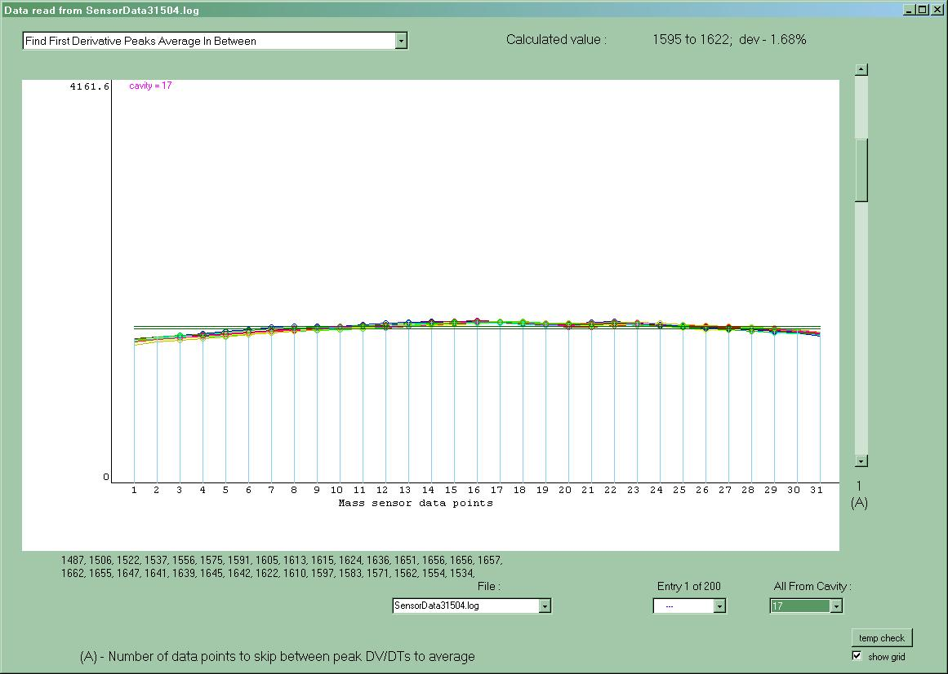
Typical profile of data from Base Sensor - Pepsi swirl bottle
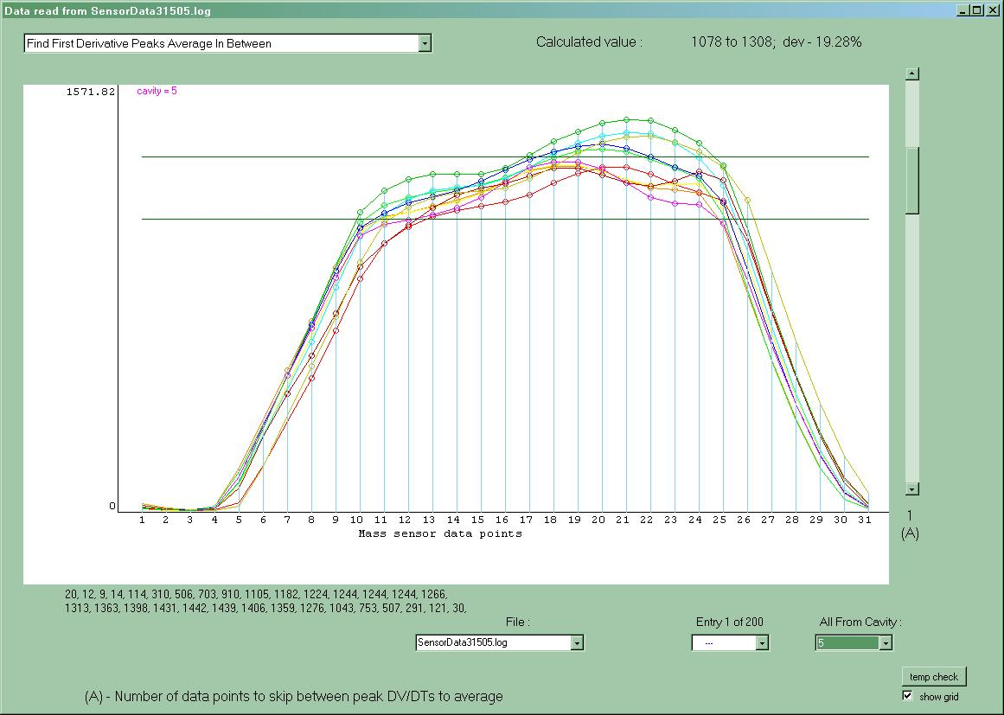

16.9 Oz Propel Bottle Panel Measurement
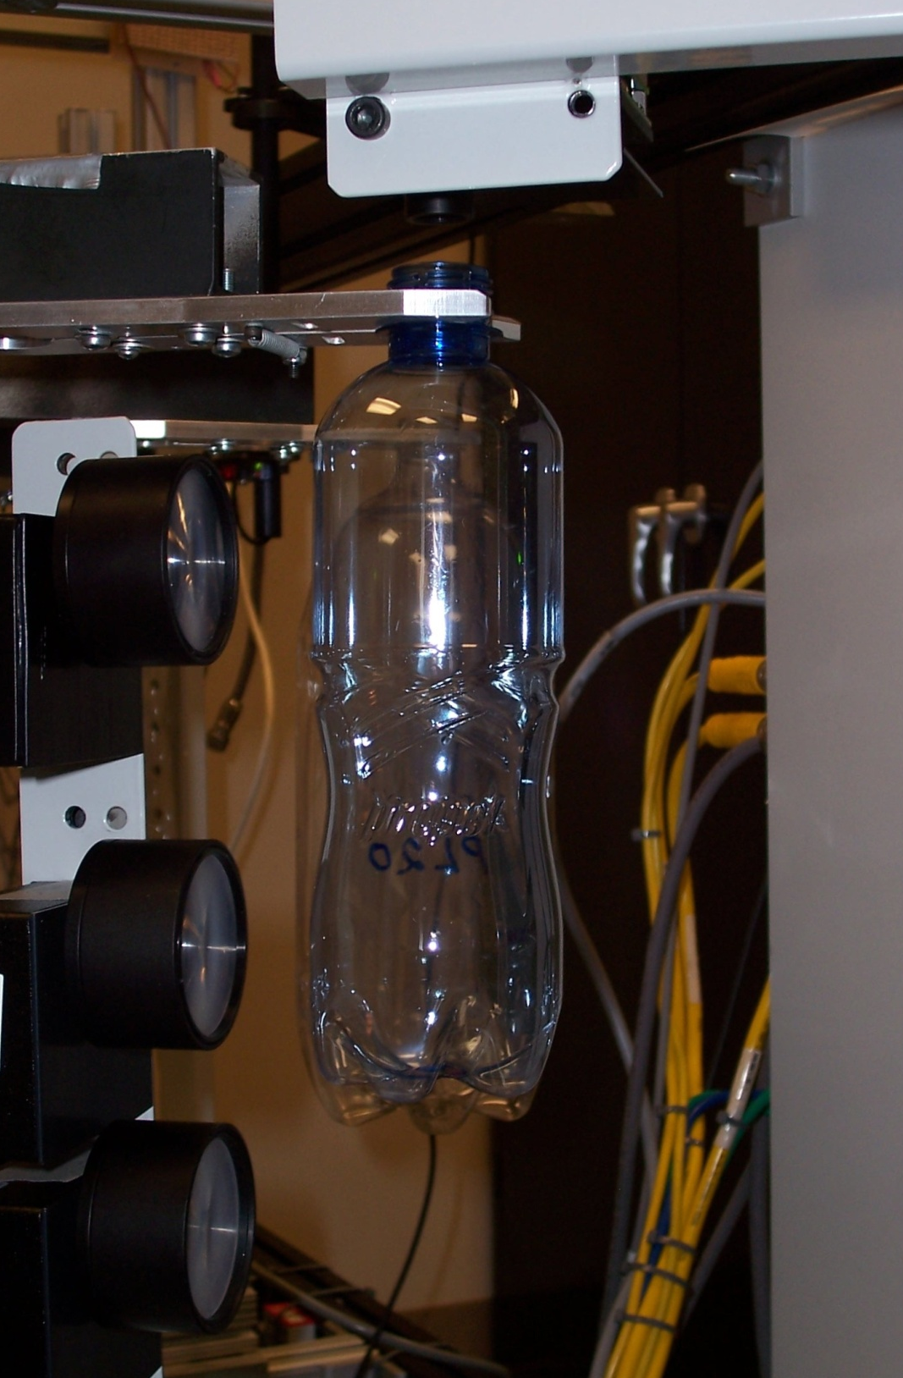

Sidewall Sensor 2
Sidewall Sensor 1
Sidewall Sensor 1
Sidewall Sensor 2

Bottle | Sensor 2 reading | Sensor 1 reading
High 1 | 9.541608 | 7.123698
High 2 | 9.392346 | 7.309235
Low 1 | 7.894434 | 8.308623
Low 2 | 8.103746 | 9.458742
Comparion of VERISPEC thickness to INTELLIMASS readings (in Cal units). The conclusion was the measurements were consistant with the effect thickness of the areas covered by the beams.

