In this slide the user brings up the File>Print (setup dialog) and after selected Document=Notes goes through the Slide Notes. Slides 3 & 4 appear blank. The same thing happens when the user prints these Slide notes.
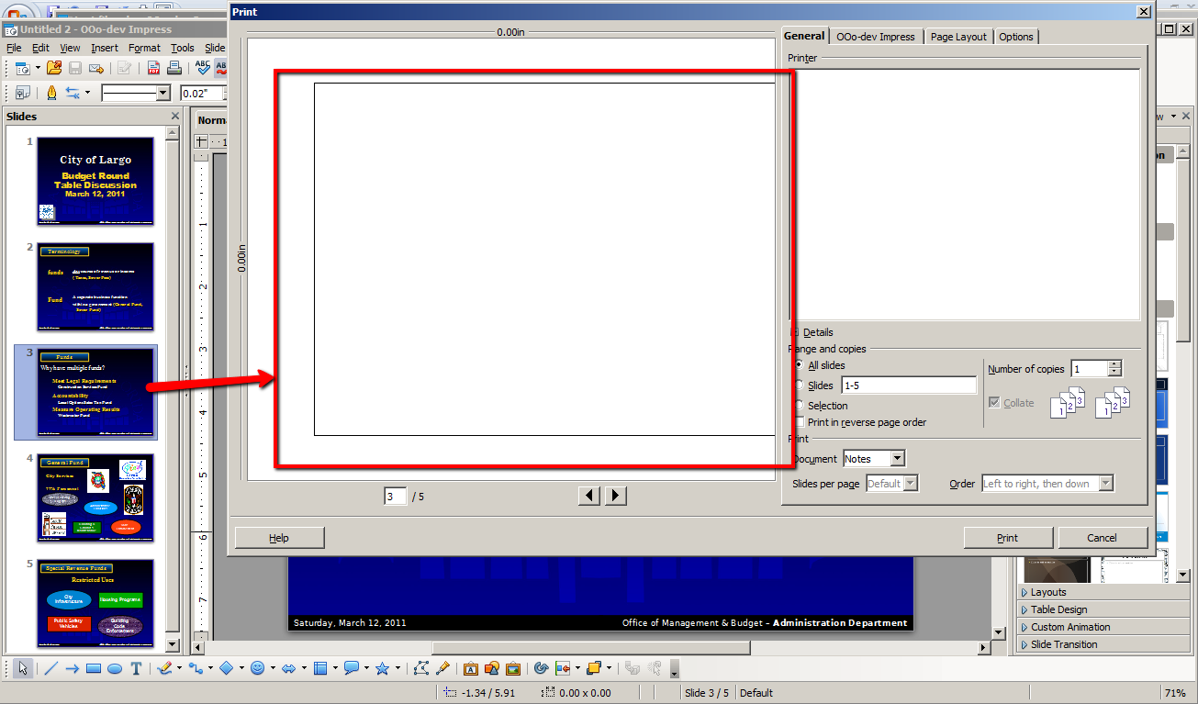
PowerPoint 2007 – the same document when viewed in print setup has issues in PowerPoint 2007 (slides 3 & 4 appear blank)
