Empty range bookmarks in Word2007 DOCX file
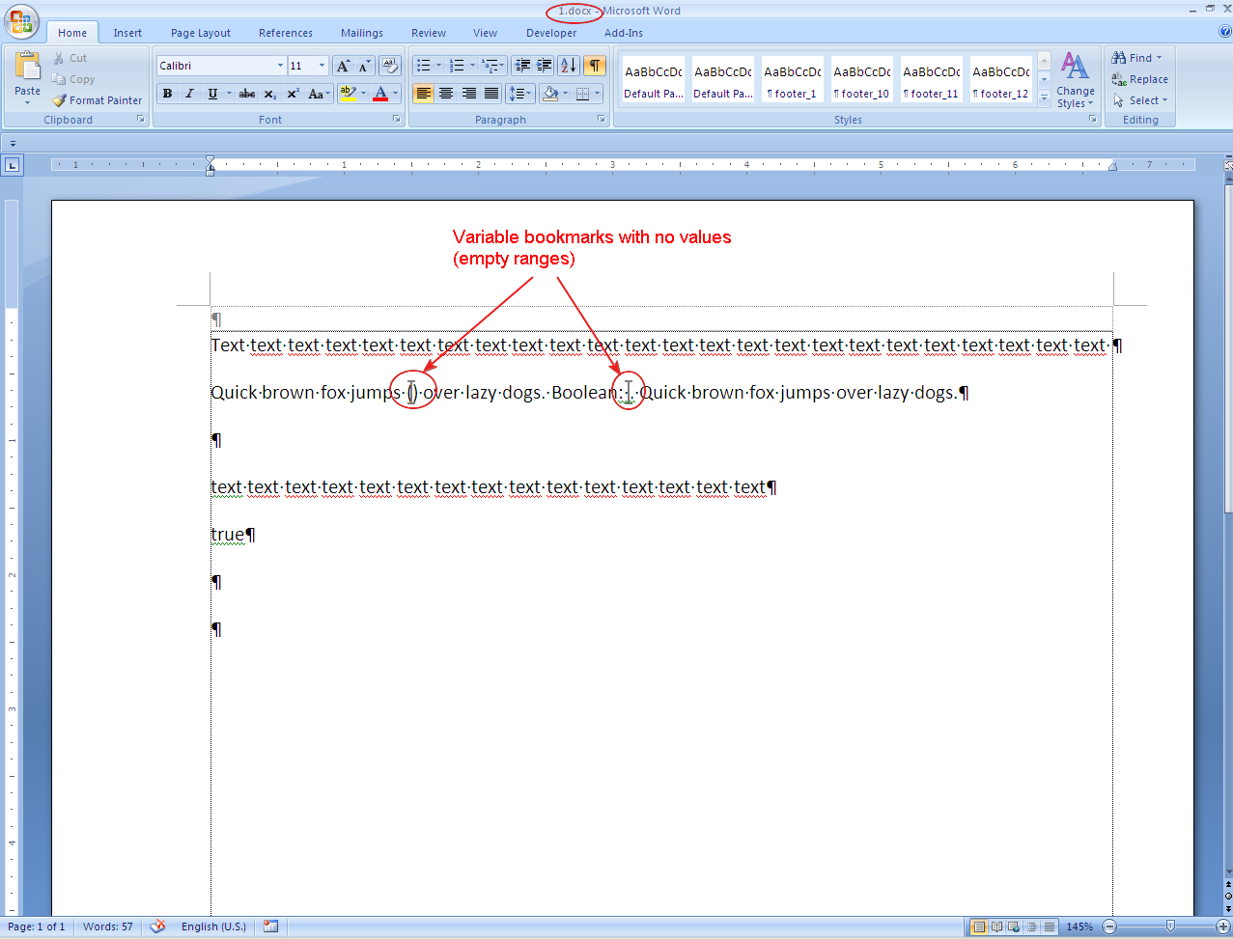

ODT document, converted from DOCX by ODFConverter, opened in OpenOffice. It is visible, that bookmarked ranges are incorrect.
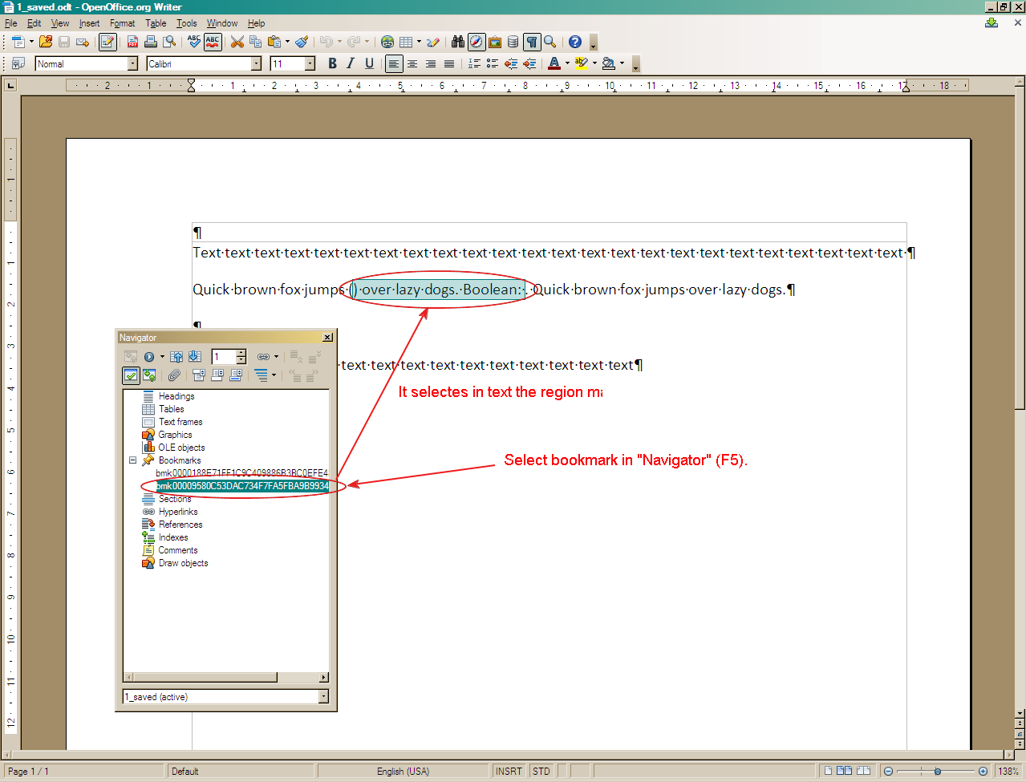

It is visible that <text:bookmark-start> and <text:bookmark-end> tags are applied correctly and the problem is in OpenOffice treats them incorrectly.
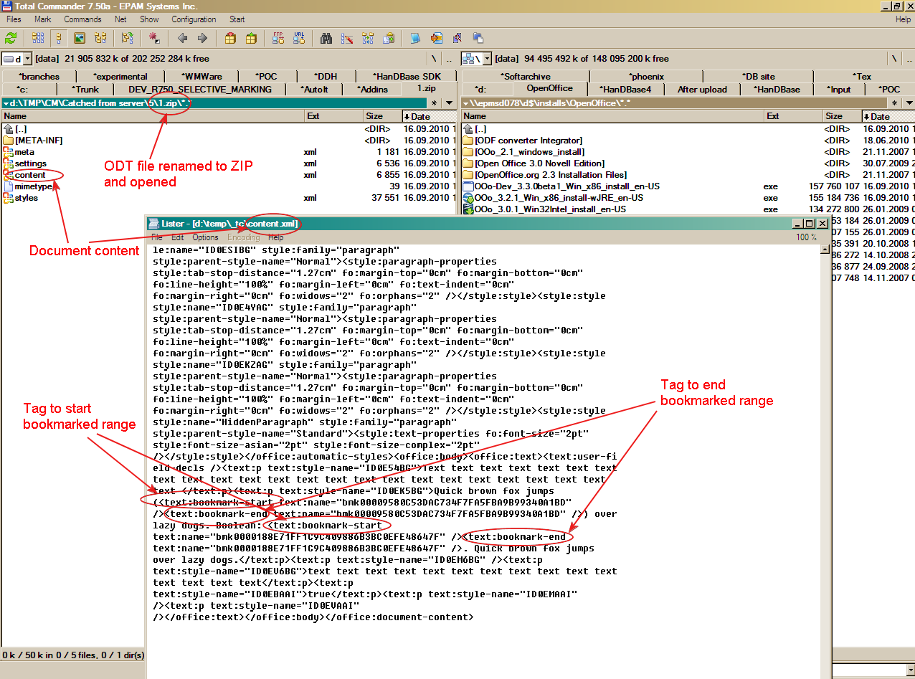

ODT document created from DOC works correctly with empty bookmarks, because another bookmark tag is used (see below).
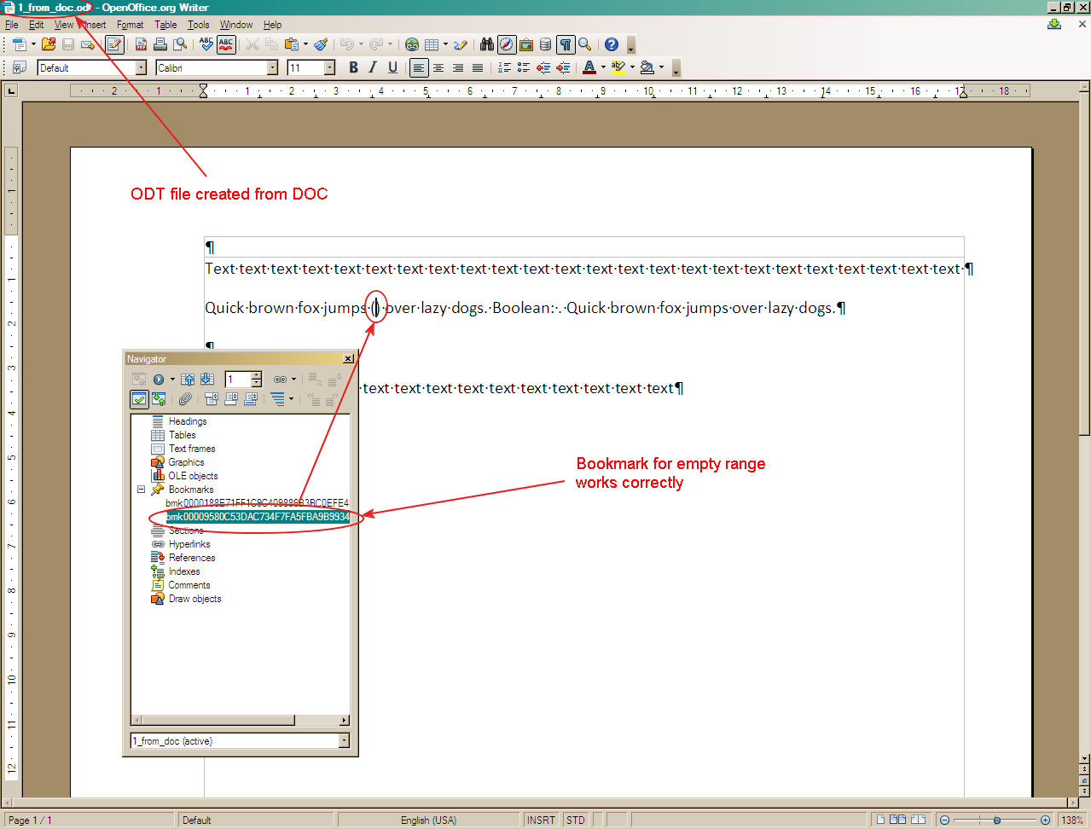

Another tag <text:bookmark> works correctly in OpenOffice.
