key position information
Job Title  Research Analyst | Position Reports To  Parin Rafiei-Thompson
Incumbent  Click here to enter text. | Location  Burwood East
Division  Policy & Programs | Job Description  New Updated  Double Click on box and select ‘checked’ | FTE  N/A
Team  Innovative Partnerships | Effective Date  15/10/2010 | Date Updated  Click here to enter a date.

primary purpose of Job
Why does the job exist? This statement should encapsulate the overall significance of the job from WVA’s point of view.
To support the existing program of work and the identification, assessment and planning of new project opportunities within the Climate Change and Carbon Markets team, Innovative Partnerships (IVP), World Vision Australia.

dimensions
Direct Reports  None | Financial Authority – Budget  N/A | Financial Authority  N/A

key result area (KRA) | key performance indicator  (KPI) | weighting  (%)
World Vision core values | Acts consistently in accordance with WVA values, challenge practices inconsistent with these values and uses values as a basis managing relationships and decision making.
Support delivery of the existing project pipeline | - Review, evaluate and give feedback on relevant technical reports on current pilot project  - Assist Carbon Program Manager (PM)to coordinate progress of Energy Efficient Stoves and other projects with World Vision Ethiopia and other stakeholders  - Develop and monitor key project documentation (including terms of reference, plans, resource forecasts, budgets) and help PM to proactively manage the on time delivery of milestones for projects  - Contribute to efforts of Carbon Technical Advisor on best practises and standards to apply for Low carbon technologies, specifically energy efficient stoves  - Prepare Climate Change and Carbon markets team meetings and identify gaps  - Support PM in all aspects of the carbon program management (e.g. support in communication, stakeholder management and reporting) | 50
Help assess and prepare appropriate new opportunities | - Work with PM and team manager to define the scope of Stoves scale up project and assist with proposal writing  - Other project scoping and proposal development as required. | 30
research low carbon technologies, processes, compliance standards and funding streams | - Work with team to establish shortlist of low carbon/pro-poor technology suppliers.  - Assist team to establish shortlist and summary screening checklist of most attractive compliance standards.  - Support the creation of a calendar for major climate change/technology events (e.g conferences, networking events, etc) | 20
To add additional KRA’s, place put your cursor in the far bottom right hand cell in the above table and press the ‘Tab’button on your keyboard

functional KRA’s | key performance Indicators | weighting
Functional KRA’s are standard in all JD’s and provide for KPI’s which are consistent across all jobs within WVA.
OH&S | - Undertake business activities in safe manner so as to avoid or reduce the risk of injury or illness to self and others; and  - Ensure you comply with WVA OH&S policies and procedures. | 100%
People | - Ensure you actively participate in LINK and fulfil all its requirements in line with prescribed timelines; and  - Ensure you participate in the WVA Induction process and your probationary review is completed within prescribed timelines. | N/A
Risk & Governance | - Ensure you operate in line with WVA policies and procedures, Code of Conduct and ethics; and  - Actively participate in risk awareness training. | 100%

key relationships
Internal | Innovative Partnerships (IVP), International Programs (IP), Australia Programs (AP), Economics Climate Change Natural Resources (ECNR) and Program Effectiveness (PE)
External | Compliance bodies, research centres, technology suppliers
Committee/Groups | WVA Climate Change and Carbon Markets Practitioners

organisation context
Attach a current organisation structure which includes: manager, manager’s manager, peers, direct reports and this role accessible via the Hub).
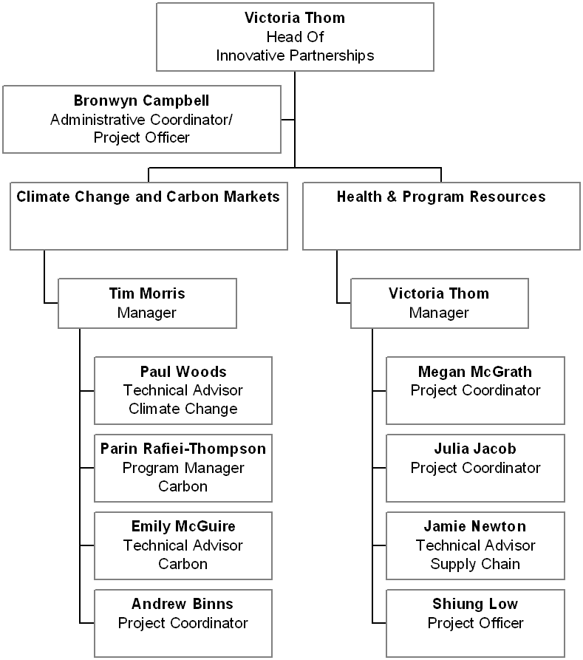

Sign Off
Manager Name  Tim Morris | Employee Name  Click here to enter text.
Manager Signature | Employee Signature

To be completed for recruitment purposes only
Job description

values
Demonstrated commitment to World Vision values and philosophy, and capacity to engage with the broader community in living these values:
We are Christian | Willingness to be open about their faith / discuss their spiritual life and respect others’ beliefs. e.g. participate in corporate spiritual life in an enthusiastic manner and show respect for others’ opinions and religious beliefs
We are committed to the poor | Demonstrate community involvement and interest in issues of justice
We value people | Be able to demonstrate good interpersonal skills and accept diversity in the workplace
We are stewards | Understands issues regarding conserving resources, i.e. financial, physical and can improve efficiencies in work practices
We are partners | Is able to influence decision making in their area of concern
We are responsive | Responsive to customer expectations in a timely and appropriate manner. Can make decisions under pressure

credentials
Qualifications / Memberships | Essential  Qualification in business, engineering, science, economics or any other discipline that is able to demonstrate knowledge in low carbon technologies  Desirable  Corporate Environmental and Sustainability Management qualification
Knowledge | Essential  Knowledge of carbon markets; CDM, Gold Standard, CCB, etc.  Desirable  N/A
Experience | Essential  Strong business analysis skills including modelling, financial feasibility, budgeting, project scoping and contract management  Desirable  Presentation (oral and written) skills, report writing, proposal and presentation development  Commercial and financial acumen  Experience in NGOs and International development

capability profile
Please select 6-8 capabilities essential to the successful performance of the incumbent in the position. Please note – you will find details of these capabilities, together with behavioural anchors and sample descriptors on the Hub – WVA Capability Framework.
Dimensions 1: Self Awareness
Continuous Personal Learning | Personal Impact | Understanding Others
Self Confidence | Integrity | Resilience
Dimension 2: Accountability
Strategic Leadership | Strategic Influence | Implementing Strategy
Self Management | Analytical Thinking | Decision Making
Planning & Organising | Prioritising | Stewardship
Organisational Awareness | Industry Awareness | External Environment Factors
Compliance Awareness | Technical Expertise | Business Communication
Meeting Management
Dimension 3: Performance Leadership
Spiritual Leadership | Managing & Leading Others | Developing Others
Driving Culture | Leading Teams | Interpersonal Communication
Conflict Resolution | Negotiation | Influencing
Managerial Courage | Talent & Succession Management
Dimension 4: Innovation & Change
Innovation & Creativity | Continuous Improvement | Change Leadership
Challenging & Questioning | Risk Taking | Organisational Learning
Dimension 5: Collaboration
Teamwork | Stakeholder Management | Managing Diversity
Systems Thinking | Information Sharing | Political Savvy

notes/comments
Click here to enter text.

sign off
Manager Name  Tim Morris | Recruitment Advisor
Manager Signature | Employee Signature

