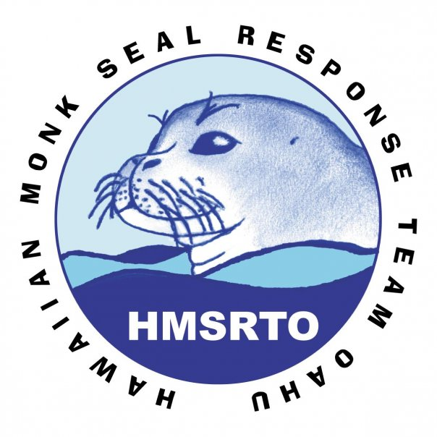Turtle Bay
Monk Seal Response Team Volunteer
Effective June 29- September 2010

