Welcome Screen
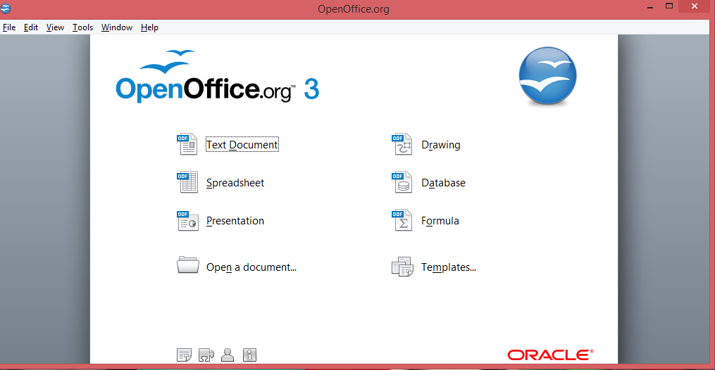
(X) Button to get Exit.
