Screen shots of the dialog boxes

Text to type into each editor:
This is a test for the BBST Bug Advocacy course. I am suppose to test the CTRL-F function to see if it toggles the Find function or has it been fixed to match what other word processors do – stays open until you close it. . . .

Repeated word = function
OOo 3.3.0 :
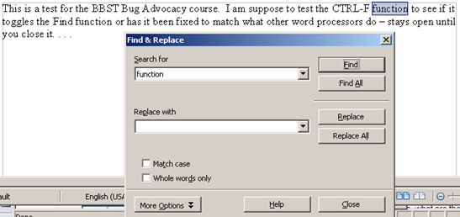

OOo 3.4.1 :

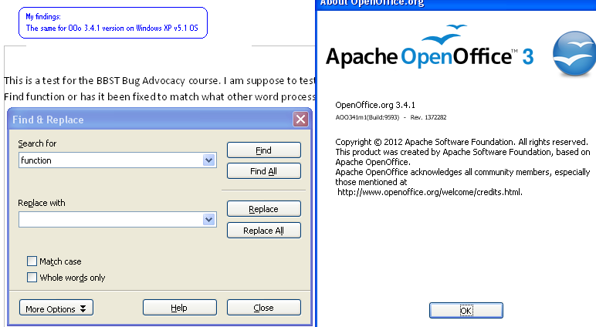
MS Word 2010
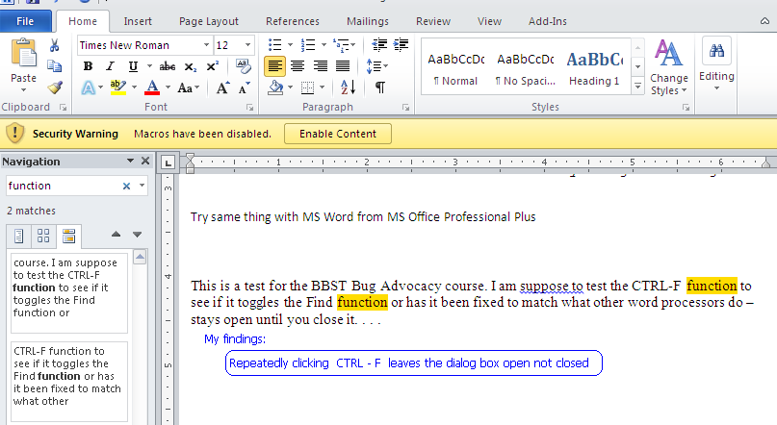

MS Notepad 2010
