Note: there are three bug reports with the same bug from 2004. First bug report with number 25855 has status of verified and fixed. As for the rest of the reports with number 98359 and 108708 has status of unconfirmed. This bug seems to be in its existence in the latest build of Open Office Calc(build 3.4.1).

These tests were under following configurations:
- Windows 7 K Home Premium 32 bit (Korean version)
  - Intel Centrino duel core CPU (P8700)
  - 4 GB RAM
- Windows 8 K 64bit (Korean version)
  - Intel i7 3rd Generation CPU (3630QM)
  - 16GB RAM
- Windows 8 Professional K 64bit (Korean Language pack installed)
  - AMD Six core CPU (FX-6100)
  - 8GB RAM
- Win32 (virtual OS)
  - AMD Six core CPU (FX-6100)
  - 8GB RAM
Software used:
- Open Office build 3.4.1
- MS Office 2013
Related bug reports:
- 25855(verified and fixed)
- 98359(unconfirmed)
- 108708(unconfirmed)

Tests: I have cross tested both Open Office Calc, and MS Excel
- Single column, multiple rows
  - Copy number of rows in same column and paste elsewhere(A2, 4, 8)
  - Result: successfully copy and pasted the selected cells in both software
    - Open Office Calc:
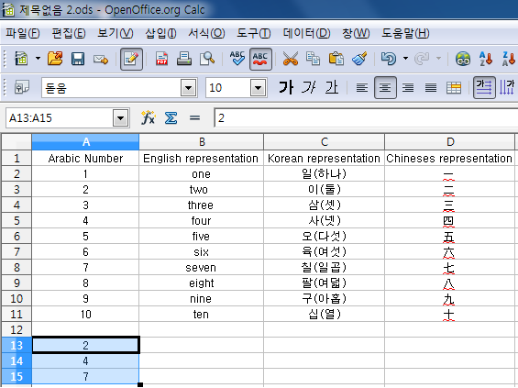
    - MS Excel
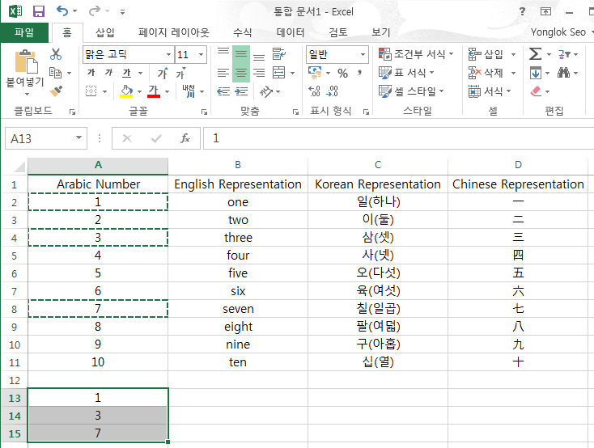

- Single row, multiple columns
  - Copy number of columns in same row and paste elsewhere(A2, C2, D2)
  - Result: successfully copy and pasted the selected cells in both software
    - Open Office Calc:
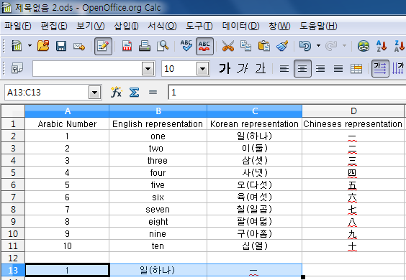
    - MS Excel
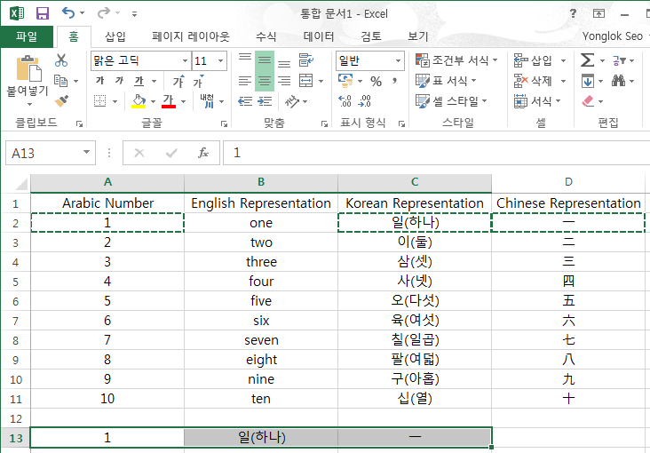

- Multiple rows and columns
  - Consecutive columns in same rows(same height)
    - Copy A2, A4, B2, B4, C2, C4 and paste elsewhere
    - Result: successfully copy and pasted the selected cells in both software
      - Open Office Calc:
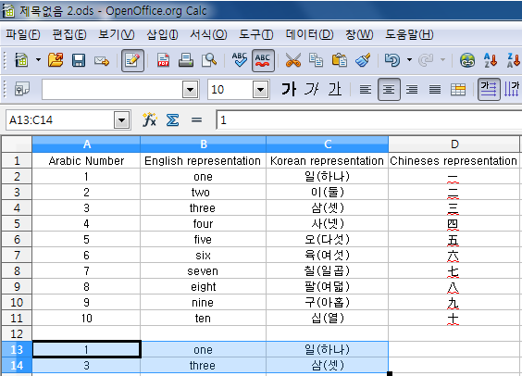
      - MS Excel
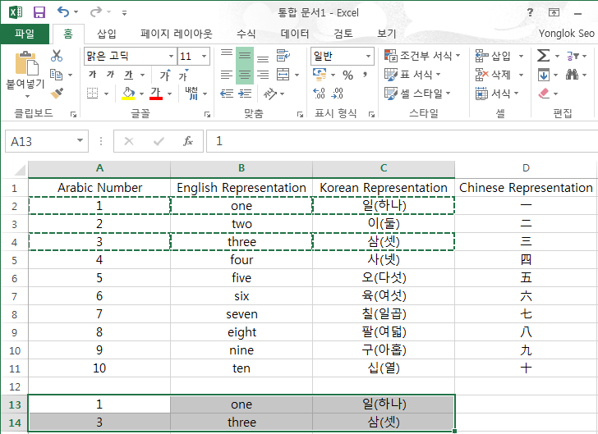

  - None consecutive columns in same rows
    - Copy A2, A4, A6, C2, C4, C6, D2, D4, D6 and paste elsewhere
    - Result: successful in Excel, unsuccessful in Calc(unable to copy selected cells).
      - Open Office Calc:
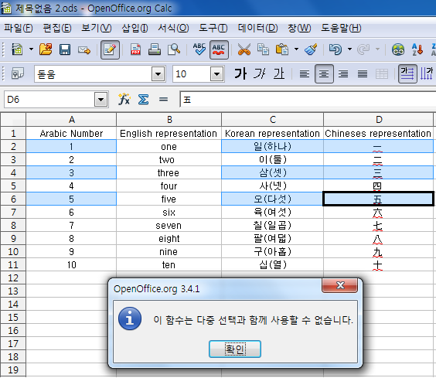
      - MS Excel
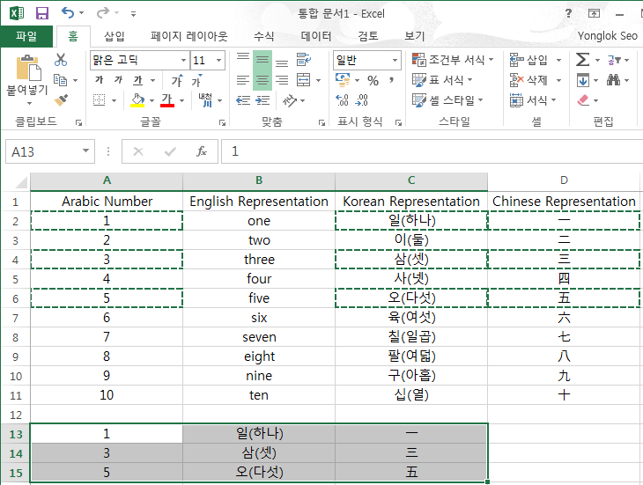

- Random selection
  - Copy A2, B7, C5, D9 and paste elsewhere
  - Result: unable to copy cells, unsuccessful on both software.
    - Open Office Calc:
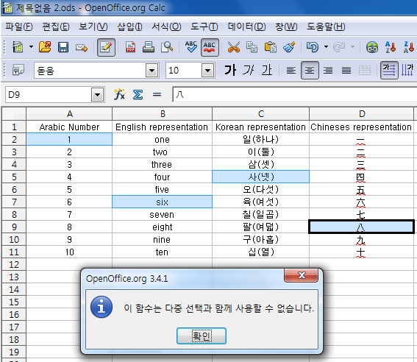
    - MS Excel
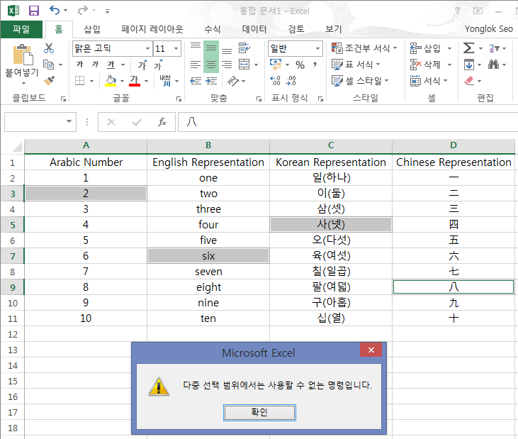

As test results shows that there is a functionality missing or misbehaving in test 3B for Calc in comparison with Excel. Test 4 was to show that it is not possible to do the task in both software.
*Note: All of the above tests were done in all four configurations with both software

