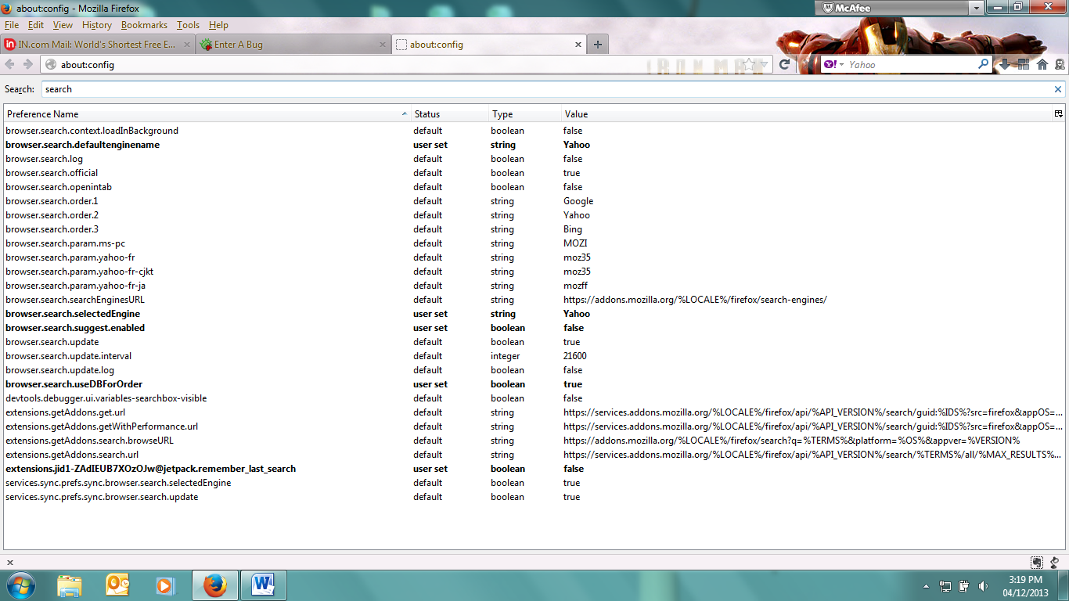
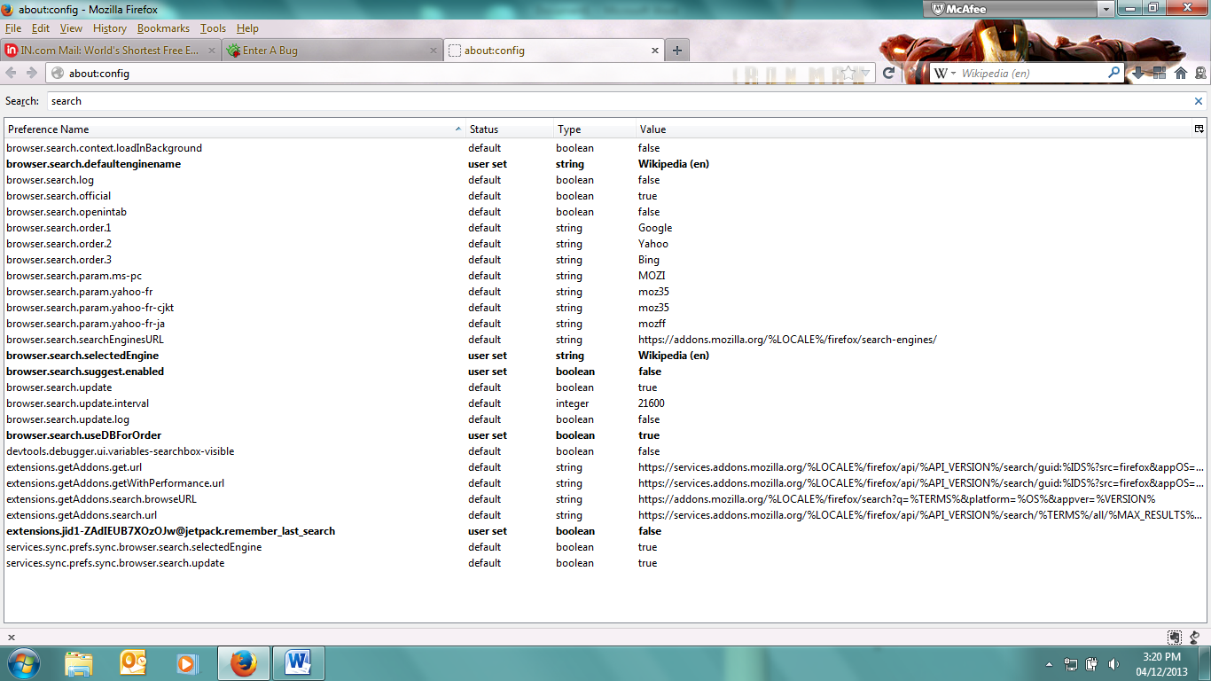
- Search preference set to yahoo in the search bar. Default search engine name key changed to Yahoo.

- Selected search provider Wikipedia and the key changed to Wikipedia(en)

