LOUIE SCHWARTZBERG
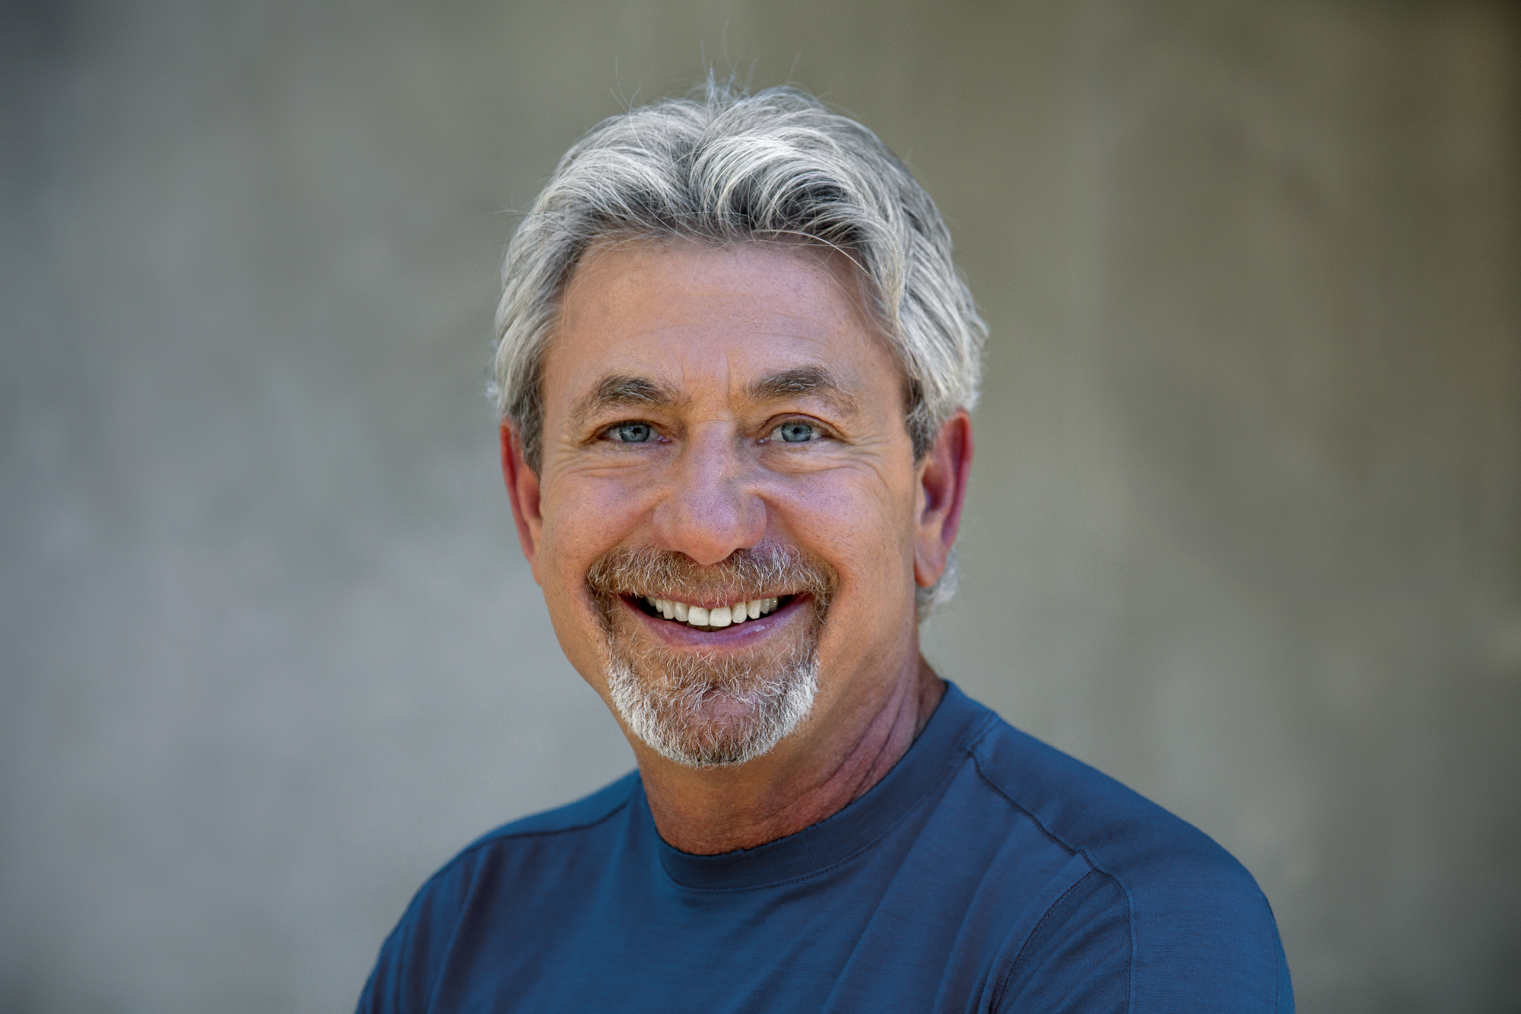
Louie Schwartzberg is an award-winning producer, director, and cinematographer whose notable career spans more than three decades providing breathtaking imagery for feature films, television shows, documentaries and commercials.
As a visual artist, Louie has created some of the most iconic and memorable film moments of our time. He is an innovator in the world of nature, aerial and “slice-of-life” photography - the only cinematographer in the world who has literally been shooting time-lapse 24 hours a day, 7 days a week continuously for more than 30 years.
He recently completed Wings of Life, a documentary feature for Disneynature, narrated by Meryl Streep. It won Best Theatrical Program at the Jackson Hole Science Media Awards 2012, a Best Cinematography Roscar Award, and the Best Cinematography Award at the 2013 Waimea Ocean Film Festival. The film reveals the fragile relationship between flowers, and their pollination partners. It is a love story that feeds the earth. The film will be released April 16 on Blu Ray. As a director, he is completing Mysteries of the Unseen World, a 3D-IMAX film with National Geographic, that is targeted for an October 2013 release. The film is a journey into invisible worlds that are too slow, too fast, too small and too vast for the human eye to see. He has received Clio Awards for Best Environmental PSA, an Emmy nomination for Best Cinematography for Oceans of Air on the Discovery Channel, and recognized as one of the top 70 Cinematographers for the On Film Kodak Salute Series.
LOUIE SCHWARTZBERG QUOTE
For over 30 years, I have been constantly engaged in filming the connections we all share, as humans, with the rest of our planet. The moments that make us inspired and connect us to the universe through the celebration of life. Firefox Flicks is all about connecting people
through the mobile web and I’m more than happy to share my perspective
with the filmmakers of tomorrow in this pursuit."
CATHERINE OGILVIE

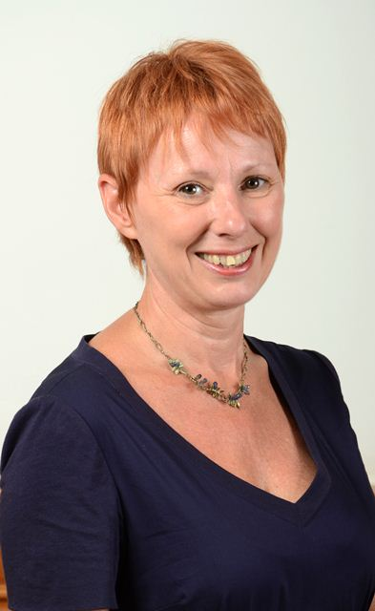

BIO
As General Manager, EMEA Marketing, Catherine Ogilvie is responsible for brand, product, and partner marketing throughout Europe, the Middle East, and Africa (EMEA). Catherine joined Dolby in 2009 as Vice President, Global Corporate Communications.

Prior to starting at Dolby, Catherine was Executive Vice President and General Manager at Edelman, the world’s largest independent PR agency, where she led the San Francisco office, building award-winning integrated communications programs for clients.

Previously, Catherine served as Director, Global Marketing and Communications, for the Almond Board of California, and as Senior Director, Marketing, for Napster, the original peer-to-peer music service. Catherine has also worked as a management consultant based in Munich, Germany, working with international media clients such as Bertelsmann, Kirch Gruppe, and Universal Studios.

Catherine studied theatre at Dartington College of Arts in Devon, England, and pursued post-graduate business studies at the University of London earning a Master’s degree in Marketing and Communication.

- CATHERINE OGLIVIE QUOTE
"Sound and cinema have been inextricably linked since the movies started
talking to us. Partnering with Firefox Flicks is a natural fit for Dolby as we’re passionate about using sound to tell great stories through the medium of film. We’re looking forward to helping young filmmakers capture the power of sound to deliver unforgettable experiences in their films.”
Helen Estabrook
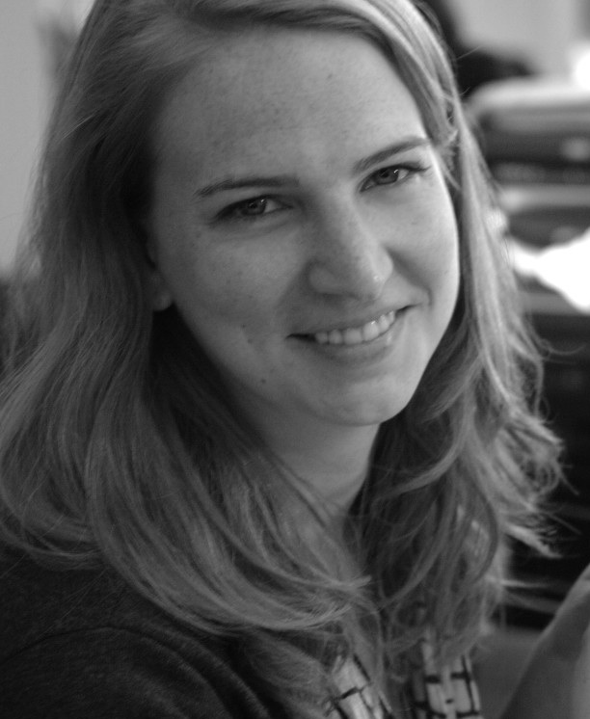

Helen Estabrook is the producing partner of director Jason Reitman and runs their production company, Right of Way Films. She most recently produced Reitman’s upcoming film, “Labor Day,” starring Josh Brolin and Kate Winslet. Currently, they are producing a pilot for HBO written by Bruce Eric Kaplan, for Reitman to direct, as well as a feature adaptation of the Sundance-winning short “Whiplash,” directed by Damien Chazelle. Helen also served as an executive producer on the Duplass Brothers’ film “Jeff, Who Lives at Home” and Reitman’s previous feature, “Young Adult”.

Andrzej Szajna

Andrzej Szajna has been in and out of the film and Tv industry for 19 years, he started his career as a assistant director in low budget action movies such as, Avalon,
Derailed and Out of Reach and worked for Independent producers such as Nu Image and Lucky 7 productions. at this point, Andrzej delved into stockbroking and entrepreneurship for 3 years. He went to produce Snow White Russian Red which won best film in 2010 at the polish eagle awards, as well as, the polish Hollywood Eagle awards. after which he produced Londoners a polish Tv series with a 13 million euro budget, which was nominated for prix europa and other awards internationally. Andrzej has spent the last couple of years fund raising for non profit organisations and is currently developing a
slate of new projects for 2014.

Gina Rodriguez
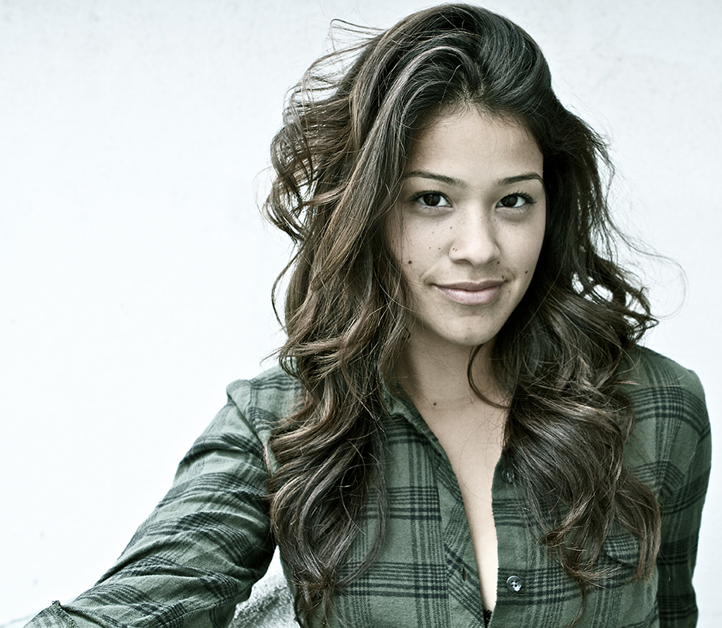

Named the “next big thing” and one of the “top 35 Latinos under 35,” by The Hollywood Reporter, Gina Rodriguez’s profile has been rising steadily since her breakout performance as the titular character in FILLY BROWN during the 2012 Sundance Film Festival. A 2012 Imagen award winner for “Best Actress in a Feature Film: FILLY BROWN,” Gina is steadily noticed by the public and entertainment industry due to her incredible acting chops and infectiously joyful personality.
Growing up in Chicago, Gina Rodriguez started performing at age seven with the salsa dance company Fantasia Juvenil. At sixteen, Gina was one of thirteen teens to be accepted into Columbia University NY- Theatrical Collaboration taught by Richard Niles. She was accepted into the Tisch School of the Arts, and the calling was clear, theatre was it. After the years of success in NY, Gina booked a lead role in a feature film GO FOR IT (Lionsgate) in which she received a 2011 Imagen Awards nomination. After this, Gina booked her first co-star TV role on CBS’ “Eleventh Hour.” She went on to book series regular roles on web series “Eden's Court” and “No Names;” her first studio film OUR FAMILY WEDDING with America Ferrera; and a lead in film SUPERCHICAS. It was also recently announced that Gina has been cast in the highly coveted lead role of Pilar "Maytag" Robles in the Fox Navy drama pilot WILD BLUE.
Gina is a supporter of Inspira, an organization that works to spotlight Latino leaders who shape their communities. She also works with the National Hispanic Foundation for the Arts and the Boyle Heights Learning Collaborative. She lives in Los Angeles, CA.

GINA RODRIGUEZ QUOTE
"I love working with companies that give opportunities to independent artist, by combining technology and art Firefox is doing just that! Thank you Firefox flicks for opening doors and allowing me to be a part of the process!" - Gina Rodriguez

