Browser crashing report due to insert large input in Facebook chat .
Steps:
- We will insert large size of data in other offline user chat windows and send it.
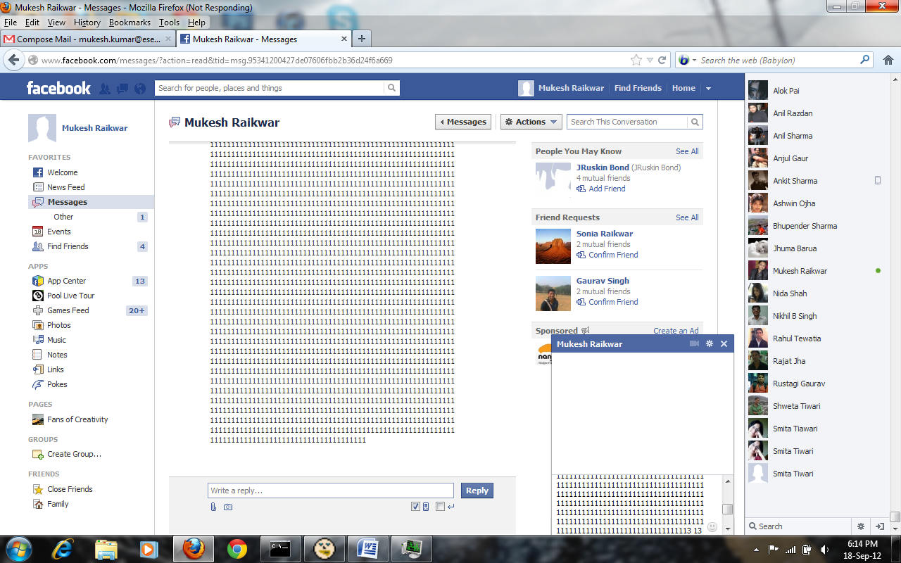

- Whenever victim open his account, then that message he will receive.
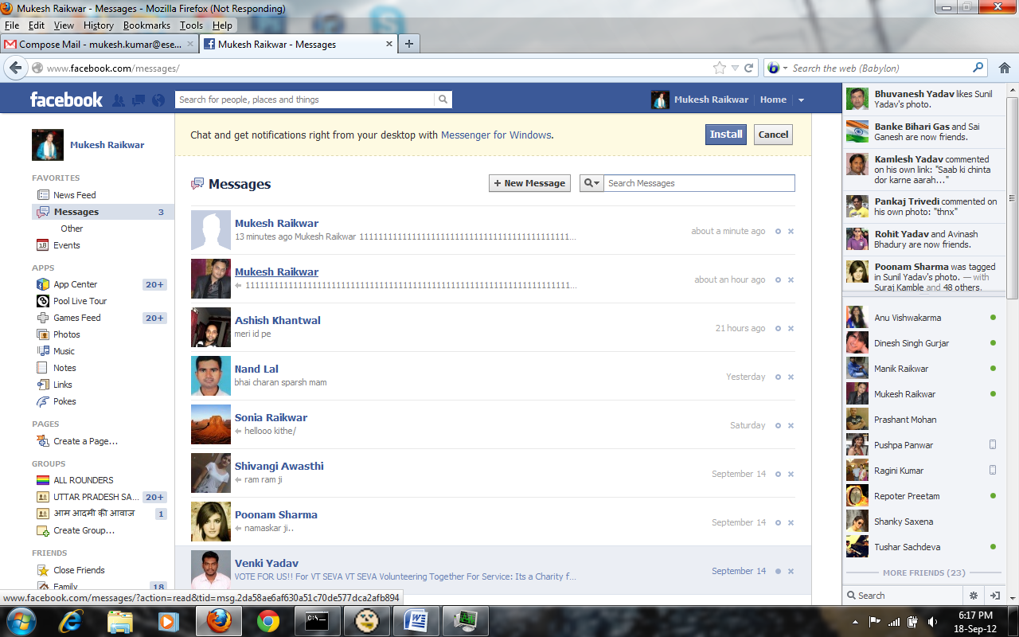

- Once he will try to read that message his browser will goes to crash.

